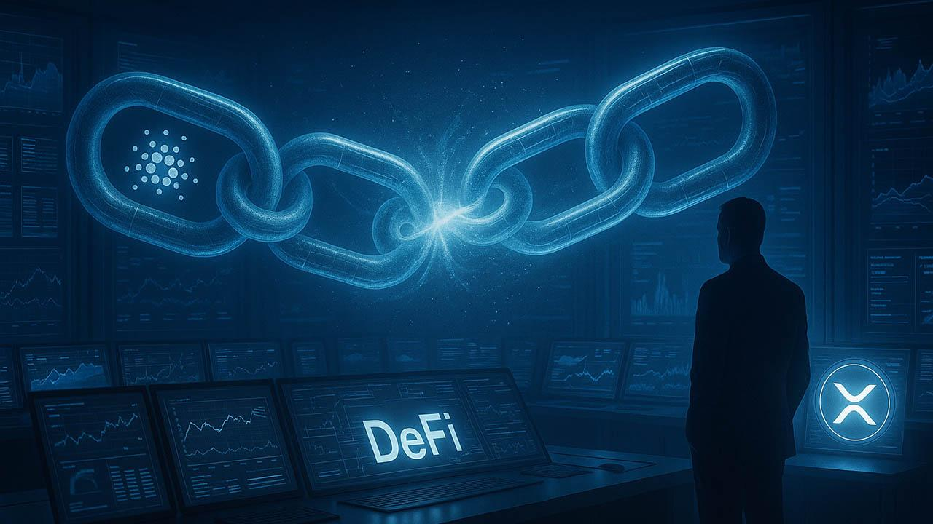Cardano Founder Turns to XRP Community in Surprise DeFi Move
Cardano founder Charles Hoskinson caught the crypto world off guard when he suddenly asked the XRP community a question: if an XRP-focused DeFi summit were hosted at the University of Edinburgh, which projects should be invited?
The post didn't go over well because Hoskinson and XRP holders have always had a rocky relationship. Just a year ago, he publicly clashed with parts of the XRP community, accusing some members of misrepresenting his words and rejecting claims that Ethereum insiders influenced the SEC against Ripple. Those disputes left scars on both sides, making this outreach feel deliberate rather than casual.
This time, though, the tone was different. Hoskinson skipped the explanations and went straight to the builders. The replies quickly filled with XRPL infrastructure projects, DeFi tools, and interoperability solutions, showing that at least some of the XRP ecosystem is open to engagement if the door stays open.
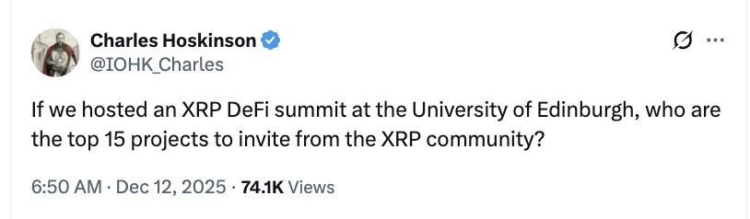
It's not clear if this move is part of a bigger strategic shift or just an academic project. But the timing is interesting.

Solana + XRP
At the same time, Solana confirmed that it had integrated XRP, meaning that wrapped XRP is now live on Solana and is backed 1:1. This means that XRP is now seen as an active DeFi asset outside of its native ledger. This change is making Ethereum less dominant in the world of cross-chain DeFi.
When you look at all the signs, it's hard to ignore. Cardano is probing XRP builders, Solana is onboarding XRP liquidity, and Ethereum's exclusive grip on DeFi is loosening. What seemed impossible a few years ago is now being tested, and the lines between ecosystems are starting to blur.

