How to earn $100-$6500 a day? Start your path to wealth using the XRPstaking platform.
In a crypto market rife with volatility and uncertainty, the real scarcity isn't the "next big surge," but rather consistent, predictable returns. Amid pressure on Bitcoin ETFs and increased volatility in mainstream assets, more and more investors are choosing a new direction—no longer watching the market closely or chasing rallies, but instead using the XRP Staking platform to allow their cryptocurrencies to generate continuous returns amidst market fluctuations. Transform market instability into visible daily profit growth. XRPstaking platforms are becoming the choice of more and more users.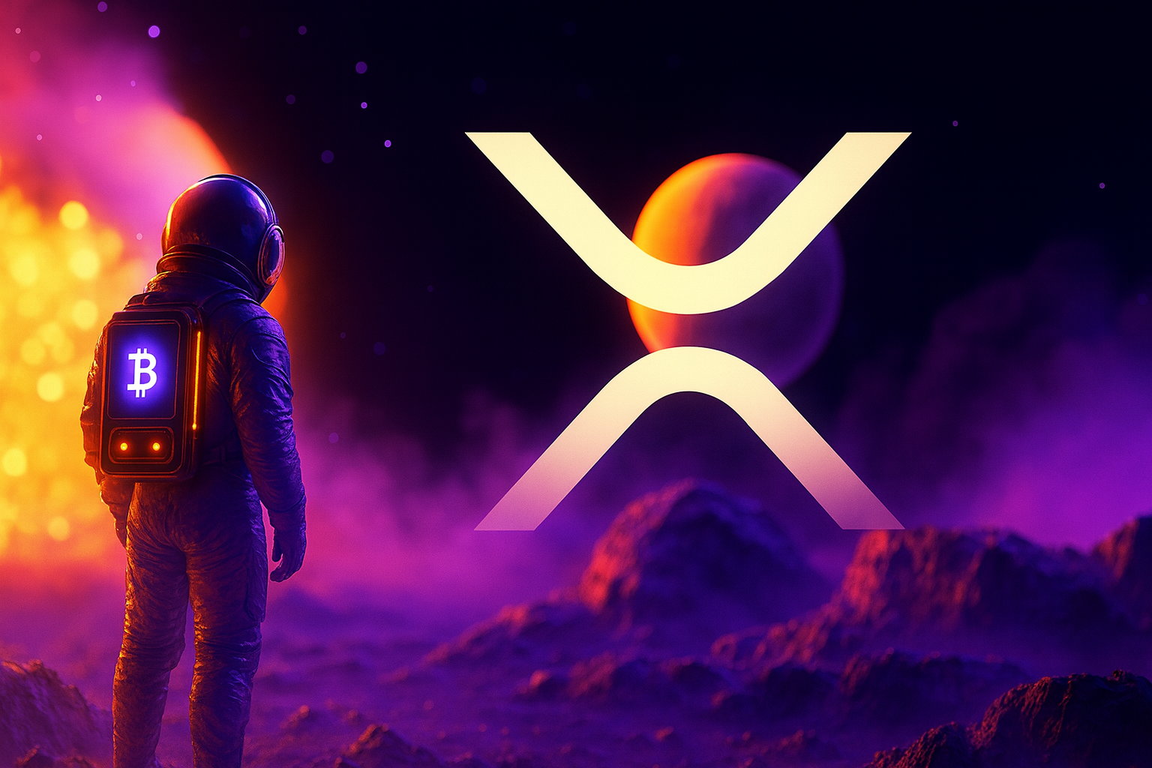
What is an XRPstaking platform?
XRPstaking involves locking up your cryptocurrency to support the security, integrity, and efficiency of the blockchain.
Its function is similar to:
Bank fixed deposit → Earning interest
Investing assets in a staking program → Earning additional returns
Making your cryptocurrency holdings not just "sitting idle," but continuously generating income
During the staking period, your principal will not disappear, but will instead receive daily, weekly, or periodic returns based on the staking program.
Advantages of the XRPstaking Platform:

1. Industry-Leading Security: Employing multi-signature, cold storage, cross-chain security verification, and real-time risk control mechanisms, the entire process is transparent on-chain, ensuring user assets are independent and tamper-proof.
2. More Stable and Sustainable Returns: Through multi-chain staking strategies and risk diversification models, stable and continuous return growth is achieved while ensuring security, making staking rewards more reliable.
3. Intelligent System Automated Optimization: The AI-driven intelligent scheduling system automatically optimizes collateral allocation based on market conditions, lowering the operational threshold and allowing users to achieve the best return path without requiring specialized knowledge.
4. 24/7 Monitoring and Operational Transparency: No additional terms or hidden fees.
5. Users can use the following assets (XRP, BTC, ETH, USDT, USDC, SOL, DOGE, LTC, BCH) to deposit or activate contracts, and can switch assets at any time to optimize returns.
How to join the XRPstaking platform?

1. Register
Visit the XRPstaking website and register an account using your email address.
After registration, you'll receive a $15 bonus and earn $0.60 in free daily returns.

2. Choose a Plan
We offer a variety of staking plans to help you achieve financial freedom. Choose the staking plan that best suits your investment preferences and return needs.

3. Start Earning
Once your purchased contract becomes effective, the system will automatically credit your earnings to your account daily.
XRPstaking Plan Contract Options
⦁【Free Staking Plan】Principal: $15, Term: 1 Day, Total Earnings: $15.6
⦁【Trial Staking Plan】Principal: $100, Term: 2 Days, Total Earnings: $107.2
⦁【Classic Staking Plan】Principal: $500, Term: 7 Days, Total Earnings: $548.65
⦁【DOGE Staking Plan】Principal: $3000, Term: 25 Days, Total Earnings: $4132.5
⦁【ETH Advanced Staking Plan】Principal: $25000, Term: 42 Days, Total Earnings: $44110
After purchasing the contract, your earnings will be guaranteed and automatically credited to your account every 24 hours. Upon contract expiration, your principal and earnings will be fully returned. You can withdraw or reinvest at any time and enjoy compound interest.
Conclusion:
In this Christmas season surrounded by lights and blessings, the best gift is often not a fleeting surprise, but a choice that brings lasting peace of mind. The market may still be volatile, but your assets don't have to fluctuate with it. With the XRP staking platform, let your cryptocurrency continue to grow steadily during the holidays, leaving uncertainty to time and reaping the rewards. Starting this Christmas, embark on a more stable growth path for your assets. Experience the XRP Staking platform now and let this gift of "long-term returns" arrive early.
官方网站：https://xrpstaking.com/
官方邮箱：info@xrpstaking.com

