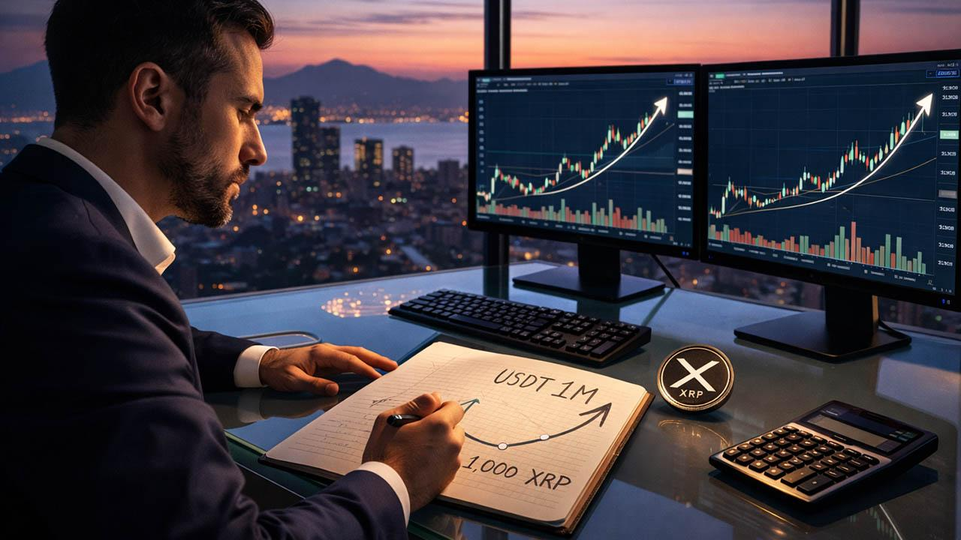Here’s How 1,000 XRP Worth $2,000 Today Could Become $1 Million
With XRP near $2, buying 1,000 tokens costs roughly $2,000 today. The big question remains: how could that relatively small sum ever grow into $1 million? For 1,000 XRP to be worth $1 million, the price must reach $1,000 per token, a 49,900% increase.
Changelly, a crypto exchange, projects XRP to reach $100 by 2033–2034. Telegaon suggested $285 by 2050. CryptoGuard’s Matthew Brienen has argued that XRP will reach $1,000 by the mid-2030s.

Can XRP Reach $1,000?
Bitcoin surged from $0.005 in 2009 to $126,000 in 2025. Similarly, Ethereum climbed from $1 to nearly $5,000, and Solana rose from below $1 to over $250.
XRP’s main hurdle is its 100 billion token supply. At $1,000 per XRP, its valuation would be $100 trillion. This reality has led many to seek alternatives with stronger upside-to-supply dynamics.

A Realistic Path To Life-Changing Growth
While XRP faces decade-long projections, Minotaurus (MTAUR) offers a more realistic path to major upside. The token has risen more than 260% in recent months to 0.00012605 USDT.
At current prices, $50 secures roughly 400,000 MTAUR. If it reaches 0.012, that position becomes $5,000. If it climbs to 0.12 USDT, the upside becomes dramatically higher, offering the same opportunities that early holders once saw in XRP, SOL, and ETH.
Notably, Minotaurus is also audited. The team has also confirmed that major announcements and partnerships are on the horizon. To learn more and explore the ecosystem, visit the official Minotaurus website.
