XRPstaking Global Christmas Event 2025: Year-End Global Gala - Christmas Rewards Galore!
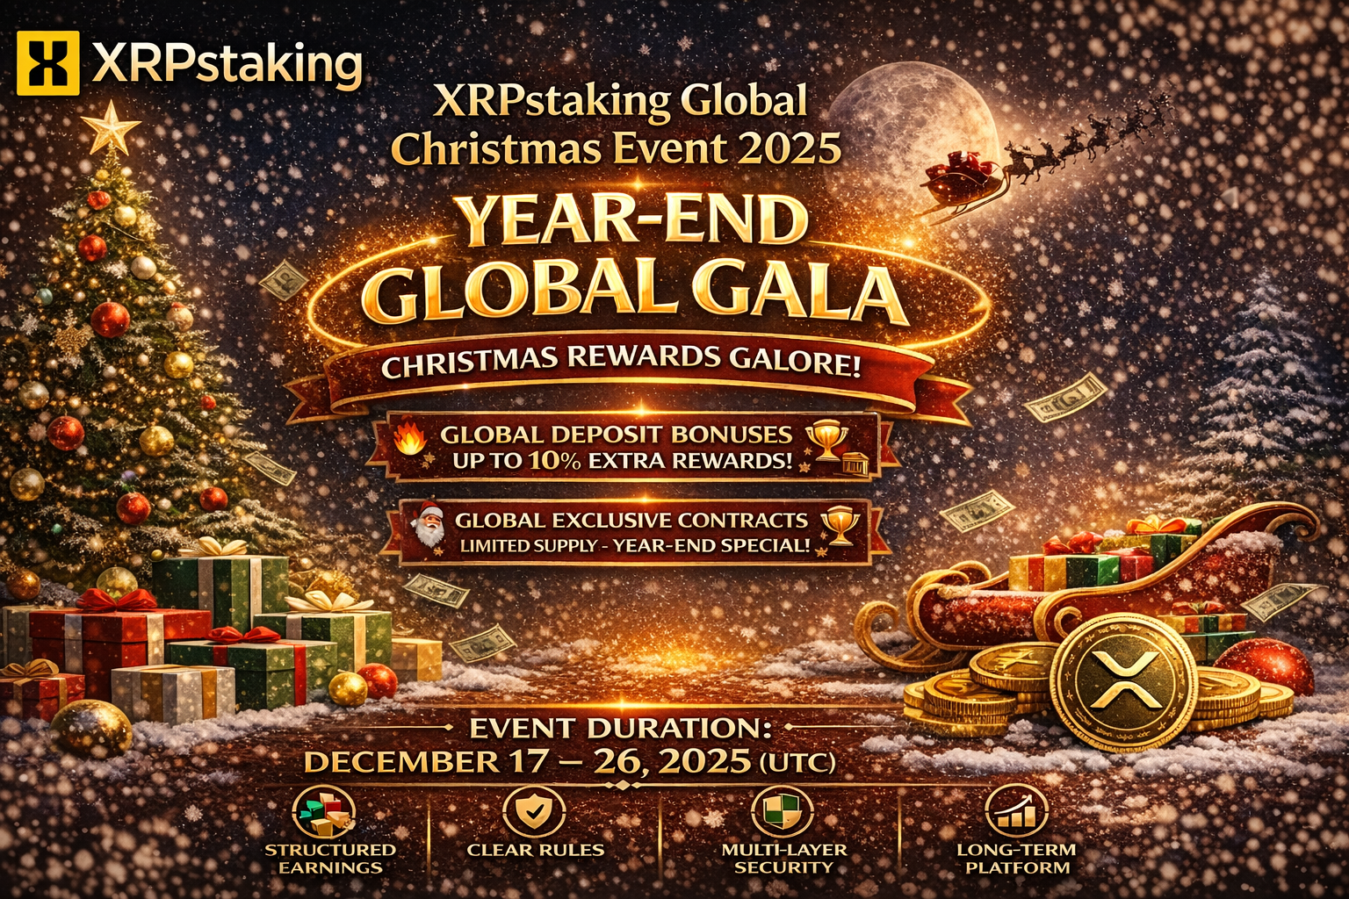
This Christmas, XRPstaking launches its most significant rewards event of 2025 for users worldwide.
Whether you're from Asia, Europe, the Americas, or the Middle East,
the same time, the same rules, the same Christmas rewards.
Amidst continued global market volatility and the greater need for safe havens for funds,
XRPstaking chooses to deliver a truly substantial year-end gala for the community through real rewards, a structured mechanism, and globally synchronized events.
This is a reward, not a gimmick.
This is a reward, not a short-term hype.
Three Christmas Mechanisms - Shared by Global Users
This event is open to all XRPstaking users worldwide, including new users, active users, and long-term supporters.

🔥① Global Christmas Deposit Bonus
Up to 10% · Instant · Globally Uniform Standard
Complete your deposit during the promotion period to immediately receive an extra Christmas bonus.
The bonus is directly added to your participation amount and does not change your original earnings structure.
Globally Uniform Bonus Tiers
1,000 – 4,999 USD → +5%
5,000 – 9,999 USD → +7%
10,000 – 49,999 USD → +9%
50,000 – 200,000 USD → +10%
Global Example:
Deposit 50,000 USD → Actual Participation Amount 55,000 USD
Deposit 200,000 USD → Actual Participation Amount 220,000 USD
Earn a year's worth of value with just one Christmas.

🎅 ② Limited-Edition Christmas Global Exclusive Contract
Born for the Year-End, Designed for the Global Market
XRPstaking will simultaneously open its limited-edition Christmas exclusive contract to the global market:
Special Year-End Structure
Fixed Term, Transparent Rules
Utilizes Institutional-Grade Security and Yield Model
Limited Quantity, Released Globally Simultaneously, First Come, First Served.

③ Global Referral Rewards · Earn Invite!
5% Instant Return, Regardless of Country or Region
Christmas is the season for sharing and a time to maximize your earnings.
During the event, invite friends to join XRPstaking.
When your friend successfully registers and deposits ≥1,000 USD:
You will receive a 5% globally unified referral reward.
When your friend deposits 1,000 USD,
You will receive a 50 USD reward.
The more you invite, the more rewards you receive, with no upper limit.

Global Event Period
🗓 December 17, 2025 – December 26, 2025 (UTC Time)
All Christmas reward access will be closed after the event ends.

Why do global users choose XRPstaking?
Even during the most exciting holiday events, XRPstaking adheres to the following principles:
Structured returns, not blindly high returns
Clear rules, not hidden terms
Multi-layered security, not single point of risk
A long-term platform, not a one-off project
This is the foundation of XRPstaking's global reach.

A Global Christmas Greeting from XRPstaking
Thank you to every user from around the world.
It is your participation that makes XRPstaking a truly global platform.
This Christmas,
we don't offer empty words, only real rewards.
XRPstaking wishes all global users:
Merry Christmas · Happy New Year · Stable returns · Unwavering confidence
For more details, please visit the company website: https://xrpstaking.com

