Bitcoin Shows Glimpse of 2021 Bull Top—Here’s How Low It Could Dump
Bitcoin recorded a disappointing 2025. It fell drastically from its October all-time high of $126,000 to below $100,000, playing contrarian to top assets like gold and silver.
Meanwhile, recent analysis suggests it could get worse for Bitcoin. Specifically, analyst Chiefy highlighted a similarity between the current price trend and the 2021 bull market cycle. For the uninitiated, Bitcoin peaked at $69,000 in 2021 amid a strong bullish run.

Why Does This Matter for Bitcoin?
Bitcoin recorded two peaks in 2021, reaching $64,900 in April 2021 and $69,000 in November 2021. An accompanying chart shows that this is repeating for BTC. It peaked at $109,350 in January 2025 and $126,200 in October 2025 before a steep correction.
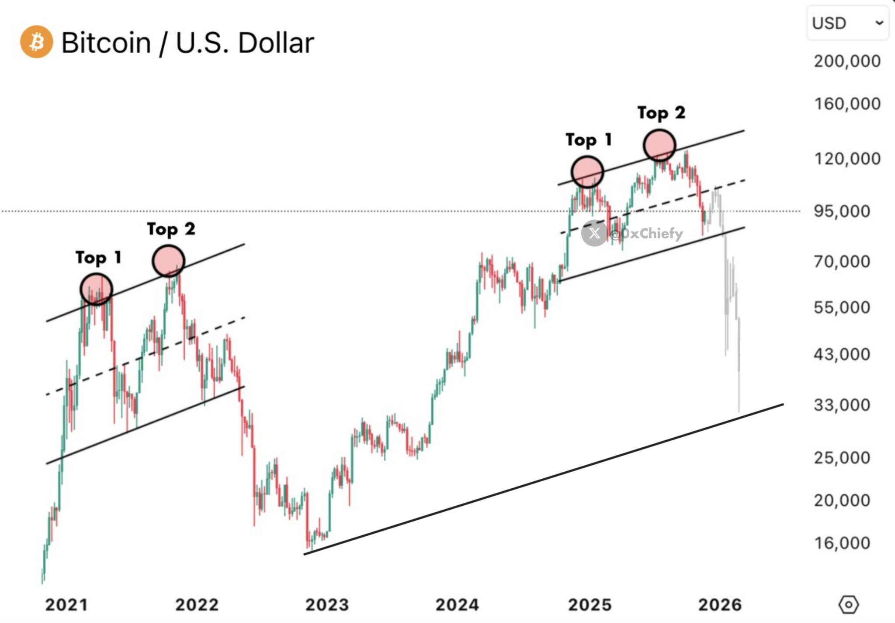Source X
Chiefy stated clearly that if the 4-year cycle hasn’t broken, as some suggest, then Bitcoin will see further dumps from here. How low? The analyst predicted a crash to $33,000, a price level last seen in 2023. Remarkably, this will also significantly impact altcoins.
However, an early-stage project is defying this trend. While others dropped, it has rallied significantly. Minotaurus (MTAUR) posted an over 200% rally in 2025 and looks to do more this year. Currently above 0.000126 USDT, analysts expect it to cancel several more zeros, making it a must-have asset now.
Learn more at minotaurus.io.

