Binance Coin (BNB) Price Prediction: Analysts Forecast BNB Price to Rally to $920
Meta Description: Binance Coin (BNB) price maintains above support as analyst charts a bullish path for the crypto to skyrocket to $920 soon.
Binance Coin (BNB) has performed relatively better compared to many altcoins in the market. Priced at $841, it has shown resilience amid broader market declines. As one of the few altcoins to hold steady, BNB's strong performance is noteworthy, especially during challenging periods for other cryptocurrencies.
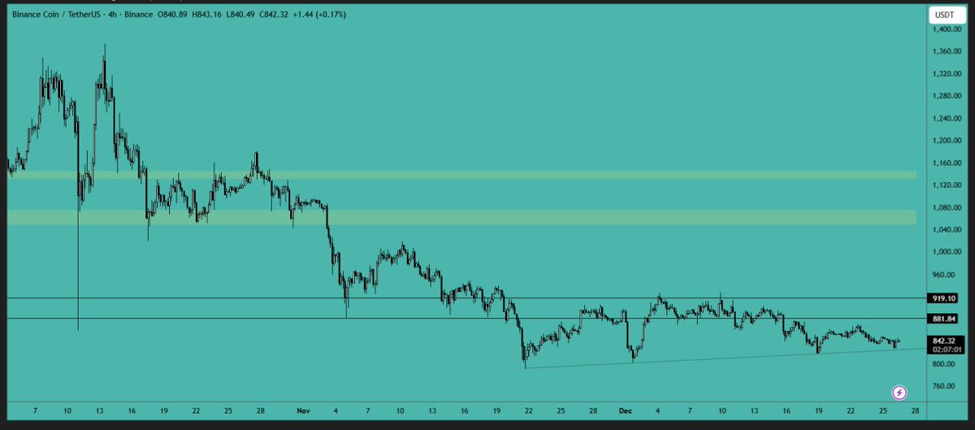
Source: X
Despite its recent stability, BNB’s price could face challenges in breaking through resistance levels. Analysts are eyeing the $920 mark as a key resistance level for BNB. A break above this level could signal bullish momentum and open up new potential for the coin.

Minotaurus (MTAUR): A Gaming Token with Major Potential
Amid the crypto market dip, new projects like Minotaurus (MTAUR) are getting attention. Minotaurus is a Web3-based gaming token built on Binance Smart Chain (BSC). It allows users to upgrade characters, unlock features, and participate in the game.
At Stage 6, MTAUR is priced at 0.00014 USDT, with the official launch price set at 0.00020 USDT. This represents a 60% surge for anyone buying at Stage 6 before the price surges. For example, if you buy 100 USDT worth of MTAUR now, you'll receive approximately 714,285 tokens.

This gaming token stands out because it’s fully audited by SolidProof and Coinsult, ensuring that it’s 100% safe to buy.

Best Crypto to Buy Now
As we approach the New Year, Binance Coin (BNB) is showing potential for recovery, with BNB testing crucial support levels and maintaining stability in a volatile market.
However, for buyers looking for new opportunities, Minotaurus (MTAUR) offers an exciting chance to buy before its official launch.

