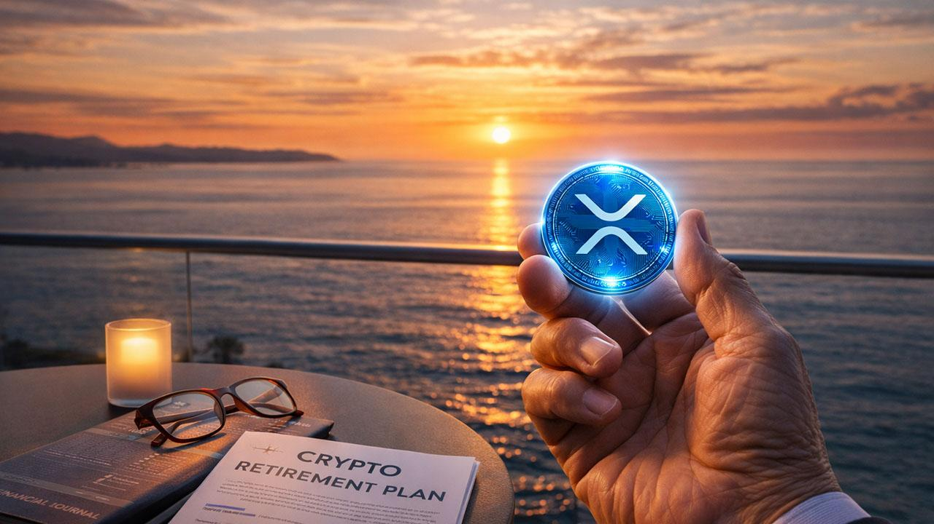Crypto CEO Says XRP Can Help a Lot of People Retire
Doginal Dogs founder says XRP will retire a lot of people, echoing a common crypto hope of achieving financial independence. Retirement needs vary widely, from ~$700K in low-cost areas to $2M+ in places like Hawaii.
At XRP’s current price of $1.91, turning $10K into $2M would require XRP to be at $380. Changelly projects $380 by 2040; Telegaon sees a max of $128 by 2050.

More realistic paths for XRP
- 20,000 XRP ($38K) → $2M if XRP hits $100
- 50,000 XRP ($100K) → $2M if XRP hits $40
- $500K becomes → $2M if XRP reaches $7.60
Jake Claver of Digital Ascension Group stresses planning over price chasing—accounting for taxes, security, and access. He suggests trusts, LLCs, collateralized liquidity, and digital family offices for larger portfolios to preserve wealth across generations.

One 2026 Early-Stage Opportunity
Minotaurus (MTAUR) is an early-stage crypto attracting attention as a diversification play beyond XRP. Unlike established assets, its early adoption phase offers higher upside potential.
- Current price: 0.000126 USDT (up 3X from 0.00004)
- $100 buys 800,000 MTAUR.
- At 0.024 USDT → $18,750; higher adoption could push it further (e.g., 0.24 USDT).
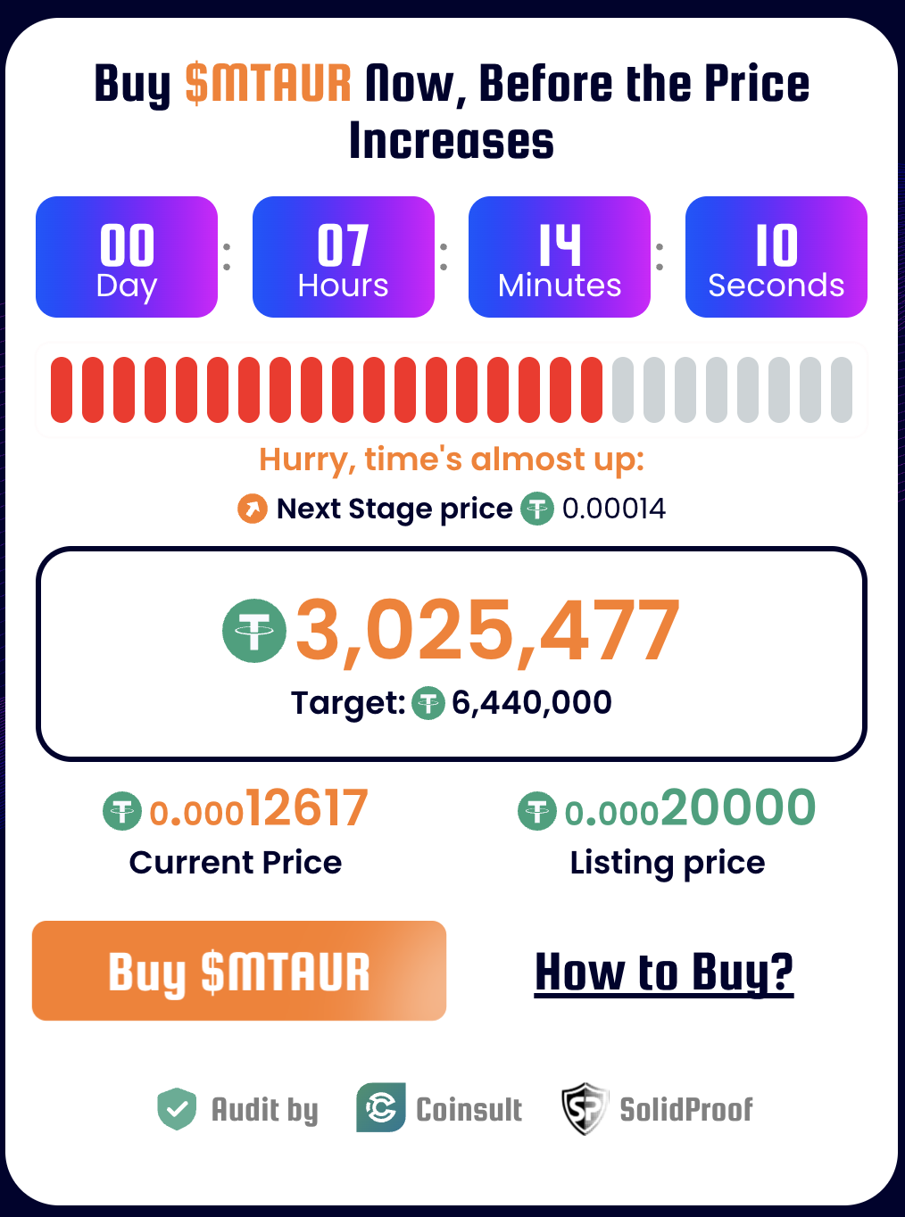

The market cap is 5.6M, leaving significant room to expand toward 250M+. Upcoming exchange listings and adoption-focused partnerships could boost liquidity and demand. It is independently audited, adding credibility.
For those who missed early XRP or BTC, MTAUR is seen as a potential early-entry “second chance” due to its low valuation, growing ecosystem, and pending milestones. Learn more.

