Solana Crosses $1.6T Volume, Beats Top Exchanges, Opens Path For Utility Tokens

Solana has shown renewed strength after breaking out of a monthlong downtrend. The token’s price rebound reflects rising demand across its ecosystem. Recent activity suggests growing confidence among market participants.

Solana has also outperformed several major exchanges this year. That momentum has helped reposition the network as a serious contender in digital asset infrastructure.

How Has Solana Performed In 2025?

Solana’s performance in 2025 has exceeded many centralized exchanges by volume. According to Artemis researcher ZJ, decentralized exchange activity on Solana reached $1.6 trillion. This figure places Solana second overall, trailing only Binance at $7.2 trillion. The data highlights how on-chain exchanging has expanded at a rapid pace.

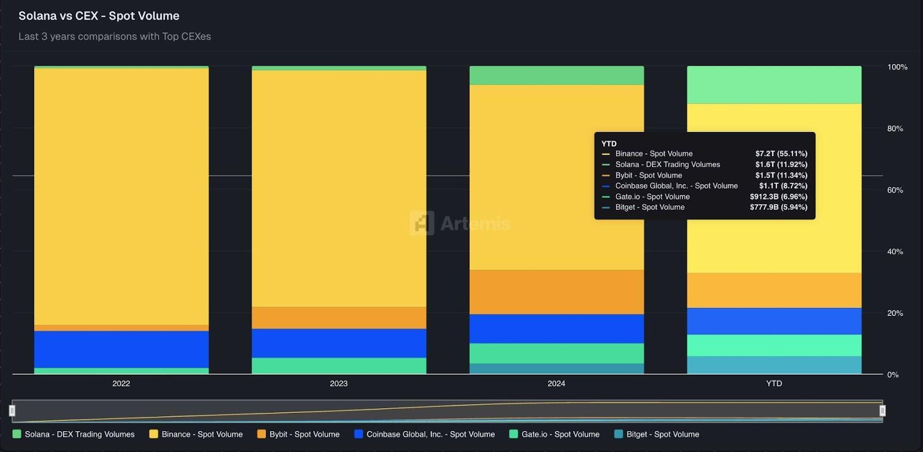
Solana vs CEXes - Source - ZJ

Solana surpassed platforms including Bybit, Coinbase Global, and Bitget. ZJ noted on X that Solana ranked fifth among major venues just one year ago.

“just a year ago, solana was 5th among major CEXes. today in 2025, it’s 2nd - only behind Binance, having just overtaken Bybit. with propAMMs and CLOBs being a major growth story in recent months for solana. its hard not to be bullish looking into 2026 (sic),” ZJ noted.

Can Solana Price Recover Soon?

Solana spent most of December moving under a clear downtrend. That structure broke this week as buying pressure has risen. The token is now holding above the $120 level. Holders are watching a potential move toward the $133 resistance. Sustained volume would be needed to support that advance.

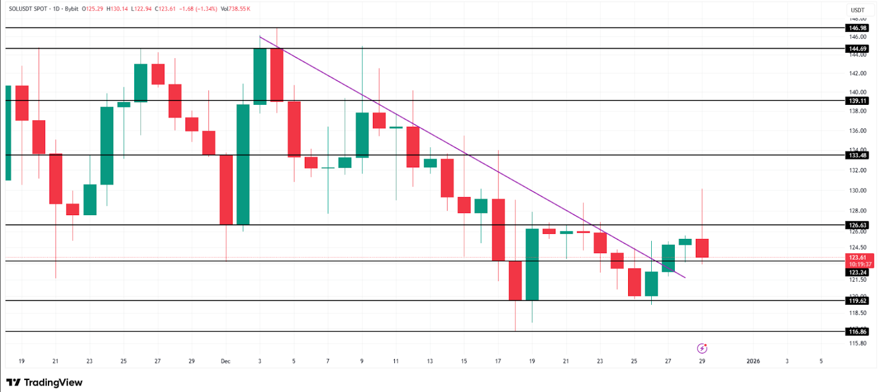
Solana Price - Source - TradingView

Holder demand continues to support price action. Solana’s use in payments, exchanging, and applications reinforces its utility narrative. This positioning may help SOL extend its rise. Analysts see $140 as a possible target if momentum holds. Market conditions remain a key variable.

How Is Solana Setting Up Minotaurus (MTAUR)?

Solana’s surge underscores rising interest in utility-driven crypto assets. Networks that support real activity often attract durable demand. This could also help other similar utility-driven tokens such as Minotaurus (MTAUR).

Minotaurus (MTAUR) follows a similar approach within gaming. The token is integrated directly into gameplay mechanics. Players use MTAUR to upgrade equipment and unlock levels. It also enhances character abilities. This structure ties demand to in-game activity rather than speculation.

MTAUR is priced near 0.000126 USDT, offering a low entry point. Its distribution emphasizes balance, with 2% allocated to the team. Another 10% is reserved for community incentives. As Solana continues to expand, utility-focused tokens may benefit from broader market validation.

