2 Best Cryptos to Buy Under $1 With 900x Potential By 2026 April
Meta Description: Dogecoin (DOGE) priced near $0.13 as wedge and triangle patterns suggest a potential breakout or drop with low liquidity.
Dogecoin (DOGE) is consolidating tightly near $0.13 as transacting volume declines and volatility compresses. The daily chart reveals a falling wedge pattern, where lower highs meet converging support. According to analyst Surya, momentum indicators show bullish divergence, which could point to an upcoming breakout if DOGE clears the $0.127–$0.130 range. A move above could open the path to $0.14.
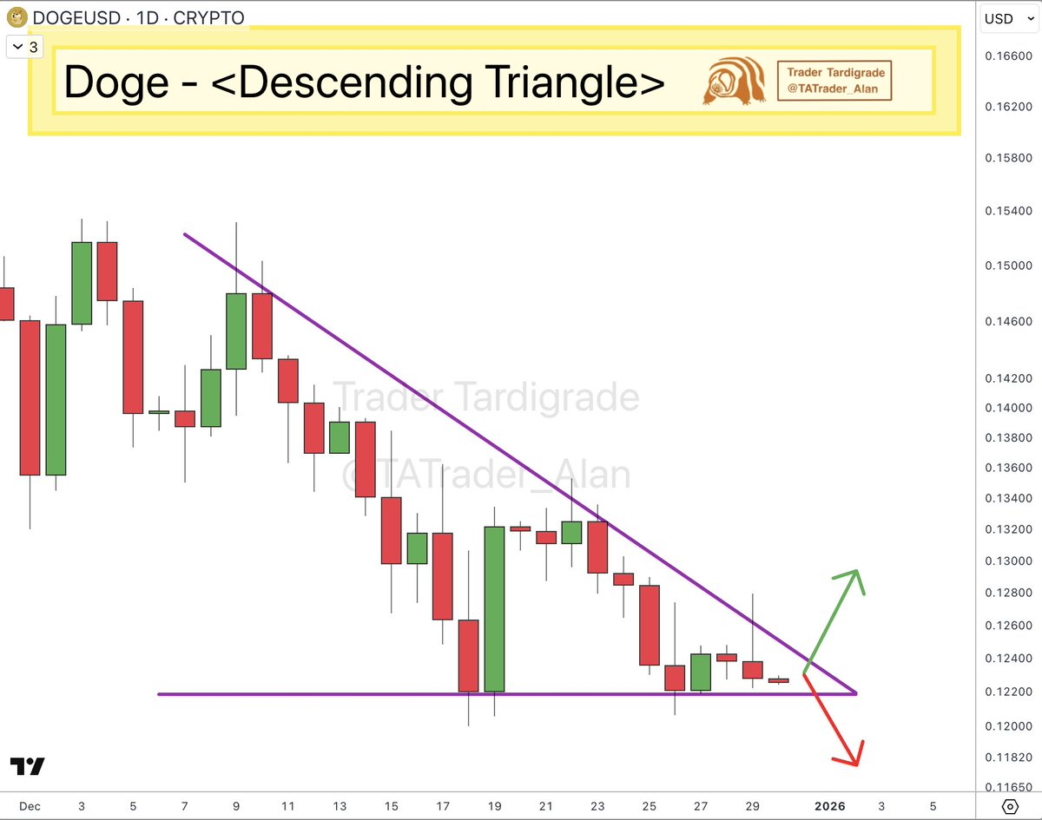
Source: X
However, another formation—identified by analyst Tardigrade—adds caution. A descending triangle with flat support at $0.122 suggests downside risks remain if that level fails. A breakdown may target the $0.10 region, especially with low liquidity increasing the risk of false breakouts.

Buyers are Eyeing New Crypto with 900x Rally Potential
Beyond Dogecoin, some market participants are also monitoring lower-priced cryptocurrencies with different use cases. One such project being discussed in this context is Minotaurus (MTAUR).
Minotaurus (MTAUR) is a new Web3 gaming token on Binance Smart Chain. Priced at just 0.00012625 USDT, MTAUR is still in presale Stage 6. The token will launch at 0.00020 USDT, giving early buyers a 58%+ price jump on day one.
A 100 USDT buy today gets over 790,000 MTAUR. If the token hits just $0.10 in the next bull cycle, that $100 turns into 79,000 USDT — nearly 900x rally potential.

Minotaurus powers a blockchain-integrated gaming platform where players use MTAUR for avatar upgrades, in-game items, and access to special bonuses. The project has already gotten over 3 million USDT, and all smart contracts are fully audited by SolidProof and Coinsult for safety. With real use, low price, and rising demand, MTAUR stands out as a best crypto to buy under $1 before April 2026.

