Solana (SOL): Achieve Smart Daily Earnings of $8,856 with Fleet Mining Cloud Mining

The use of Solana (SOL) is also known as one of the most efficient and quickest blockchain networks in the cryptocurrency market. Solana is also famous due to its high transaction rate and low charges, making it the preferred option in the field of decentralized applications, NFTs and payment systems. With the ever-increasing interest in SOL, most users are seeking methods to create returns on their assets, without any complicated technical processes.
It is necessary to add that Solana is not mined, but Proof-of-Stake (PoS) consensus mechanism. Nonetheless, SOL holders may engage in earning opportunities using the contemporary cloud computing platforms.
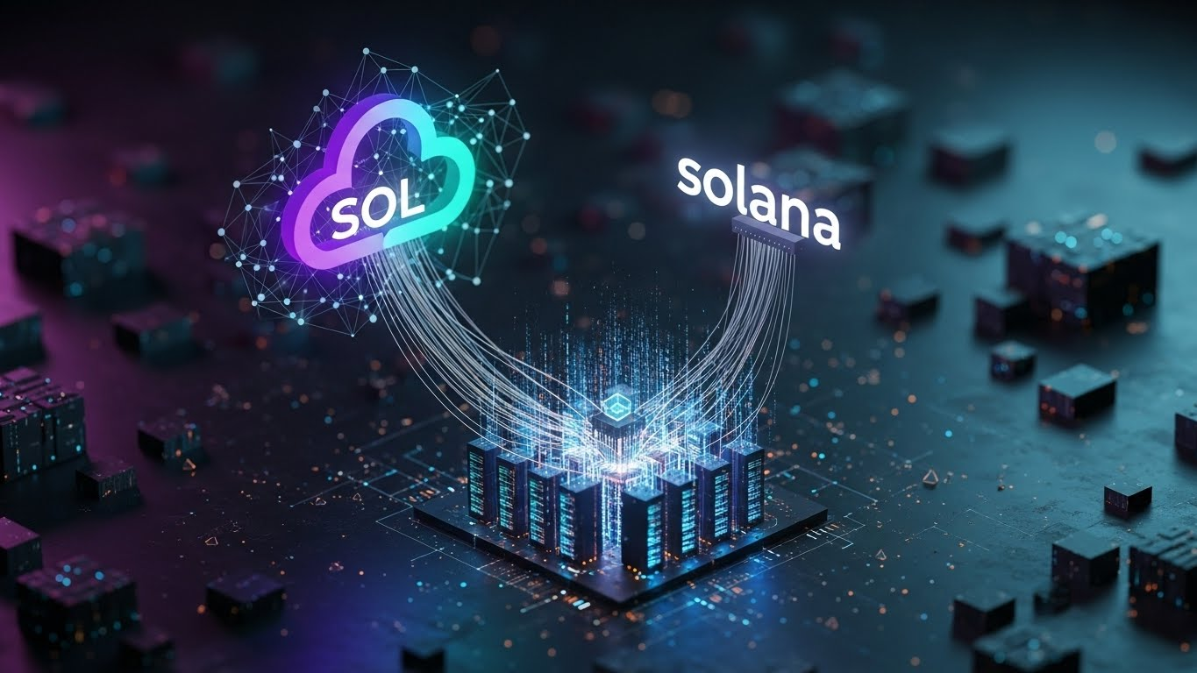
Solana to Cloud Mining Participation
Though not directly mineable, there exist platforms such as Fleet Mining that enable users to deposit SOL that is automatically transformed through the system into computational power. It is used to join the Bitcoin cloud mining and receive on a daily basis reward without having to operate mining equipment.
The given approach gives SOL holders the opportunity to transform idle assets into a source of passive income without focusing on the technical complexity of traditional mining.
Cloud Mining vs Traditional Mining
The conventional mining takes a lot of equipment, power and needs proper cooling mechanisms as well as constant technical upkeep. These challenges render mining a nightmare to most individual users.
Cloud mining does away with these problems. All the infrastructure, such as hardware, electricity, cooling, and optimization of the system is attended to by Fleet Mining. It only requires the users to choose an appropriate agreement and the AI-based system of the platform does all work automatically.
Why Choose Fleet Mining
Fleet Mining resorts to the AI cloud computing to distribute resources in an efficient manner and ensure the maintenance of stable performance. With this model, the user is able to enjoy the returns associated with mining without the need to have a physical equipment or maintain it.
Key advantages include:
- No mining hardware required
- No technical expertise required.
- Automated daily earnings
- Open income management.
- Flexible agreement options
Cloud Mining Contracts (Examples of Earnings)
The following are sample earning arrangements that are offered by Fleet Mining:
- $15 agreement, 1-day duration
Daily earning $0.6
You may be involved on a daily basis.
(Free plan, start at zero cost)
- $100 agreement, 2-day duration
Daily earning $3
Total: $106
- $1,200 agreement, 10-day duration
Daily earning $16.20
Total: $1,362
- $6,000 agreement, 20-day duration
Daily earning $96
Total: $7,920
- $30,000 agreement, 45-day duration
Daily earning $540
Total: $54,300
These examples demonstrate how the levels of investments can give a systematic and predictable returns by cloud mining.
Additional Rewards
Fleet Mining offers additional incentive to enhance user returns too:
- Registration Bonus: $15-$100 to new members.
- Daily Login Reward: $0.60 per day
These benefits may be added to the mining income to obtain improved outcomes.
Getting Started
To become a member of Fleet Mining, it is easy:
- Create an account by using your email address.
- Supported assets like SOL were deposits.
- The system transforms assets into mining energy automatically.
- Choose a contract and get bonuses every day.
The AI cloud system of the platform controls all the processes.
Conclusion
Although Solana cannot be mined, it can still be useful in the production of passive income. By means of Fleet Mining, SOL holders receive an opportunity to turn their assets into the power of cloud-based computing and engage in Bitcoin mining without any technical load. It is an efficient, automated and user-friendly modern earning model, which is why it is a good choice to a novice and an advanced user.
Website: https://fleetmining.com/
Email: info@fleetmining.com

