BYDFi Review: Fees + Perpetuals Experience
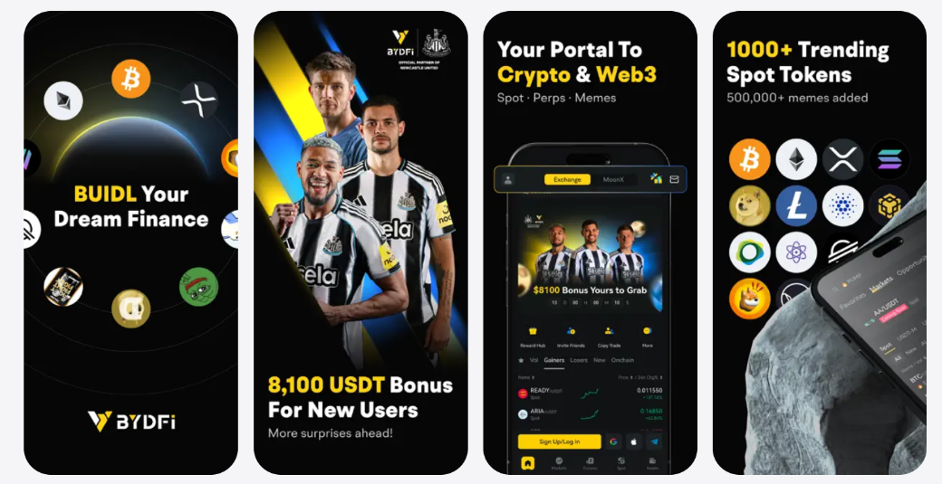
In modern financial markets, clarity, efficiency, and security are essential for investors. BYDFi offers a platform designed to meet these needs. From transparent trading fees to professional-grade perpetual contracts, the platform aims to serve both individual and institutional users.
This review provides a detailed look at BYDFi trading fees, perpetual trading experience, security measures, platform design, and strategic credibility—including its sponsorship of Newcastle United, which underscores BYDFi’s global reach.
Company Overview
Founded in 2020, BYDFi has grown rapidly to serve over 1 million users across 190+ countries. Its business model focuses on providing a reliable, transparent, and scalable platform. BYDFi’s international credibility is reinforced by its partnership with Newcastle United, a Premier League football club, highlighting the brand’s global recognition and commitment to professionalism.

Key Highlights of BYDFi:
- Transparent trading fees
- Advanced perpetual contract offerings
- Multi-platform access (desktop & mobile)
- Strong security and compliance measures
- Global brand credibility
BYDFi Trading Fees
One of BYDFi’s strongest selling points is its transparent fee structure. Investors can calculate costs accurately, ensuring that trading decisions are made without surprises.

Fee Overview
Trading Type | Fee Type | BYDFi Fee | Industry Average
Spot Trading | Standard | 0.1% | 0.15%
Perpetual Contract | Maker Fee | 0.02% | 0.05%
Perpetual Contract | Taker Fee | 0.06% | 0.08%
Maximum Leverage | - | 200x | 100x-125x
Fee Transparency | - | Full | Moderate
The combination of competitive BYDFi trading fees and high leverage options makes the platform attractive for serious investors seeking both cost efficiency and flexibility.

Comparison with Industry Standards
Compared to competitors, BYDFi maintains lower trading fees while delivering professional execution and risk management tools. This allows investors to focus on strategy rather than hidden costs.
Perpetual Trading Experience
Perpetual contracts are essential for investors looking for long-term positions without expiration constraints. BYDFi offers advanced features for perpetual trading that prioritize precision and efficiency.

Key Perpetual Features
Feature | BYDFi Advantage
Leverage Options | 1x – 200x, flexible capital allocation
Margin Modes | Isolated & Cross Margin
Execution | Real-time, precise order placement
Analytics | Profit/Loss tracking, risk indicators
Security | Proof of Reserves & multi-level approvals
BYDFi’s perpetual trading system ensures fast execution, minimal slippage, and clear tracking of positions. Investors can monitor risk and performance in real-time, enhancing confidence in decision-making.
Security and Compliance
Security is a critical factor in choosing a financial platform. BYDFi incorporates multiple layers of protection to safeguard investor assets.

Security Measures
Security Measure | Description
Proof of Reserves | Over 1:1 reserves with periodic public reports and 800 BTC Protection Fund
Cold Storage | Offline storage for majority of funds
Multi-Party Approval | Requires multiple signatures for transactions
Two-Factor Authentication | Extra layer for account protection
Regulatory Compliance | BYDFi has MSB registrations and it's member of South Korea’s CODE VASP Alliance
These measures ensure that BYDFi operates with transparency and reliability, building trust for both retail and institutional investors.
Platform Design and User Experience
BYDFi provides a seamless experience across desktop and mobile devices, catering to the needs of global users.

Platform Features
Feature | Desktop | Mobile App
Dashboard | Comprehensive overview | Real-time portfolio tracking
Order Types | Spot & Perpetual trading | One-click execution & monitoring
Notifications | Alerts & reports | Push notifications for trades
Account Management | Multi-wallet management | Seamless switching & overview
Analytical Tools | Charts, indicators | On-the-go analytics
BYDFi allows users to switch between desktop and mobile platforms without losing continuity. The platform design is clean, professional, and intuitive, making complex financial management easy to understand.
Strategic Partnerships
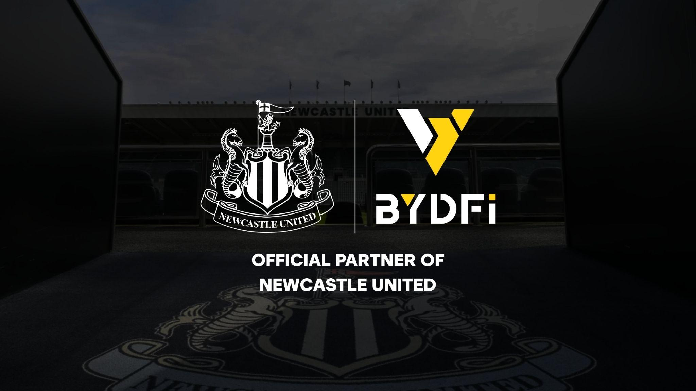
BYDFi’s sponsorship of Newcastle United strengthens its global business credibility. By partnering with a Premier League club, BYDFi gains international visibility, reinforcing trust among professional investors.

Benefits of the Partnership
- Enhanced brand credibility
- Access to a global audience
- Alignment with professional and corporate standards
The Newcastle United partnership signals BYDFi’s commitment to professionalism and its strategic approach to global growth.
Advantages of BYDFi
Advantage | Description
Transparent Trading Costs | Competitive BYDFi trading fees ensure predictable expenses
Advanced Perpetual Trading | High leverage, flexible margins, and real-time execution
User-Friendly Interface | Professional dashboard for desktop and mobile
Security and Compliance | Proof of Reserves, 2FA, and regulatory adherence
Global Reach | Serving 1M+ users in 190+ countries
Credible Brand Partnerships | Newcastle United sponsorship strengthens trust
BYDFi combines professional-grade tools with accessibility, making it ideal for investors who prioritize clarity, security, and efficiency.
Trading Fees in Practice
Investors using BYDFi benefit from consistent and clear trading fees that allow accurate cost management. Unlike other platforms, there are no hidden charges, enabling reliable planning for both short-term and long-term strategies.
BYDFi also provides flexible fee management for VIP users, offering tiered reductions based on trading volume, further enhancing its appeal for professional investors.
Mobile vs Desktop
BYDFi offers a fully functional mobile platform, ideal for investors on the go. The mobile version includes:
- Real-time portfolio monitoring
- One-click order execution
- Push notifications for key trading events
- Multi-wallet management
Desktop users benefit from advanced analytical tools, multi-window support, and deeper market visibility. Both platforms share a unified account system for seamless switching.
FAQs
1. What are BYDFi trading fees?
BYDFi charges 0.1% for spot trades and 0.02%/0.06% for maker/taker fees on perpetual contracts.
2. Can I trade with high leverage?
Yes, BYDFi supports leverage up to 200x for perpetual contracts.
3. How does BYDFi ensure security?
The platform uses Proof of Reserves, cold wallets, multi-party approvals, and two-factor authentication.
4. Is BYDFi available globally?
Yes, it serves users in over 190 countries.
5. Does BYDFi provide analytical tools?
Yes, for both perpetual contracts and spot trading, with profit/loss tracking and risk metrics.
6. Can I manage multiple wallets?
Yes, BYDFi allows multi-wallet management for diversified strategies.
7. Are fees reduced for VIP users?
Yes, VIP users enjoy tier-based fee reductions.
8. Does BYDFi offer mobile trading?
Yes, the mobile app supports real-time portfolio monitoring and order execution.
9. How reliable is BYDFi’s brand?
BYDFi sponsors Newcastle United, adding international credibility and trust.
10. Can I switch between desktop and mobile platforms?
Yes, both platforms share a unified account system for seamless switching.
11. How fast is order execution?
Trades are executed in real-time with optimized routing and priority settings.
Conclusion
BYDFi delivers a reliable, transparent, and professional trading platform. Competitive BYDFi trading fees, advanced perpetual contracts, and secure infrastructure make it ideal for both institutional and individual investors.
With its Newcastle United partnership, BYDFi demonstrates global credibility and professional branding. The platform’s design, multi-platform support, and clear operational framework ensure efficiency, transparency, and long-term trust.
Investors seeking predictable costs, advanced trading tools, and secure operations will find BYDFi a well-rounded choice for modern financial markets.

