Sonami Token Presale Launches With 53% Staking Rewards, Powering a Solana Layer-2 Network Vision

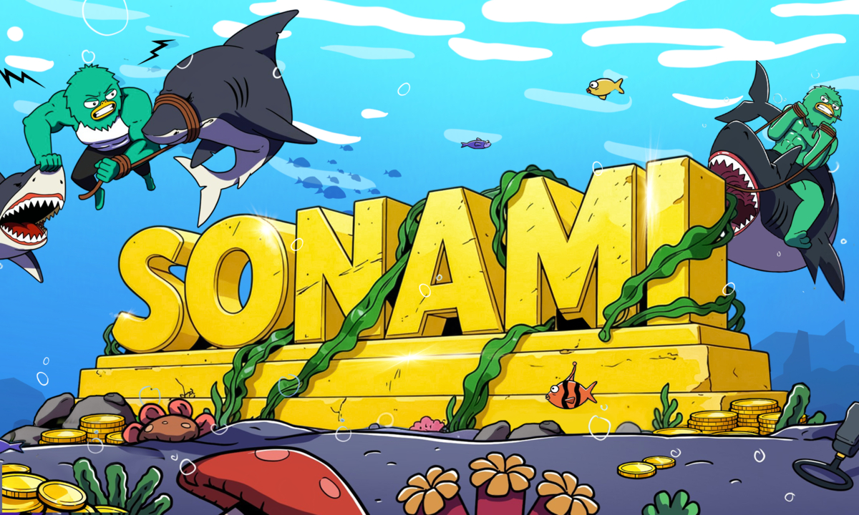

New York, United States, January 20th, 2026, Chainwire

Sonami ($SNMI) announced the launch of the Sonami Token presale, introducing an early-access opportunity for supporters to participate in an ecosystem designed to expand performance, usability, and liquidity across the Solana landscape. The presale includes a staking program offering 53% staking rewards, positioning Sonami for community-led growth as it builds toward a Solana Layer-2 network roadmap.
Sonami aims to combine fast settlement, scalable throughput, and user-friendly tooling—targeting a network experience optimized for builders, traders, and everyday users. As demand rises for lower fees, smoother user journeys, and reliable scalability, Sonami’s approach focuses on creating infrastructure and incentives that support long-term participation.
The Sonami Token presale is designed to bring new participants into the ecosystem and support ongoing development. Early contributors may benefit from presale allocations and structured participation across phases (if applicable), with proceeds intended to accelerate product development, security reviews, liquidity provisioning, and ecosystem partnerships.
Staking Rewards: 53% to Incentivize Long-Term Participation
A core feature of the Sonami ecosystem is its staking utility, introduced alongside the presale. Sonami is offering 53% staking rewards to encourage long-term alignment and strengthen network participation as the project scales.
Staking is intended to support:
- Community commitment through aligned incentives
- Network security and participation (as applicable to the protocol design)
- Ecosystem sustainability by rewarding active supporters
Rewards rates, lock periods, and distribution mechanisms may vary by phase and are typically subject to on-chain conditions and governance updates. Sonami encourages participants to consult official documentation for the most current parameters.
Commitment to Transparency and Security
Sonami stated that security reviews, open technical communication, and clear risk disclosures are core priorities as development progresses. The team plans to publish additional updates covering technical milestones, staking mechanics, and network progress tied to the Solana Layer-2 roadmap.
About Sonami
Sonami is building an ecosystem aligned with a Solana Layer-2 network vision, focused on scalable infrastructure, community incentives, and developer tooling. Through the Sonami Token, staking utility, and a roadmap designed for performance and accessibility, Sonami aims to support the next wave of applications in the Solana ecosystem.
Website | X | Instagram | Telegram

Contact
David Dylan
contact@sonami-so.io

