XRP: Register and Receive $100 — Unlock Cloud Mining Potential with Fleet Mining and Earn a Stable Monthly Income of $9,816.

XRP is not just a usual cryptocurrency. There was no mining of XRP as with Bitcoin or Dogecoin, but rather fast and cost-effective international cross-border payments. All XRP is issued at the start and thus serves no purpose in being mined.
But to the users with XRP, this does not imply a lack of opportunities in mining. Recent sites such as Fleet Mining have enabled XRP owners to gain indirectly by mining.
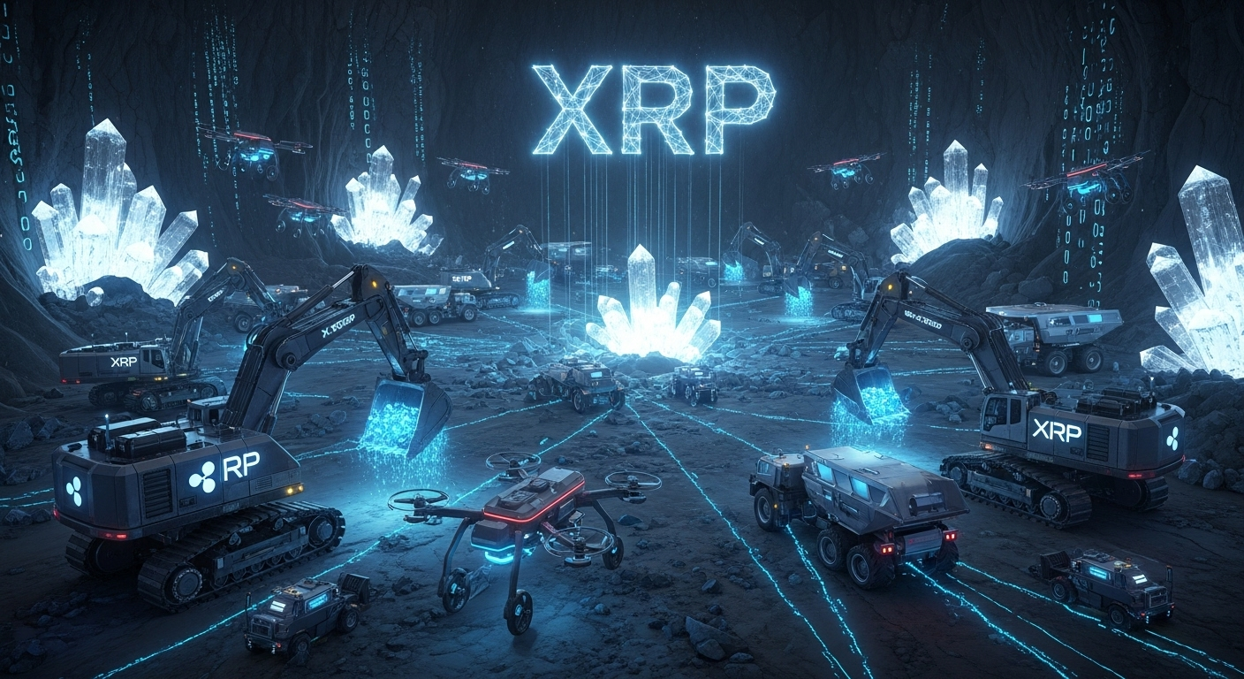
The role played by XRP in Mining
Although XRP is not available as a mining coin, Fleet Mining provides users with a chance to deposit XRP in the system. After the deposits are made, the system will automatically transform the XRP into computational power. This energy is utilized to get involved in the mining of Bitcoins, which rewards them daily.
This method enables XRP holders to utilize their holdings without having to sell them, and benefit on the advantages of mining where no technical effort is required.
Fleet Mining Cloud Mining Made Simple
Fleet Mining operates the whole mining infrastructure:
- Hardware management
- Electricity supply
- Cooling systems
- AI-powered optimization
The only thing the users have to do is to choose a mining agreement and the platform takes care of uninterrupted, automatic functioning. This allows mining to be accessible to those who did not have any technical knowledge.
Advantages for XRP Holders
With Fleet Mining, the XRP holders will be able to receive:
- No mining equipment or system needed.
- No electricity or maintenance charges.
- Daily automated rewards
- Clear tracking of earnings
- Adaptive contracts that would fit various budgets.
This system enables the users to look at the results as opposed to the operational issues.
Praise and the Fortune Egg Function
Fleet Mining provides the user with extra incentives:
- Registration Bonus: $15-$100 on new users.
- Daily Login Reward: $0.60 per day
- Lucky Egg Daily Check-In: The user can open a lucky egg on the day to day basis. Those rewards can be cash bonuses and additional cash power, discount vouchers, and the first place, which may be up to a million dollars.
These characteristics bring possibilities and enjoyment to cloud mining.
Example Earnings
Earnings of samples of various mining agreements:
- $15 agreement, 1-day duration → Daily earning $0.6 → Participate once per day (Free plan, zero cost)
- $100 agreement, 2-day duration → Daily earning $3 → Total $106
- $1,200 agreement, 10-day duration → Daily earning $16.20 → Total $1,362
- $6,000 agreement, 20-day duration → Daily earning $96 → Total $7,920
- $30,000 agreement, 45-day duration → Daily earning $540 → Total $54,300
Such examples assist the users to select the proper plan to achieve their objectives.
How to Get Started
It is easy to join XRP in Fleet Mining:
- Create an account with the help of an email address.
- Additional XRP to the platform.
- Select a mining agreement
- Earn daily automated rewards.
The AI cloud system of Fleet Mining handles all technical processes.
Conclusion
Even though XRP cannot be mined in a direct way, Fleet Mining enables the owner to convert their resources into a productive mechanism. Transforming XRP into mining power, users will be able to receive the income of Bitcoin mining, have automated rewards, and use the bonus programs, such as the Lucky Egg system. This renders cloud mining using XRP feasible and profitable and creates a new opportunity where the digital assets can act in favor of the owners.
Website: https://fleetmining.com/
Email: info@fleetmining.com

