Dogecoin Entering Critical Resistance as Tesla news by Elon Musk Sparks Market Conjecture; Poain Mining Places for Increasing Cryptocurrency ROI
Global Financial News — Dogecoin (DOGE) recently attracted the attention of investors once again following a chain of positive signs associated with the overall mood in the crypto market and the actions taken by Tesla and its leader, Elon Musk. According to traders and analysts, meme-coin sentiment will change, which can be the possible rebound phase in 2026, which may favor the platforms that provide stable participation models such as Poain Mining.
This rush comes after prolonged market volatility, macroeconomic changes towards other alternative assets and ongoing institutional researches on digital currencies other than Bitcoin and Ethereum.
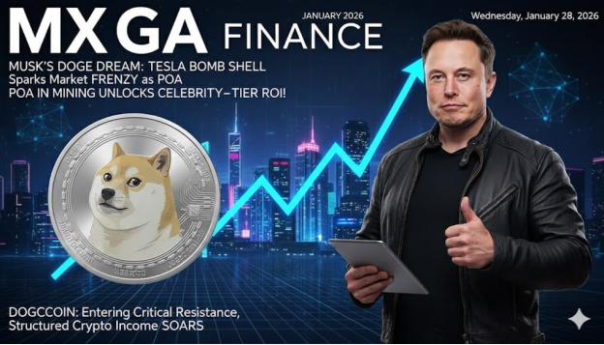
DOGE Price Momentum and Market Drivers
Dogecoin has been experiencing significant price activities in the recent trade sessions with positive breakouts driven by a distinctive combination of social feeling and underlying stories. On-chain information shows that DOGE has shed off an extended trading band and surpassed multiple levels of resistance, and technical analysts have reconsidered the short-term targets.
There seem to be a number of reasons why it has become interesting again:
• Those high-profile business operations of Elon Musk such as Tesla booming network utilization and wider technology efforts can be expected to be associated with increased Dogecoin coverage, despite the absence of causal relationship to DOGE fundamentals.
• The social media buzz and community presence cannot be ignored, and conversations about retail are going viral, and the coverage by influencers increases the retail interest.
• Macro sentiment indicates that the U.S. is weak and a flight to non-traditional assets is stimulating capital flows to cryptocurrencies with a strong brand name.
These dynamics earned Dogecoin a new liquidity and trading volume at the critical points, which has raised the issue of the possibility of future recovery.
Memes to Market Narrative
Despite starting as a light-hearted project in the crypto world, Dogecoin has been resilient, supported by its community, and this gave it permanence. According to industry observers, the price activity of DOGE is being gradually influenced by:
• Whale wallet and retail behavior.
• Social and cultural drivers
• The development of payment integrations in key digital platforms.
• Regular promotions of renowned personalities like Musk.
With that said, analysts also warn that meme-coin volatility and speculative cycles are still among the primary risk factors, and the price forecasts continue to be highly dispersed across different markets.
Poain Mining: Organized Gaming During Dogecoin Instability
As Dogecoin volatility and social momentum headline, applications such as Poain Mining are positioning themselves to provide structured methods of entry into participation devoid of technical overhead.
In contrast to traditional mining, where one is required to have hardware, energy, and technical expertise, Poain Mining offers contract-based cloud mining, which enables the user to access earning potential via pre-established investment plans, with consistent returns.
The present Poain Mining contract offerings are:
• $100 contract (2 days) → $106 return
• $600 contract (6 days) → $648.60 return
• $1,300 contract (12 days) → $1,518.40 return
• $3,300 contract (16 days) → $4,065.60 return
• $5,700 contract (20 days) → $7,410 return
• $9,700 contract (27 days) → $13,890.40 return
These contracts enable members to make an accurate prediction of the result, as an alternative to actual trading returns, which are directed at the changes in the price of DOGE.
Involvement and Nonmonetary Rewards
Poain Mining also has a daily program, Lucky Egg, in which users can claim once a day to get a random reward — such as cash, tech prize, or other reward; there is no limit to the potential reward, with a high reward of $1,000,000. This interactive method fits the culture of high engagement over meme coins that provide users with an additional participatory dimension to the typical contract yields.
Also, the site offers a registration bonus of $15 on a new account that will allow novice users to experiment with the models of income without requiring an immediate capital expenditure.
In the Future: The Future of Dogecoin in a Changing Cryptopia
The price action of DOGE still evokes a hybrid market story: that in which social influence, significant technological trends, and macroeconomic sentiment, co-exist with technical analysis and investor positioning.
Although conventional stories of cryptocurrency use surround Bitcoin and Ethereum in terms of institutional products such as ETFs and staking vehicles, resources such as Dogecoin demonstrate how community participation, culture, and new earning structures such as Poain Mining are establishing new entry points.
With the market changing in 2026 and observers will be keen to determine whether the Dogecoin rally will evolve into a wider trend, or continue to be fuelled by intermittent sentiment changes.

Name of the company: Poain BlockEnergy Inc.
Website: https://poain.com/
Email: marketing1@poain.com

