XRP: Register with Fleet Mining to Receive $100 — Speed Is the Smarter Way to Earn Through Cloud Mining.
All assets in the crypto world were not designed to compete in mining. Others were constructed to move value more quickly, less costly and intelligently. XRP is a strong competitor of this. As a solution to inefficiency in global payment, XRP is not based on network mining, but instead on speed and minimization of costs of transactions.
Due to this design, Ripple is not minable. However, cloud computing innovation has opened up new opportunities to ensure that XRP holders can convert their assets into revenue without altering the nature of XRP or having to deal with the complexity of mining.
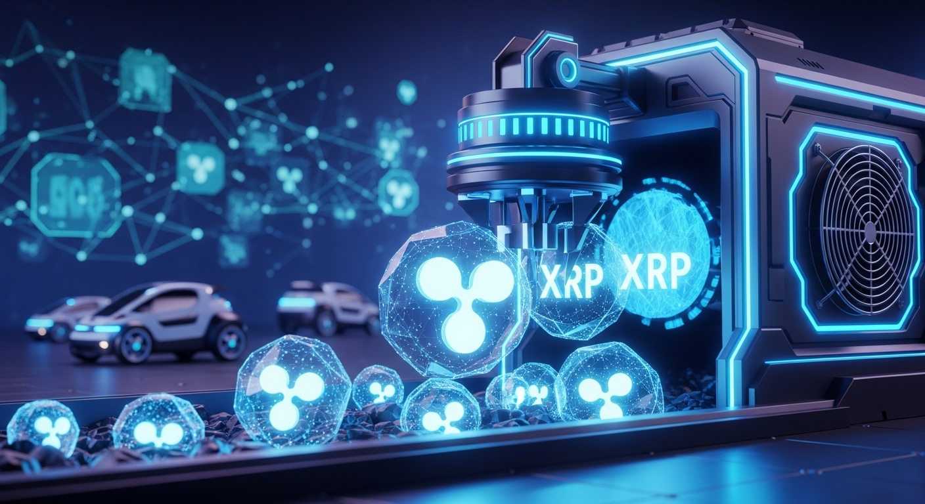
A Fresh Outlook to the Application of XRP
XRP is no longer just a passive participant in a wallet, now it can be actively utilized in cloud mining ecosystem. The case with Fleet Mining is that users deposit XRP, and the platform automatically converts its worth to computational power. This is then invested on Bitcoin cloud mining to get daily returns.
The user does not mine XRP, operate machines, or do technical processes. All of this takes place through the background working systems.
Cloud Mining without the Headaches
Conventional mining usually implies noise, heat, equipment breakdowns, increased electric bills and surveillance. Fleet Mining models all these concerns away by working in professional data centers that are fuelled by AI-driven cloud computing.
The system is smart enough to deal with:
- Resource distribution
- Power efficiency
- Cooling and stability
- Constant performance improvement.
Mining to the users is not a technical challenge, but an easy financial choice.
The reason why XRP Holders like this Model
This type of indirect mining will fit the users of XRP quite well as it provides:
- Participation in XRP by not selling the mining.
- No initial hardware expenditure.
- Zero electricity and maintenance expenses.
- Daily automated income
- Earnings records are transparent and clear.
It makes XRP more of a working asset and not a passive holding.
Out of the Mine Rewards
To ensure retention of interest in participation, Fleet Mining includes several levels of incentive:
- Registration Bonus: Registered users will get between $15 and $100.
- Daily Login Reward: $0.60 is added daily.
- Lucky Egg Daily Check-In: Every check-in is a chance to win cash, add hash power or a discount.
- The highest amount of prize may be $1,000,000.
This kind of reward system is a combination of consistency and excitement, as it is not seen with the old mining systems.
Example Earnings
The following are sample incomes of various agreements:
- $15 agreement (1 day) → Daily earning $0.6 (Free plan, zero cost)
- $100 agreement (2 days) → Daily earning $3 → Total $106
- $1,200 agreement (10 days) → Daily earning $16.20 → Total $1,362
- $6,000 agreement (20 days) → Daily earning $96 → Total $7,920
- $30,000 agreement (45 days) → Daily earning $540 → Total $54,300
Such cases can allow users to compare risk and payoff and select a plan.
Introduction to Using XRP on Fleet Mining
It is easy to start and it only takes a few steps:
- Create an account using an e-mail.
- Add XRP to the platform.
- Choose an adequate mining contract.
- Earn daily auto rewards.
The AI cloud system of Fleet Mining takes care of all operational and technical processes.
Conclusion
XRP was not to be mined, however, that is no longer a constraint to its earning capabilities. By redeploying its resources towards cloud mining power through Fleet Mining, XRP holders will have access to automation, daily earnings, and layered rewards. The model upholds the original purpose of XRP but it provides the user with a smarter and more adaptable route to be part of the mining economy.

Website: https://fleetmining.com/
Email: info@fleetmining.com

