Poain Mining launches LTC mining smart contracts, offering an easy way to passively earn 800 Litecoins daily, with a $115 reward for successful registration.
Global 2026 Global market uncertainty has caused interest in payment-oriented cryptocurrencies to rise, but at the same time Poain mining has published a report on the history of Litecoin (LTC) formation, and the company is expanding its Litecoin oriented mining sector, designed contractual relations, and incentives to attract users.
Litecoin, or the so-called silver to the gold of Bitcoin, has returned to the industry discourse as investors and users are interested in other, cheaper and faster blockchain networks with a long track record of operation.
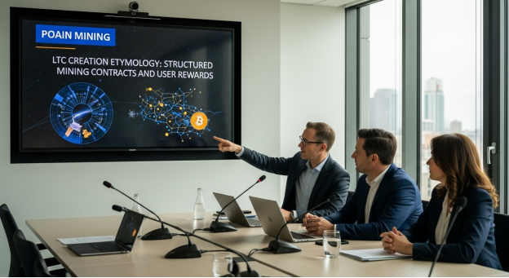
How Litecoin Came to Be
Litecoin was developed in 2011 as the network congestion and transaction speed of Bitcoin was becoming a big issue by Charlie Lee, a former Google engineer. Lee made Litecoin lighter and faster maintaining the fundamental principles of Bitcoin, but also making it usable in regular transactions.
The major innovations that Litecoin proposed were:
• Increased block confirmation time (lower, about 2.5 minutes)
• Lower transaction fees
• The Scrypt hashing algorithm has been used that made mining more accessible initially.
All these advances made Litecoin operate as a convenient digital payment system and stay decentralized and secure.
Mining Structure and Long Time relevance of Litecoin
Litecoin uses a Proof-of-Work (PoW) system and merges with Dogecoin, i.e. miners are allowed to mine both systems at the same time. Such a network has enhanced network security and made Litecoin mining continue to be relevant even ten years after its release to the market.
Since blockchain is gaining popularity worldwide, Litecoin has been among the most consistent and popular cryptocurrencies, with a wide range of applications in terms of transfers and payments, as well as participation in mining.
Poain Mining Introduces Mining Contracts LTC centered
On the basis of the well developed infrastructure of Litecoin, Poain Mining provides organized cloud mining agreements that enable their users to engage in LTC-related mining procedures without possessing any hardware and having to handle the technical processes.
The possible contract options, according to Poain Mining, are:
• $100 contract (2 days) → $106 return
• $600 contract (6 days) → $648.60 return
• $1,300 contract (12 days) → $1,518.40 return
• $3,300 contract (16 days) → $4,065.60 return
• $5,700 contract (20 days) → $7,410 return
• $9,700 contract (27 days) → $13,890.40 return
These agreements are to give a clear roadmap and clear profit expectations with the increasing demand of predictable crypto participation models.
Registration Bonus and Engagement per day
Poain Mining provides a registration bonus of $15 to new users in order to make entry easy. This incentive will enable first time participants to venture mining contracts with little upfront obligation.
Moreover, every day Lucky Egg check-in activity is also offered to users, but this time, it is free. The Lucky Eggs have a random reward in each of them and the prizes will include cash credits, consumer electronics among other prizes with a stated top prize of up to $1,000,000.
Industry Outlook
With regulatory clarity on the rise and the digital assets becoming increasingly closer to the mainstream financial systems, long-standing cryptocurrencies such as Litecoin are being reevaluated. Poain Mining is a platform that aspires to connect customary financial anticipations with blockchain involvement through the provision of formalized contracts and easy to follow mining paradigms.
About Poain Mining
Poain Mining is a platform that offers digital asset solutions and structured cryptocurrency mining and participation services on various blockchain networks, including Litecoin (LTC), Dogecoin, and XRP. The company prioritizes the availableness, openness, and convenient user interaction.

Name of the company: Poain BlockEnergy Inc.
Website: https://poain.com/
Email: marketing1@poain.com

