XRP Price: Register and Receive $100 — Turn Cloud Mining into Stable Daily Earnings of $8,973.

XRP was not designed to rival mining giant publications such as Bitcoin. Day one was different, as it was meant to transport value across borders as quickly, cheaply and reliably as possible. Whereas most cryptocurrencies concentrated on the idea of decentralised mining, the XRP concentrated on efficiency as it sought to address real life payment issues instead of mining rewards.
The result of this design philosophy is that XRP is impossible to mine. However, in the modern cloud-based crypto world, the fact that one is not mineable does not imply that it is inactive or inefficient.
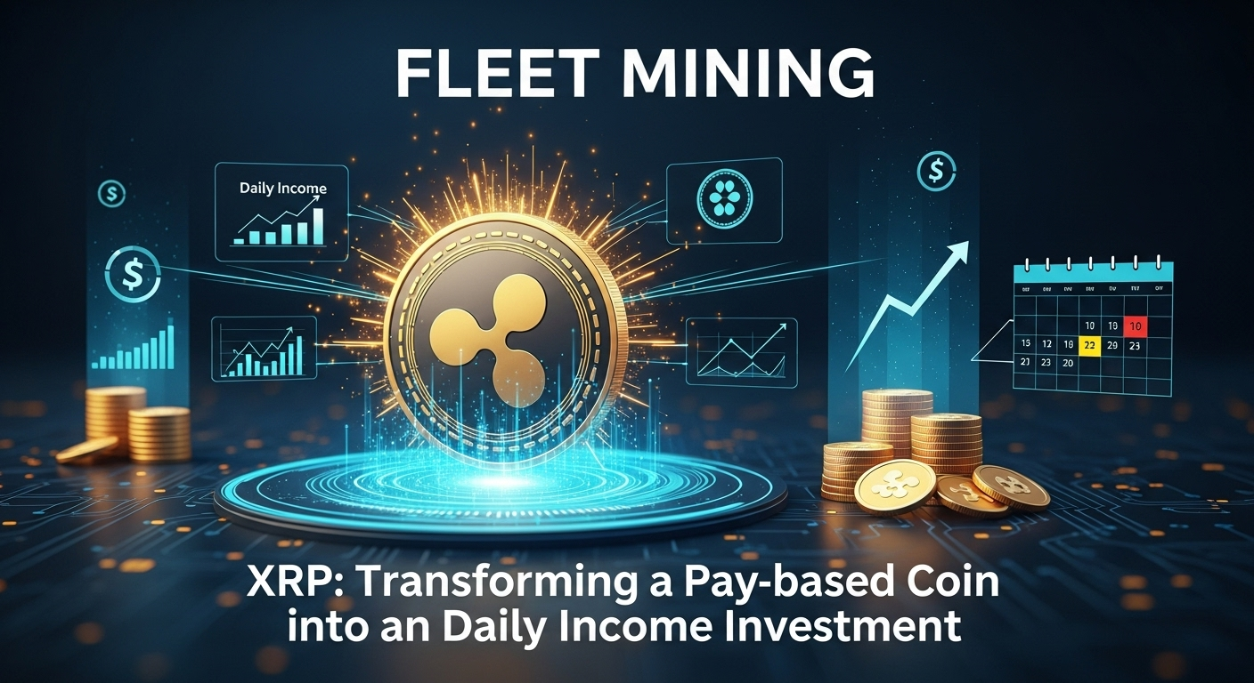
When To Hold XRP No Longer Be Holding
To most investors, XRP usually hangs in pockets pending market action. Fleet Mining proposes an alternative, that is, rather than waiting, XRP can be put to the task. The process of XRP being deposited on the platform automatically translates the value into computational power so that the users can have the opportunity to engage in cloud mining in Bitcoin.
One does not have to know about mining mechanics. XRP is not mined, changed, or modulated it is just the place of entry to participation in mining with the help of cloud computing.
Cloud Mining Devoid of the Convention laden Tether
Conventional mining is hard to ignore: machines overheat, the price of electricity increases, equipment becomes obsolete, and the efficiency decreases. Fleet Mining eliminates all of these points of pain by using industrial grade mining facilities with AI-intelligent cloud systems.
The platform handles:
- Deployment and upgrades of hardware.
- Electricity usage and cooling.
- Hashrate optimization
- Constant monitoring of the system.
The users are not exposed to the process, only results.
The reason why this model can be relevant to XRP users
This is a method that would be quite natural to the XRP holders since it provides:
- Mining without sale of XRP.
- Zero hardware maintenance or maintenance responsibility.
- Predictable daily earnings
- Income tracking in real time.
- Adaptable contracting of varying budgets.
It will make XRP not a passive digital asset but an active income tool, though it will not alter its initial purpose in the crypto ecosystem.
Premises Beyond Mining Revenue
Fleet also provides incentives on top of mining in the form of Fleet Mining:
- Registration Bonus: $15 to 100 on new user registration.
- Daily Login Reward: $0.60 will be added on a daily basis.
• Daily Check-In Lucky Egg:
The most interesting part of the experience is the daily check-in feature of the Lucky Egg. The user is allowed to open a lucky egg every day where he or she will get a chance to win cash, or more hash power or a discount coupon with the maximum amount of the reward being up to $1,000,000. This system combines consistent pay with bonuses that are based on opportunities, making the participation interesting.
Example Earnings
The following are some examples of earning scenarios in various agreements:
  - $15 agreement (1 day) → Daily earning $0.6
(Free plan, zero cost, available once per day)
  - $100 agreement (2 days) → Daily earning $3 → Total $106
  - $1,200 agreement (10 days) → Daily earning $16.20 → Total $1,362
  - $6,000 agreement (20 days) → Daily earning $96 → Total $7,920
  - $30,000 agreement (45 days) → Daily earning $540 → Total $54,300
The above illustrations give users options of the agreements depending on their objectives and risk tolerance.
Fleet Mining: How to get started with XRP
To begin with, it is simple to start:
- Registration is done using an email address.
- Place XRP deposit into the platform.
- Choose an appropriate mining agreement.
- Earn daily automated benefits.
The AI cloud infrastructure of Fleet Mining controls all the technical operations.
Conclusion
XRP was not made to be mined, but that aspect no longer restricts the revenue potential of the cryptocurrency. XRP holders can transfer the assets to cloud mining power through Fleet Mining, which would provide them with the opportunity of automated income, transparent returns, and interactive reward systems. The method is in compliance with the original idea of XRP but it is a gateway into a current generation of steady income within the cloud mining system.

Website: https://fleetmining.com/
Email: info@fleetmining.com

