Bitcoin Price: The Scarcity of Digital Currency — Turning Cloud Mining Computing Power into Value
Bitcoin was not made valuable due to its speed or a bling-bling approach. It gained value due to a radical approach that it brought about, a lack of digital scarcity that is decentralized. Value was ensured, first of all, not by faith in institutions, but by the computing power. Each Bitcoin mined symbolizes actual world energy, computation and time translated into a digital product.
This distinctive basis has taken Bitcoin mining beyond a technical exercise; this is the financial drive that has sustained the existence of the network.
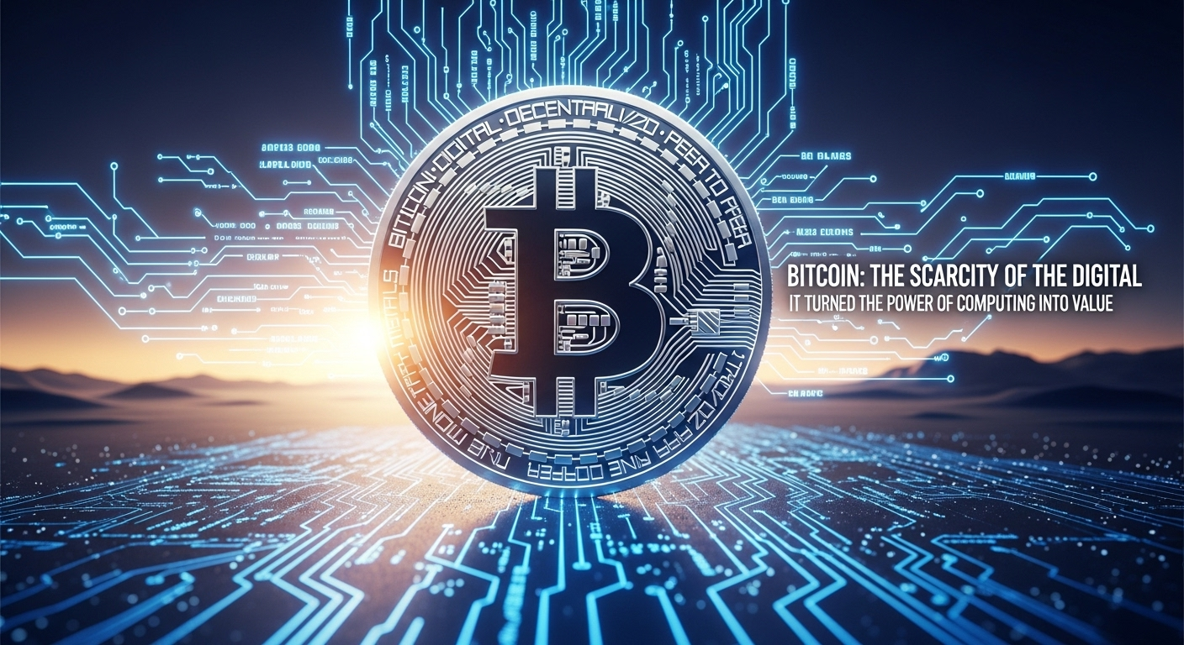

Why Mining Still Matters in Bitcoin’s World
Bitcoin uses a Proof-of-Work system, which is a method that allows miners to confirm the authenticity of transactions by finding a solution to a complicated cryptographic riddle. They in turn get rewarded with Bitcoin. This procedure secures the network against deceit and decentralization is ensured.
Due to the expansion of the network mining has become a competitive industry. Profitability is now determined by efficiency, scale as well as optimization, which makes casual home mining more of a far-fetched concept.
The Personal to Industrial Scale
First miners of bitcoin utilized the primitive computers. Nowadays, mining involves special equipment, good electricity supply, effective cooling, and regular modernization. These requirements have stressed mining to big data centers, which are intended to scale.
To individual users, this change has raised a discrepancy between mining interest and capacity to engage in it.
Cloud Mining as a viable Introduction
Cloud mining seals this divide. Users remotely control mining power using the cloud-based infrastructure instead of operating the mining equipment. Mining platforms such as Fleet Mining are in charge of the technical component, such as hardware, electricity, cooling, and optimization and enable users to engage without technical complexities.
Mining is a financial choice and not a technical challenge.
Optimization of Bitcoin Mining at Fleet Mining
Fleet Mining forms an alliance with AI driven cloud computing to perform dynamical allocation of resources and enhance efficiency in addition to stabilizing output. The deposited assets are transformed to computational power, which is further used to mine Bitcoin automatically.
This system minimizes downtime, increases consistency and eliminates the necessity of human intervention.
Advantages of Bitcoin Cloud Mining
The benefits of engaging in Bitcoin mining with the cloud platforms are obvious:
- None of hardware ownership or maintenance.
- None of electricity or cooling expenses exposure.
- Automated daily rewards
- Clear revenue management.
- Elastic participation opportunities.
Such advantages open up mining to more people.
Rewards and Award Programs
In addition to the mining revenue, Fleet Mining provides the following advantages:
- Registration Bonus: $15-$100 on new users.
- Daily Login Reward: $0.60 per day
- Daily Lucky Egg: Rewards can be of cash, additional hash power or discount vouchers with the highest rewards being $1,000,000.
These characteristics make it more interesting in the long term.
Example Earnings
- $15 agreement (1 day) → Daily earning $0.6
- $100 agreement (2 days) → Daily earning $3 → Total $106
- $1,200 agreement (10 days) → Daily earning $16.20 → Total $1,362
- $6,000 agreement (20 days) → Daily earning $96 → Total $7,920
- $30,000 agreement (45 days) → Daily earning $540 → Total $54,300
Conclusion
Mining bitcoin is the transformation of energy into faith. Traditional mining has been turning to be complicated and capital intensive but cloud mining has made it possible to have more participants. With applications such as Fleet Mining, users will have the ability to interact with the economic engine of Bitcoin in an easy and automated manner without compromising on efficiency or transparency.
Website: https://fleetmining.com/
Email: info@fleetmining.com

