Bitcoin Mining Today: From Home Setups to Cloud-Based Participation
Bitcoin mining at one point was a hobby. Citizens drove mini machines in their houses, saw their computers working all night, and gradually were earning coins. That phase is long gone. Bitcoin mining has become a very competitive process where efficiency is the key to success and scale the scale is the key to survival.
To the majority of users nowadays, the question is not how to comprehend Bitcoin what matters is how to be able to engage in mining in a realistic manner.
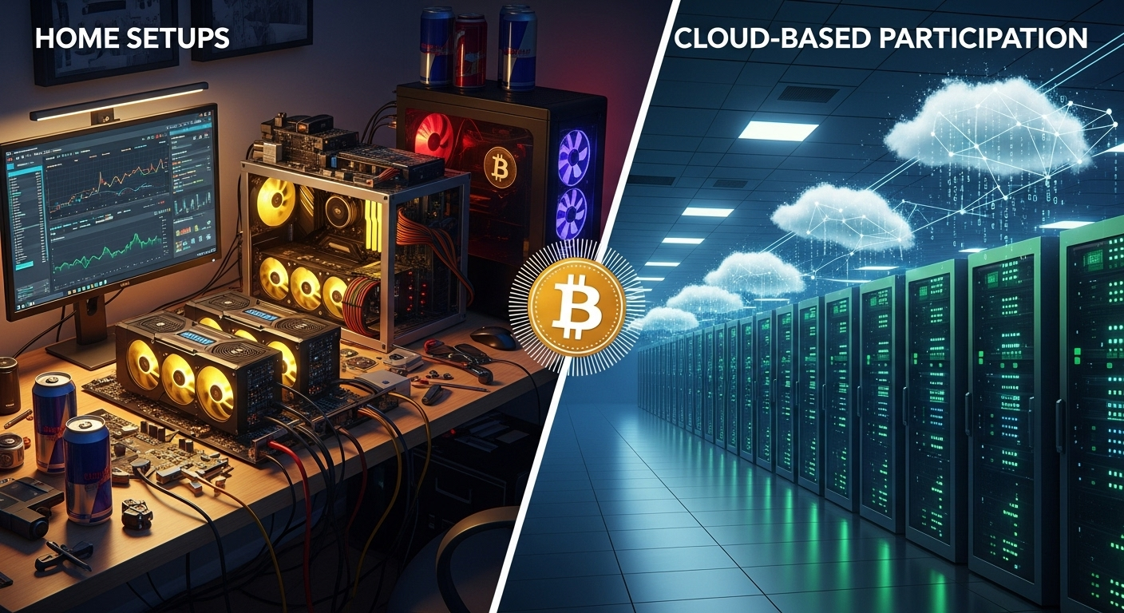
The reason that traditional bitcoin mining is not basic anymore
Bitcoin mining continues to take the Proof-of-Work, but the world surrounding it has shifted. Modern mining requires:
- Specialized ASIC machines
- Constant and cheap electricity.
- Advanced cooling systems
- Constant hardware upgrades
- The technical monitoring and troubleshooting.
These needs tend to override possible rewards to individual users. This has the effect of locking out a lot of interested participants not necessarily because they lack interest, but due to the barrier in the operations.
The Practical Alternative: Cloud Mining
Cloud mining eliminates physical mining layer. Users lease computing power in professional data centres, instead of owning machines. The process of mining has remained the same as before- but the platform handles the responsibility rather than the individual.
This model enables the user to engage in the mining of bitcoins without having to encounter noise, heat, breaking down of hardware, or increasing electricity bills.
The part that Fleet Mining plays in making access easier
Fleet Mining has a large scale mining infrastructure that is powered by AI based cloud computing. The platform controls the hardware performance, energy efficiency, cooling systems and mining optimization.
Users just have to choose a mining contract. Since then, the system is automated and provides daily rewards upon the assigned computing power.
Solid as a Rock, Not Rocket Science
The AI systems at Fleet Mining keep the resources distribution steady at the expenses of the output. This minimizes dead time and wastages that have a tendency of affecting individual miners. The earnings are documented in a transparent manner and thus users can track the performance without the technical participation.
The mining will be organized, foreseeable and controllable.
Benefits of Bitcoin Mining on the Cloud
There are a number of advantages of becoming a part of cloud mining:
- None of the hardware buys or maintenance.
- None of electricity or cooling costs.
- Revenue of automated mining per day.
- Flexible contract options
- Harmonious and transparent earning records.
This renders Bitcoin mining available to usability by those people who hold simplicity in higher esteem than technical command.
Other Rewards and Engagement
Fleet Mining is increasing the involvement in mining with additional benefits:
- Registration Bonus: $15 -100 new users.
- Daily Login Reward: $0.60 will be added daily.
- Daily Lucky Egg Feature:
  - Rewards can be in the form of cash bonuses or additional hash power or a discount coupon.
  - $1,000,000is the highest reward amount.
These characteristics contribute to value added to the normal mining income.
Example Earnings
  - $15 agreement (1 day) → Daily earning $0.6
  - $100 agreement (2 days) → Daily earning $3 → Total $106
  - $1,200 agreement (10 days) → Daily earning $16.20 → Total $1,362
  - $6,000 agreement (20 days) → Daily earning $96 → Total $7,920
  - $30,000 agreement (45 days) → Daily earning $540 → Total $54,300
The examples allow the users to compare lower and advanced participation levels.
Conclusion
Bitcoin mining has ceased to be a personal experiment and transformed to professional operation. The old mining is becoming difficult to reach, and cloud mining is a feasible way to go. At Fleet Mining, users can mine Bitcoin using an automated system, making it easy and streamlined - complexity to consistency, effort to efficiency.

Website: https://fleetmining.com/
Email: info@fleetmining.com

