Dogecoin price plummets: Poain Mining launches new contract to mitigate price risk, offering fixed daily returns of up to 25,365 Dogecoin per day.

Global Financial Update — Dogecoin (DOGE), which is an internet culture digital asset, is manifesting a new upswing in 2026 as old and institutional investors re-evaluate their attitudes towards meme tokens in the wider financial markets. As the latest regulated investment products and recent adoption signals gear up, digital assets that were previously a speculative activity are finding their way into more institutional spheres of engagement. A virtual cryptocurrency mining and involvement platform, Poain Mining declares that this changing ecosystem underscores the importance of other income models to digital currency owners.
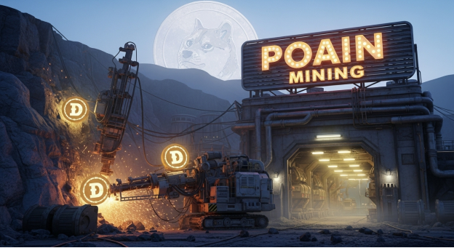
Dogecoin ETF Launch and Market Signals Gives Dogecoin Institutional Confidence
In late 2025, one of the most important recent changes to Dogecoin was the release of the first exchange-traded fund (ETF) dedicated to the memecoin, DOGE, by REX-Osprey. This product enables investors to acquire regulated exposure to DOGE in the form of traditional financial markets as a product of increasing faith in digital assets beyond Bitcoin and Ethereum as able to seek structured investment vehicles within the current legal frameworks.
A further catalyst of such products is the regulatory transparency assured by the U.S. Securities and Exchange Commission (SEC) in 2025, which again indicated that meme coins such as DOGE are treated as commodities, and stimulated further debates on the topic of institutional access to Dogecoin.
Market Response: Price and Adoption Patterns
Though the crypto market has been more volatile, Dogecoin has been resilient to the overall market due to the retail interest and shifting utility. Rumors of possible integration of DOGE payments into major platforms (such as suggestions by the leaders of the technology sector about potential payment facilities within social and commerce ecosystems) have fueled spikes in trading activity in recent months.
Meanwhile, active addresses and merchant acceptance keep increasing, and thousands of enterprises worldwide today accept DOGE as money based on recent statistics.
Analysts warn that the unlimited supply and market makeup of DOGE poses a problem with respect to long term price gains. Nevertheless, institutional fascination, ETF release, and growing corridors of payment have given Dogecoin something more than mere retail feeling.
The Role of Poain Mining: Organized Revenue by Dogecoin Investment
With these changes, Poain Mining is encouraging systematic involvement with cloud mining contracts that are characterized by sure returns within a given timeframe. The model is designed to connect the conventional approach to financial expectations with crypto interaction so that users can gain gains with the help of the Dogecoin associated income streams without a direct hardware and technical maintenance.
The offerings of Current Poain Mining contracts are:
• $100 contract (2 days) → $106 return
• $600 contract (6 days) → $648.60 return
• $1,300 contract (12 days) → $1,518.40 return
• $3,300 contract (16 days) → $4,065.60 return
• $5,700 contract (20 days) → $7,410 return
• $9,700 contract (27 days) → $13,890.40 return
These formal agreements seek to provide predictive results despite exchange conditions in the market varying.
Participation and Rewards of New Participants
Besides mining contracts, Poain Mining also offers a $15 registration bonus to anyone new to the platform and this will be granted upon registration, to make the process of joining the cloud mining a bit easier. The application also includes Lucky Egg Check-in System where users get an opportunity to open a virtual Lucky Egg every day with a maximum reward of stated up to $1,000,000.
Going Forward: Community Activity vs. Institutional Adoption
The developing history of Dogecoin is an example of a wider trend in the crypto scene a place where cultural roots and new models of institutions collide. As ETFs are launched, merchants become adopters, and new avenues to enter the market like structured mining contracts, market participants are reconsidering ways to integrate meme tokens into diversified digital asset portfolios.
The most recent practices at Poain Mining highlight how the traditional investment anticipations may be mitigated or augmented by decentralized involvement of assets, and provide users with an opportunity to be part of the changing ecosystem of Dogecoin with its transparency and predictable risk/reward consequences.
About Poain Mining
Poain Mining is an online asset platform which provides institutionalized cryptocurrency participation packages, such as cloud mining agreements, as well as user interaction operations on various blockchain networks. The platform aims at being easy to use, having clear return structure and easy access to participation by both the beginners and the advanced.

Name of the company: Poain BlockEnergy Inc.
Website: https://poain.com/
Email: marketing1@poain.com

