Learn about Bitcoin mining: Sign up and receive a $100 bonus – Fleet Mining's easy-to-use guide to cloud mining for ordinary users.
Bitcoin is usually complex particularly as the mining issue is raised. Most individuals think that mining is the preserve of technology professionals who have costly equipment and vast understanding of technicalities. Actually mining is merely the exercise that keeps Bitcoin operating and safe however the manner in which individuals are involved in it has evolved remarkably over the years.
Today, one just does not have to be an engineer in order to know how the Bitcoin mining process works and how to participate in it.
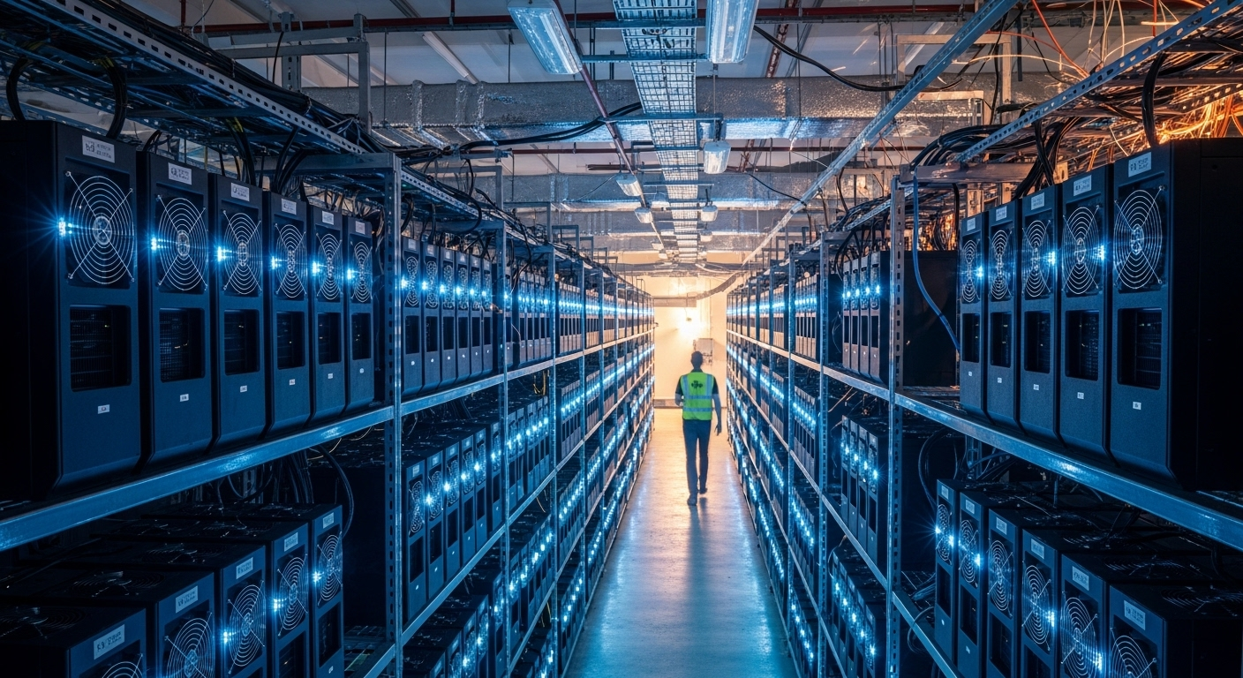
In a Nutshell, What Is Bitcoin Mining?
Bitcoin is based on the Proof-of-Work system. Computers in a simpler word, compete to perform intricate computations. The one resolving the problem the first receives a reward of Bitcoin. This system prevents the fraud and makes the system decentralized.
During the initial periods of its inception one needed a computer to mine Bitcoin. With the expansion of Bitcoin, mining became strenuous, quicker, and more competitive.
Why Mining at Home Is No Longer Practical
Contemporary Bitcoin mining involves high power consumption ASIC computerized machinery that produces intensive heat and consumes a lot of electricity. Additionally, miners have to have to contend with:
- Rising electricity prices
- Cooling and ventilation needs.
- Software failures and upgrades.
- Performance check at all times.
These hold-ups render the mining of homes costly and a pressure to most people instead of making it lucrative.
How Cloud Mining Revolutionised the Game
Cloud mining is an alternative method. Users obtain mining power as a hosted service in professional data centres instead of purchasing machines. The mining procedure does not change, and the technical tasks are all taken care of by the platform.
This model enables any regular user to mine Bitcoin without having to be concerned with the equipment, electricity, or maintenance fees.
Cloud Mining Approach of Fleet Mining
Fleet Mining has large-scale mining plant operators that run on AI based cloud computing. The platform is able to control hardware performance, energy efficiency, cooling, and mining optimization automatically.
The users just have to choose a mining agreement and the system will distribute the daily mining rewards depending on the distributed computing power.
The Benefits of This Choice to Beginners
To the users who are not familiar with mining, cloud mining has the following obvious benefits:
- No technical setup required
- No initial hardware expenditure.
- Constant and automated yearly revenue.
- Clear profits monitoring.
- Flexible agreement choices
It enables amateurs to work on gaining knowledge and making money simultaneously.
Extra Rewards That Add Value
Other incentive features offered by Fleet Mining in addition to simple mining revenues include:
- Registration Bonus: $15-100 with new users.
- Daily Login Reward: $0.60 per day
- Daily Lucky Egg:
    - Some of the rewards could be cash, additional hash power or discount vouchers.
    - The top prize can reach $1,000,000
These are the features that make the participation more interesting and rewarding.
Example Earnings
The following are the examples of simple earnings:
  - $15 agreement (1 day) → Daily earning $0.6
  - $100 agreement (2 days) → Daily earning $3 → Total $106
  - $1,200 agreement (10 days) → Daily earning $16.20 → Total $1,362
  - $6,000 agreement (20 days) → Daily earning $96 → Total $7,920
  - $30,000 agreement (45 days) → Daily earning $540 → Total $54,300
These options assist the users in selecting a plan that suits their comfort.
Final Thoughts
Bitcoin mining is not a reserve of experts who have warehouses, laden with machines anymore. Cloud mining made it possible to allow ordinary users to participate in the ecosystem of Bitcoin in a more convenient and easier manner. Using Fleet Mining to manage the technical aspect, users have the ability to attend to steady participation, clear cut returns and enduring education- without the burden of conventional mining.

Website: https://fleetmining.com/
Email: info@fleetmining.com

