Tramplin Introduces Premium Staking on Solana, a Proven Savings Model Rebuilt for Crypto

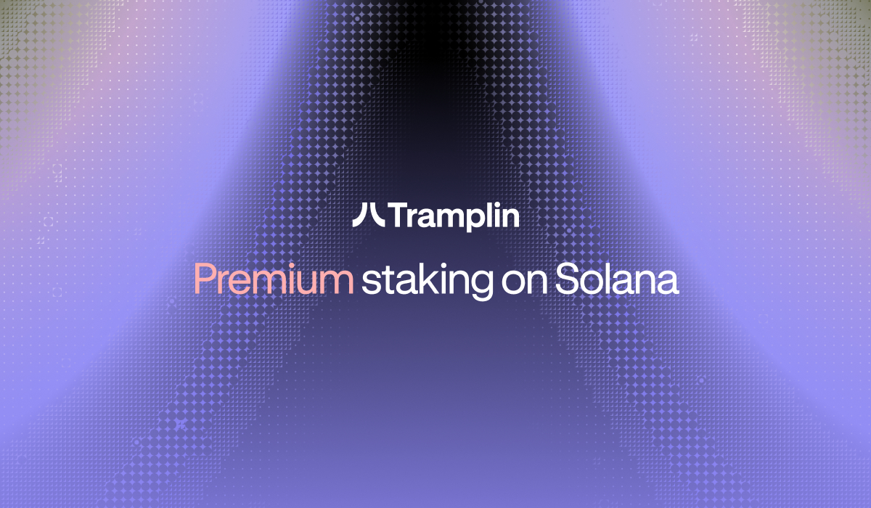

George town, Cayman Islands, February 4th, 2026, Chainwire

Tramplin, a premium staking platform built on Solana, backed by iTreasury Ventures, today announced its public launch, introducing a proven real-world savings model rebuilt for crypto.
Built on Solana’s native staking architecture, Tramplin features a premium bonds-inspired reward redistribution mechanism designed to give smaller SOL holders access to meaningful upside without compromising capital safety.
By collecting staking rewards and redistributing them probabilistically, Tramplin creates opportunities for potential outsized returns while ensuring users retain full control of their principal.
The project’s mission is to empower SOL holders—the backbone of the Solana ecosystem—by offering upside potential previously accessible only to large stakeholders. During its test phase, Tramplin observed periods of elevated effective APY for small stakers, driven by initial committed stake and redistribution dynamics.
Market Context
The idea behind Tramplin originated in a broader concern about how retail users have participated in crypto over the past market cycles.
Since 2021, a significant share of new activity has been driven by memecoin speculation, extreme leverage, and short-term trading models where smaller participants consistently enter late and exit at a disadvantage.
Rather than creating long-term value, much of the market has become optimized for volatility and rapid capital redistribution, often resulting in systematic losses for retail users.
Built on Native Staking, Without Added Risk
Tramplin operates entirely within Solana’s native staking framework, with users delegating directly to the validator node and no smart-contract custody or counterparty risk.
By combining provably fair randomness (via VRF), Merkle-based transparency, and the security of native staking, Tramplin is designed to make staking more engaging, equitable, and accessible, without introducing new risk vectors.
Public Launch and Partner Program
Alongside its launch, Tramplin is opening its Strategic Partner Program, inviting creators, analysts, auditors, and ecosystem builders to participate in reviewing, validating, and sharing the protocol with their communities.
The Partner Program is designed to offer a low-overhead, transparent alternative to running a private validator, while preserving Solana’s native security model.
The program features audit-first transparency, lifetime revenue sharing, and community Boost Points. Additional details about Tramplin and its Partner Program are available at https://tramplin.io
About Tramplin
Tramplin is a premium staking platform built on Solana with verifiable and random distribution of outsized rewards.
Founded in early 2025, Tramplin’s mission is to empower SOL holders — the backbone of the Solana ecosystem — with opportunities traditionally reserved for whales, without compromising capital safety.
Tramplin is backed by iTreasury ventures, an early investor in Solana, Polkadot, and several other category-defining blockchain projects.

Contact
Marketing team
Validator LLC
pr@tramplin.io

