Bitcoin (BTC) Price Drop: Join Fleet Mining to Receive a $100 Sign-Up Bonus and Earn Stable Daily Income Through Cloud Mining

Bitcoin mining will no longer be a technical debate akin to a technical debate in 2026, but it will be in a wider debate of energy efficiency, automation of infrastructure, and sustainability of blockchain operations. As the governments continue to increase the control on the use of electricity and mining companies are competing to maximize their output, individual users are considering how they can still engage in Bitcoin mining without the increased costs or operational risks.
What was previously a low profile hobby at home has been transformed into a highly industrialized industry. Nowadays, the actual question is not whether it is possible to still be profitable to mine Bitcoin, but how an average user can possibly participate in it within the environment of the modern market.
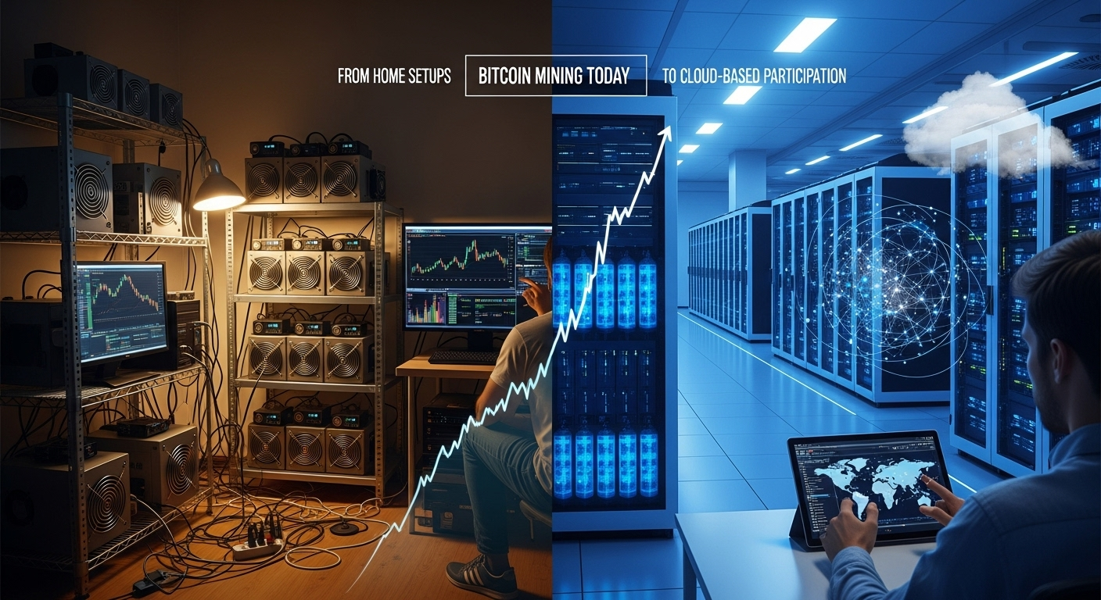
The Reason Why Mining Bitcoin is Not So Simple Anymore
The usage of Bitcoin still depends on the Proof-of-Work mechanism, but now the environment has shifted radically. Recent mining patterns indicate that the allocation of hash power is getting increasingly concentrated in professional mining facilities due to:
- ASIC-based machines with maximum efficiency.
- Increased electricity costs in the world.
- Energy consumption regulatory pressure.
- The necessity to have sophisticated cooling and optimization of infrastructure.
- Constant upgrades of hardware and monitoring of the system.
To the majority of people, these requirements supersede the possible rewards. The traditional mining has been not so much a matter of passion any more but one that is executed in an industrial scale- something that is not accessible to the common user.
The Alternative Practical: Cloud Mining
Cloud mining puts a physical layer out of the picture. Users lease computing capabilities hosted in professional data centers as they do not have to buy or maintain hardware. Although the mining process has not changed, the user is no longer involved and it becomes the responsibility of the platform.
This strategy is in line with the modern trends in the industry where the emphasis has been made on efficiency, automation and scalability rather than manual operation. The Bitcoin miners can engage in the process without heat, sound, hardware breakdowns, or unreliable power bills.
The role of a Fleet mining in contemporary access of miners
Fleet Mining uses cloud computing system that is an AI-based mining infrastructure. The system constantly modify performance, energy consumption and cooling to ensure constant mining output across a varying network environment.
All that the users do is to choose a mining contract and then the process becomes fully automated. Rewards are provided daily depending on the computing power allocated and you do not need technical participation.
Critical Performance and No Technical Complexity
The AI-based resource control offered by Fleet Mining also reduces downtimes and operational waste, which are two of the significant problems in individual miners. Earnings are documented in an open manner and the user can monitor the performance without the effort of hardware management and troubleshooting the system.
The outcome is a structured, predictable and accessible mining experience.
Bitcoin Cloud Mining Advantages
Cloud mining has a number of benefits:
- No hardware acquisitions or upkeep.
- There are no power and air conditioning costs.
- Mining daily revenue (automated).
- Flexible contract options
- Clear and consistent records of earnings.
The listed characteristics allow making Bitcoin mining available to users who appreciate simplicity and consistency more than technical complexity.
Other Rewards and User Interaction
Fleet Mining will increase involvement by additional incentives:
- Registration Bonus: $15 -$100 on new users.
- Daily Login Bonus: 0.6 dollar per day.
- Daily Lucky Egg Feature:
The rewards can be in form of cash bonuses, additional hash power or discount vouchers.
The largest reward is up to $1,000,000.
These are incentives that are on top of the normal mining earnings.
Example Earnings
- $15 agreement (1 day) → Daily earning $0.6
- $100 agreement (2 days) → Daily earning $3 → Total $106
- $1,200 agreement (10 days) → Daily earning $16.20 → Total $1,362
- $6,000 agreement (20 days) → Daily earning $96 → Total $7,920
- $30,000 agreement (45 days) → Daily earning $540 → Total $54,300
These are the examples of entry-level and advanced participation.
Conclusion
Bitcoin mining is no longer a personal endeavor or an experiment, but an efficiency-focused business. In situations where the traditional mining is turning out to be more difficult, cloud mining provides a viable substitute. With Fleet Mining, users have access to Bitcoin mining with an automated and AI-controlled system, trading complexity with predictability, and effort with efficiency.
Website: https://fleetmining.com/
Email: info@fleetmining.com

