MEXC Earn Upgrades Products for Limited Time, Raising USDT Flexible APR Up to 20%
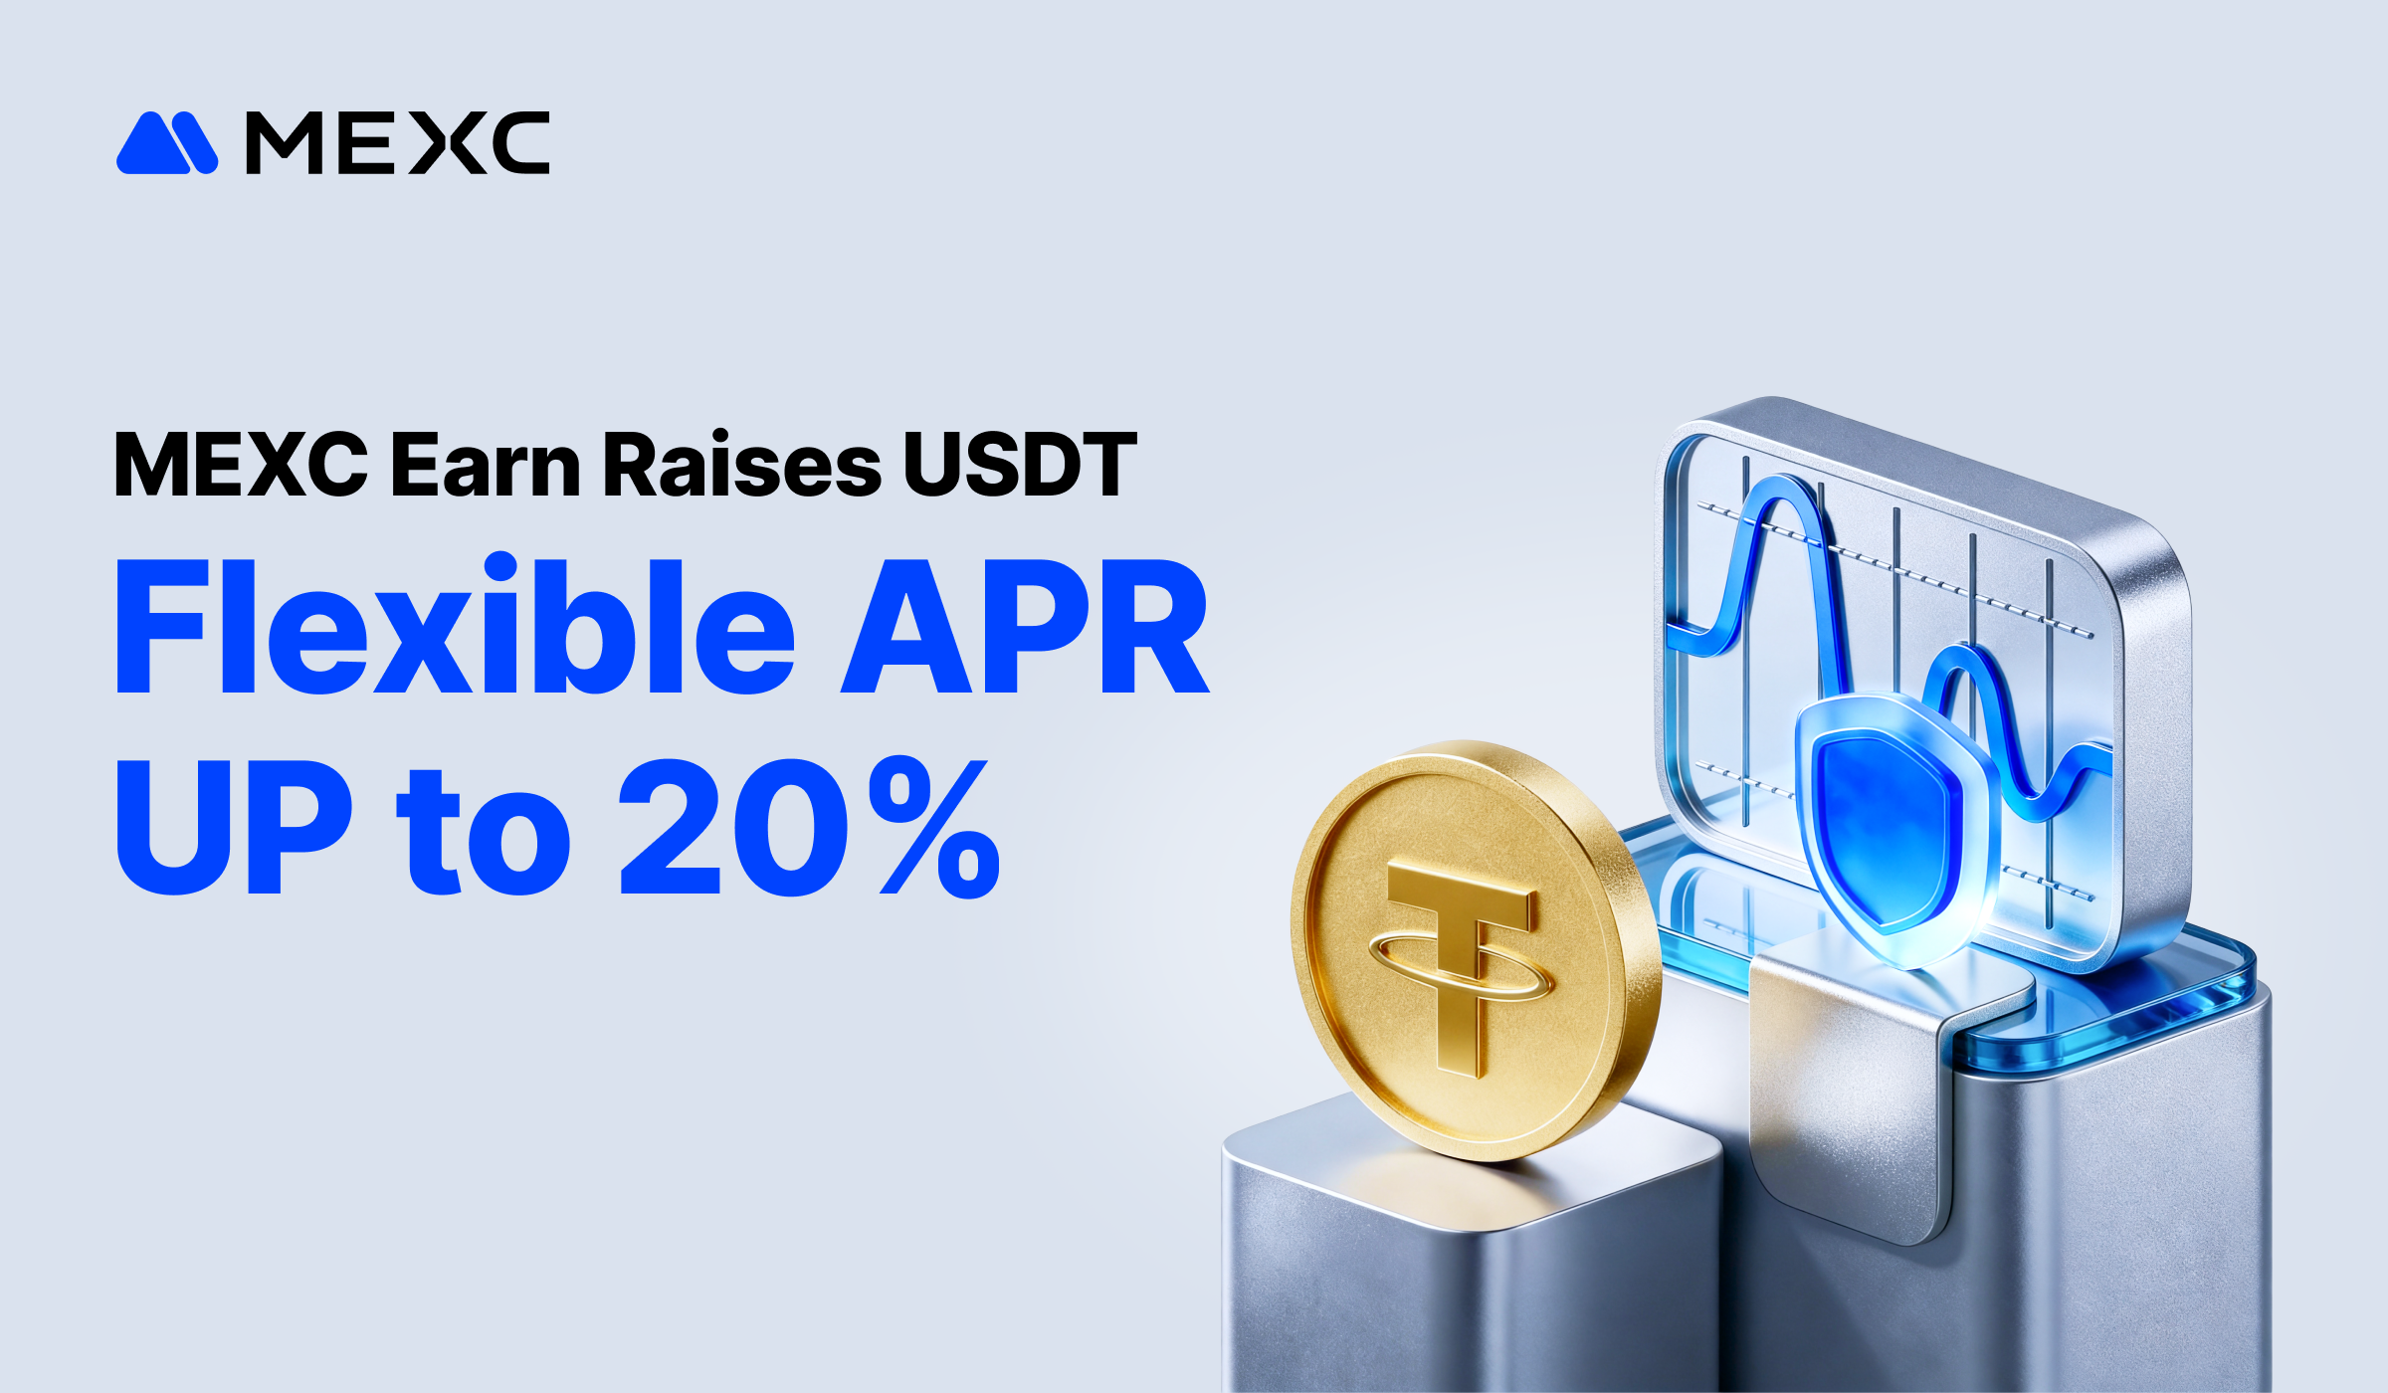
Victoria, Seychelles, February 18, 2026 – MEXC, the world's fastest-growing digital asset exchange and a pioneer of true zero-fee trading, has announced a limited-time upgrade to its MEXC Earn offerings, raising the Annual Percentage Rate (APR) on USDT Flexible Savings to up to 20%. The enhancement addresses growing demand for stable yet competitive earning solutions as investors navigate market volatility, reflecting MEXC's commitment to addressing diverse investor needs.

The upgrade primarily raises APRs for the first two tiers of USDT Flexible Savings, with both tiers now offering industry-leading rates. Deposits between 0 and 300 USDT now earn 20% APR, up from 16%, while the mid-tier bracket covering 300 to 100,000 USDT has doubled from 5% to 10% APR. The product offers high APRs, high tier limits, and no lock-up periods, enabling users to maximize returns while retaining full control over their funds with unrestricted withdrawals at any time.

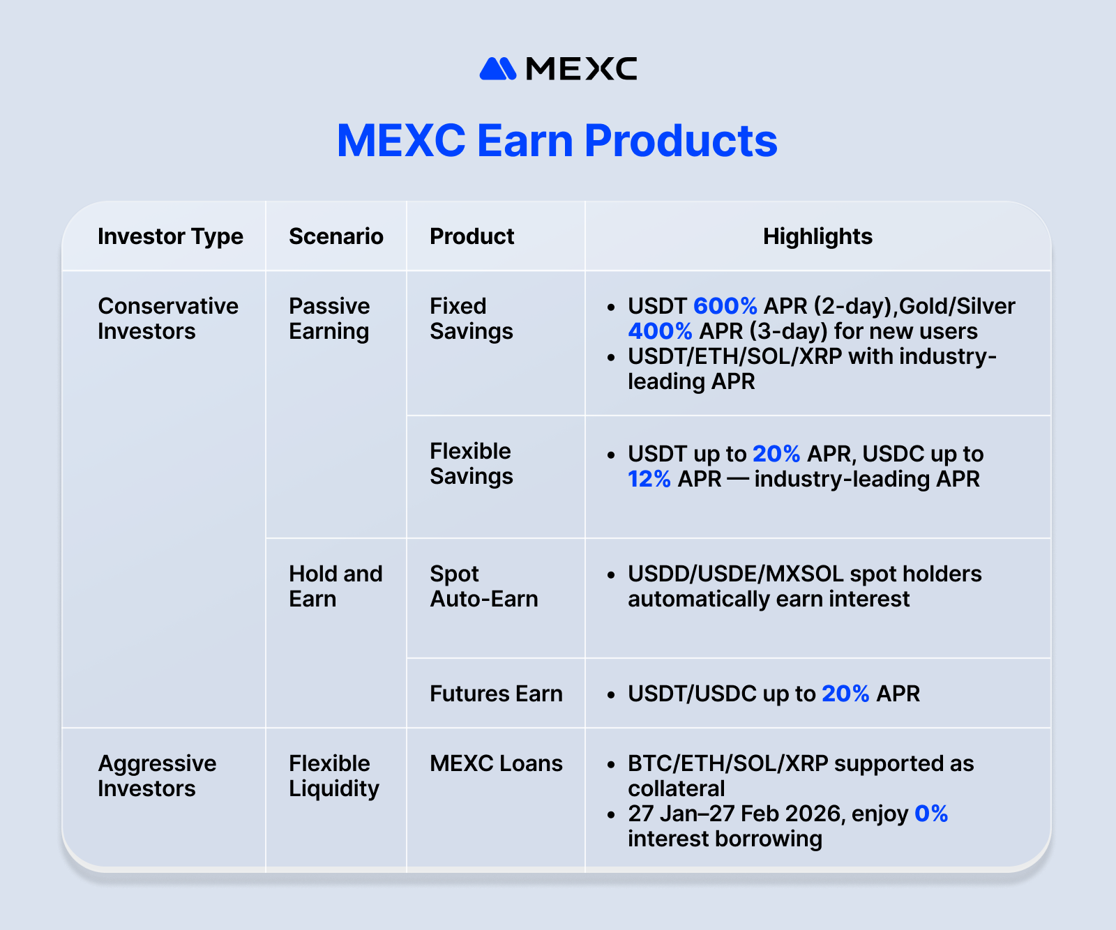
For conservative investors seeking passive earnings, MEXC Earn offers capital-protected options. Fixed Savings provides new users with exclusive 2-day USDT products at 600% APR and 3-day XAUT (Gold) and SLVON (Silver) products at 400% APR. The product also offers industry-leading APRs on USDT, ETH, SOL, and XRP for all users. In addition to the USDT upgrade, Flexible Savings offers industry-leading rates on USDC. The Spot Auto-Earn feature enables USDD, USDE, and MXSOL holders to generate passive income automatically. Additionally, Futures Earn provides users with up to 20% APR earning opportunities on USDT and USDC.

For investors seeking flexible liquidity while maintaining asset exposure, MEXC Loans provides collateralized lending services with a zero-interest promotion running from January 27 to February 27, 2026. Users can use BTC, ETH, SOL, or XRP as collateral to borrow other cryptocurrencies without liquidating holdings, preserving potential upside while accessing liquidity for trading or investment.

By tailoring solutions across the risk spectrum—from capital-protected savings to leveraged liquidity—MEXC Earn removes complexity from digital asset management, enabling users of all experience levels to pursue growth aligned with their individual goals. As part of its "MEXCmize Your Growth" commitment, the platform continues to refine product accessibility and expand earning mechanisms, ensuring users can access suitable earning solutions whether prioritizing stability, flexibility, or high returns.

For more information on products and current promotions, visit the official MEXC Earn page.
About MEXC
Founded in 2018, MEXC is committed to being "Your Easiest Way to Crypto." Serving over 40 million users across 170+ countries, MEXC is known for its broad selection of trending tokens, everyday airdrop opportunities, and low trading fees. Our user-friendly platform is designed to support both new traders and experienced investors, offering secure and efficient access to digital assets. MEXC prioritizes simplicity and innovation, making crypto trading more accessible and rewarding.
MEXC Official Website｜ X ｜ Telegram ｜How to Sign Up on MEXC

For media inquiries, please contact MEXC PR team: media@mexc.com

Risk Disclaimer:
This content does not constitute investment advice. Given the highly volatile nature of the cryptocurrency market, investors are encouraged to carefully assess market fluctuations, project fundamentals, and potential financial risks before making any trading decisions.

