Beldex Launches BNS Marketplace, Expanding Digital Ownership Across the Ecosystem

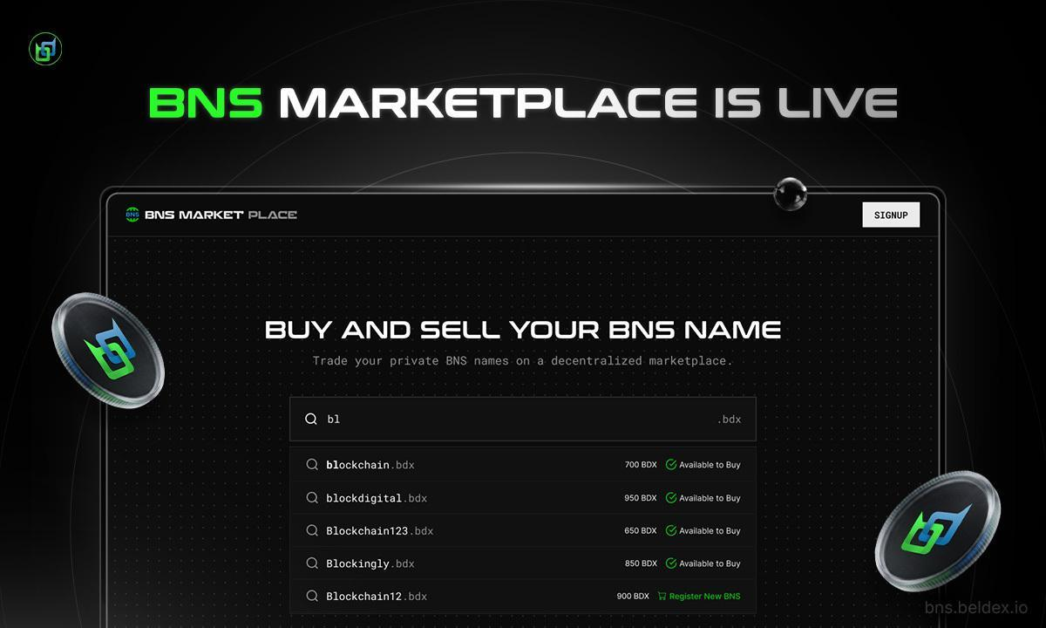

Victoria, Seychelles, May 29th, 2026, Chainwire

Beldex has announced the launch of the BNS marketplace, a platform that enables users to buy, sell, and manage blockchain-based names within the Beldex ecosystem. The launch marks the evolution of BNS names from a naming system to a dedicated marketplace where users can own and trade BNS names peer-to-peer.

This launch comes at the right moment, when Internet users are ready to take control of their identity and how it is being used. The naming systems and identities used by people today remain largely under centralized control, so the user has limited control or ownership over their username, domain, or digital identity. As a result, decentralized identities, in which naming and identity are completely owned and managed by the users themselves, are gaining attention.

Blockchain-based naming systems are gaining prominence because they operate without centralized entities. Instead, ownership is transferred directly to the user, and domain names are transferred and managed without relying on third parties or intermediaries like domain name registrars. BNS Marketplace is built on this concept, removing monopoly and giving users sovereignty over their decentralized identities and domains. The marketplace provides a private area for people to trade these names peer-to-peer and in a more organized and accessible manner.

Through the launch, users can discover available BNS names, buy them, list them for sale for a price of their choice, and sell them when required. The goal is to create a simplified and more user-friendly experience while maintaining the core principles of privacy and user ownership.

Introducing BNS Marketplace

BNS Marketplace is part of the Beldex ecosystem and is designed for managing blockchain-based names that function similarly to decentralized domains. It is a peer-to-peer platform that brings all domain activities into one place and enables users to tag their BNS names to BChat IDs, BelNet IDs, and Beldex wallet addresses.

In simple terms, the marketplace lets users buy names, sell names they own, and transfer ownership of their names to others. These names act as digital identifiers within the Beldex ecosystem, and ownership is recorded on-chain, ensuring transparency and user control. BNS names are also private by default, meaning that they share the underlying privacy and security of the Beldex network.

The goal of the platform is to make decentralized naming easier to use. Instead of relying on technical steps or fragmented tools, users can interact with, buy, list, sell, register, and manage their BNS names through a single marketplace interface. This helps reduce complexity while ensuring a seamless user experience.

According to Mok Kong Ming, COO of Beldex, the focus has been on making decentralized naming something that feels practical and usable in day-to-day life.

“At Beldex, we wanted to create something simple enough for users to actually use without having to think too much about the technical side. BNS Marketplace brings all of that into one place so users can easily manage and trade names while staying in control of their ownership and being free of intermediaries,” he said.

Driving the Next Phase of Growth At Beldex

The BNS Marketplace is an important step in how the Beldex ecosystem is evolving. The BNS functions as a user name on BChat, a human-readable address on the Beldex wallet, and a decentralized domain on BelNet and the Beldex Browser.

Domain naming is a core part of how identity works online, and by bringing it into a marketplace, Beldex is expanding what users can actually do with decentralized naming.
Over time, blockchain-based domain names are expected to play a bigger role in how people interact across decentralized applications like BChat and BelNet.

A decentralized domain today is not just a label but is part of how identity and access can work across systems. BNS Marketplace supports this by making names easier to access, trade, and integrate into different parts of the ecosystem.

In the long run, Beldex envisions building something that connects more naturally with other parts of the ecosystem, including communication, browsing, and other privacy-focused applications. The focus will remain on keeping things usable while expanding what decentralized naming can do in practice.

Afanddy Bin Hushni, Chairman of Beldex, said the launch is part of a longer-term direction toward user ownership and control.

“User ownership is the most important part of any decentralized digital system. With BNS Marketplace, we are giving users a way to truly own and manage their names without depending on any centralized platform. We believe this is an important step toward building a more open and user-controlled internet,” he said.

About Beldex

Beldex is a privacy-focused decentralized ecosystem building a privacy-first internet. It combines blockchain with privacy-preserving cryptography, helping safeguard users' data, transactions, messages, and online activities.

BChat is an application for private messaging, BelNet is for decentralized routing, and the Beldex Browser is for private web access. It also has BNS, a decentralized naming system for registering and managing blockchain-based names.

In Beldex, users can stake their tokens to participate in the network's security, while the network runs on a masternode network and Proof-of-Stake (PoS) consensus. The network utilizes the private digital currency, BDX, as a means of powering the ecosystem.

The project also remains active in developing and investigating new technologies in the realm of blockchain, like zero-knowledge systems, quantum-safe cryptography, and other advanced privacy-enhancing solutions, aiming to create a more secure and user-controlled digital environment.

Contact
Shawn G
Beldex
shawn@beldex.io

