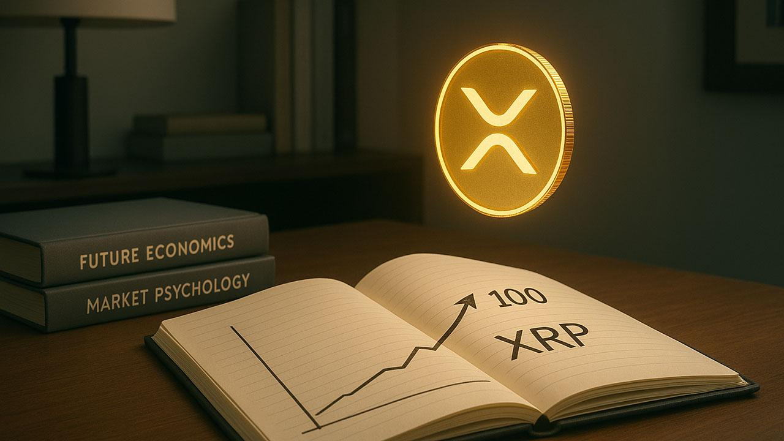‘World’s Highest IQ Holder’ Says XRP Could Hit $100 Within Five Years
YoungHoon Kim, who says he's got the world's highest IQ, has thrown himself into the XRP spotlight with a bold prediction: XRP could hit $100 in the next five years. The statement spread quickly because of its sheer scale, especially given XRP's historical trading range closer to $0.50-$1.
Kim only started posting about XRP on Dec. 12, announcing that he had started buying the token. His sudden change in tone raised some eyebrows in the crypto community, since his previous content was mostly about Bitcoin maximalism and religious commentary. The sudden change from talking up BTC to going full-on XRP bullishness came with no technical analysis, valuation model, or macro reasoning attached.
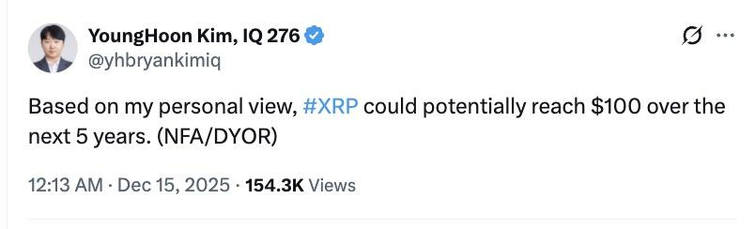
A lot of people see the move as a way to get people interested, not as a real market idea.
He often talks about an "IQ of 276," and sometimes includes links that say it's true. But experts and high-IQ society members have repeatedly dismissed the figure as statistically impossible. A score like that on the IQ test would mean that there's a one in 10²⁹ chance of getting that result. That's way beyond what most psychometric tests can measure.

Is XRP supporter the smartest man on Earth?
Kim is endorsed by all sorts of niche organizations, like the World Memory Championships and GIGA Society Professional. But critics say these groups are either self-referential or closely linked to folks promoting similar claims. A past VICE investigation talked to a bunch of leaders of well-known high-IQ societies, and they all said that Kim's claims were wrong.
Crypto users reacted quickly. One Bitcoin maximalist replied sarcastically, saying that Kim had "used only a quarter of his IQ" to arrive at the $100 XRP target.
For now, the prediction is all about being viral - loud, polarizing, and not backed up by anything solid. It's not the kind of reliable market analysis we're looking for.

