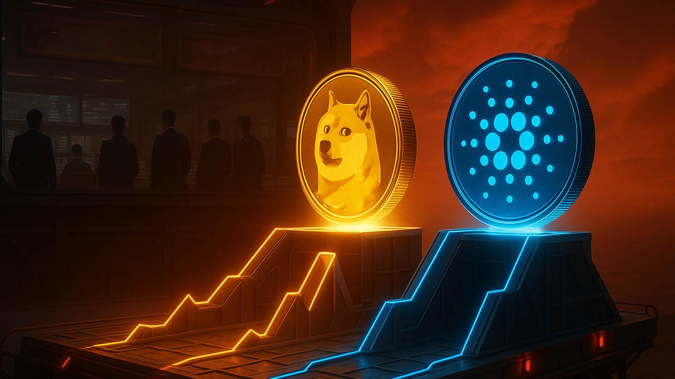Best Cryptos to Buy Under $1 with 500x Potential Before 2026
Meta Description: Two low-priced cryptocurrencies ADA and DOGE priced under $1 show strong technical and market signals ahead of 2026.
Low-priced cryptocurrencies are again drawing attention as volatility reshapes market positioning. Analysts are tracking assets that remember earlier cycles and long-term patterns. Dogecoin and Cardano are priced under $1 and remain actively discussed. These assets are now watched as the best crypto to buy during this phase.

Dogecoin Price Structure Signals Renewed Market Interest
Dogecoin continues to be priced within a familiar technical structure as analysts compare current movement with earlier cycles. Market analyst Tardigrade noted that DOGE price action resembles prior accumulation phases. On a four-hour chart, Dogecoin tested the lower boundary of its transaction range again.
This repeated interaction with support levels often attracts short-term buyers and range participants. Analysts Tardigrade stated that “Dogecoin is testing the lowest part of the lower boundary of the range.” The observation places focus on price behavior rather than projections.
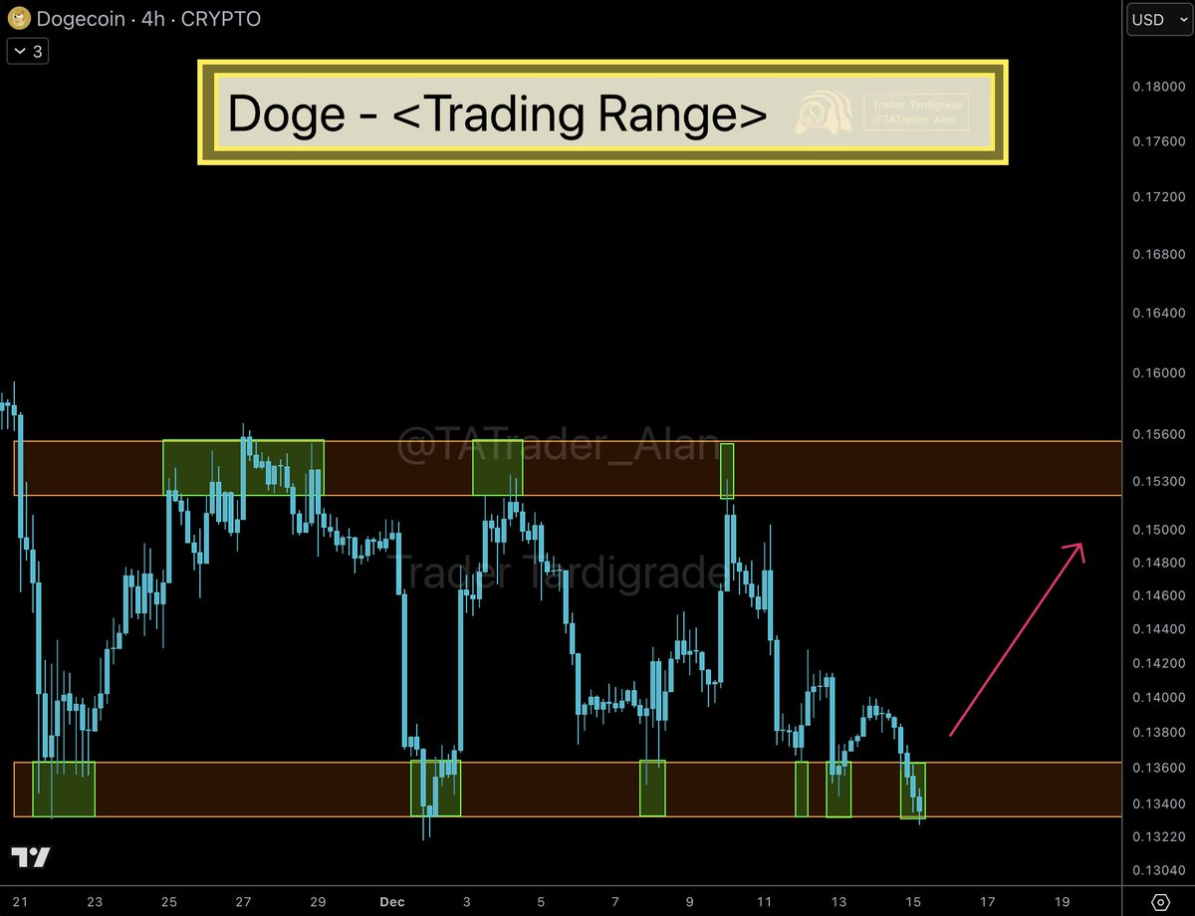
Source: X
Another analyst, Ali Martinez, shared that Dogecoin appears to be priced within a triangle pattern. He identified $0.14 as a key resistance area. Martinez said that a confirmed break above $0.14 could open a move toward $0.21 in the near term.
Market participants continue to monitor volume and confirmation signals. Dogecoin remains among the most liquid under $1 assets. This keeps it listed among the best crypto to buy for buyers seeking defined technical levels.

Cardano Holds Long-Term Channel as On-Chain Data Improves
Cardano is priced within a long-term converging channel that has guided its macro trend since launch. Analyst Quantum Ascend shared a chart showing ADA near the lower support trendline. This support has held during multiple market cycles.
The chart marks earlier cycle points including the 2018 peak, the 2020 bottom, and the 2021 high. ADA now priced in the corrective phase while holding above channel support. The structure suggests continuation within the existing pattern. Per his analysis, should the ADA price continue this trend, a rally to $4 is foreseeable in 2026. This is a conservative prediction with the analyst forecasting even a surge to $10.
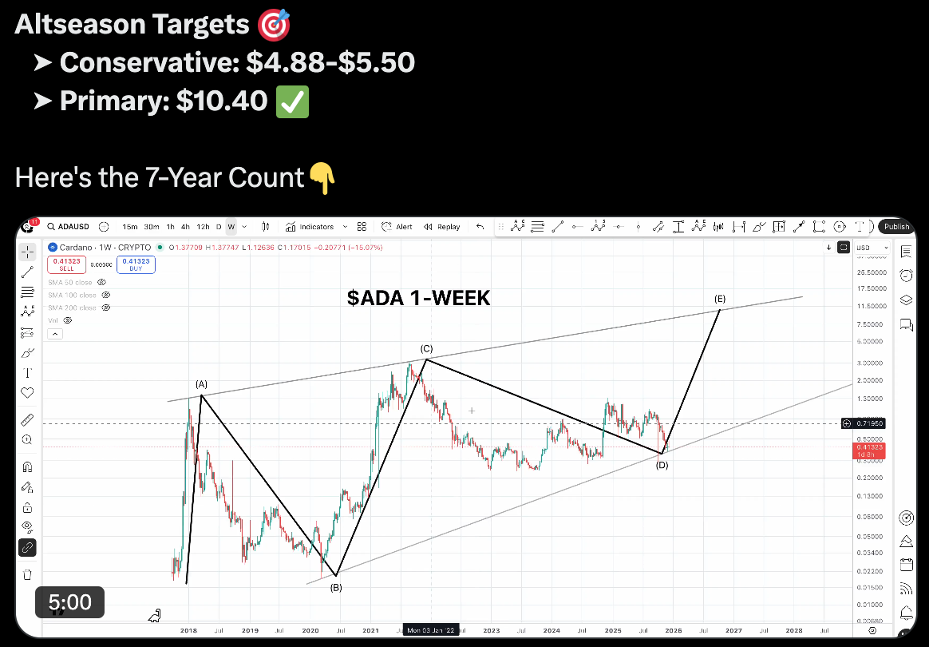
Source: X
On-chain data also reflects improving sentiment. CryptoQuant data shows buy dominance and large whale orders in both spot and futures markets. These metrics often reflect positioning rather than immediate price movement.
Derivatives data from CoinGlass supports this view. Cardano’s long-to-short ratio stands at 1.19, the highest in over a month. Ratios above one indicate more long positions than short positions. Cardano remains a closely tracked best crypto to buy under $1.

Conclusion
Dogecoin and Cardano remain priced under $1 and continue to attract analyst coverage. Each asset reflects a different market role, from technical transacting to macro structure and gaming utility.

