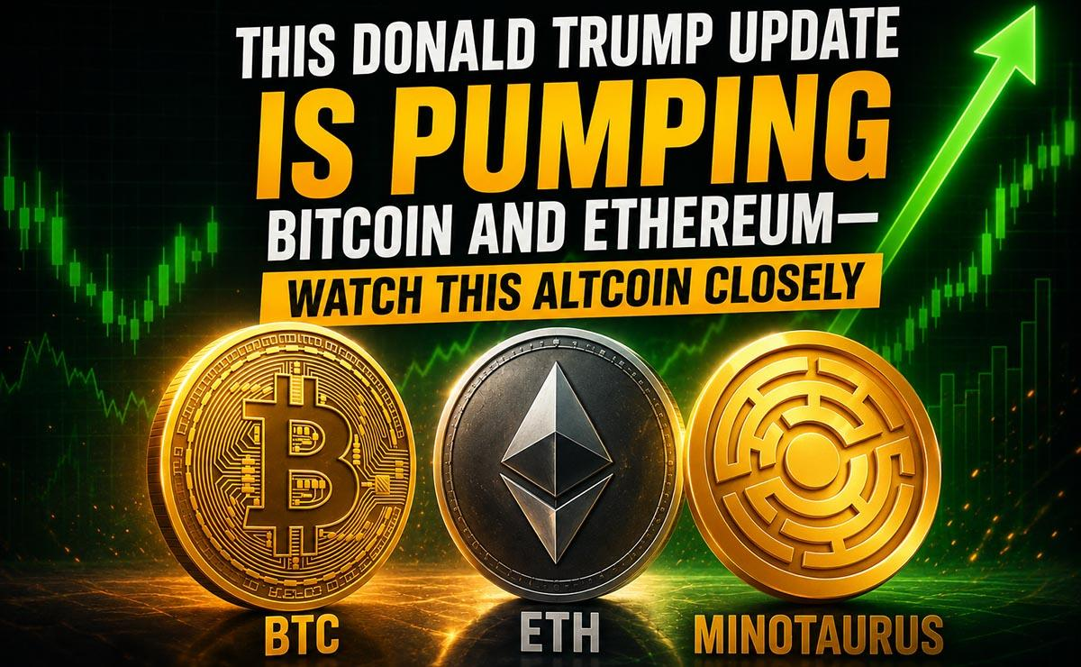This Donald Trump Update Is Pumping Bitcoin and Ethereum—Watch This Altcoin Closely
Bitcoin and Ethereum are reacting as US President Donald Trump announced a peace deal with Iran.
Trump took to Truth Social to confirm that he has finally brokered a peace deal with Iran. As he shared this update, major markets reacted differently.
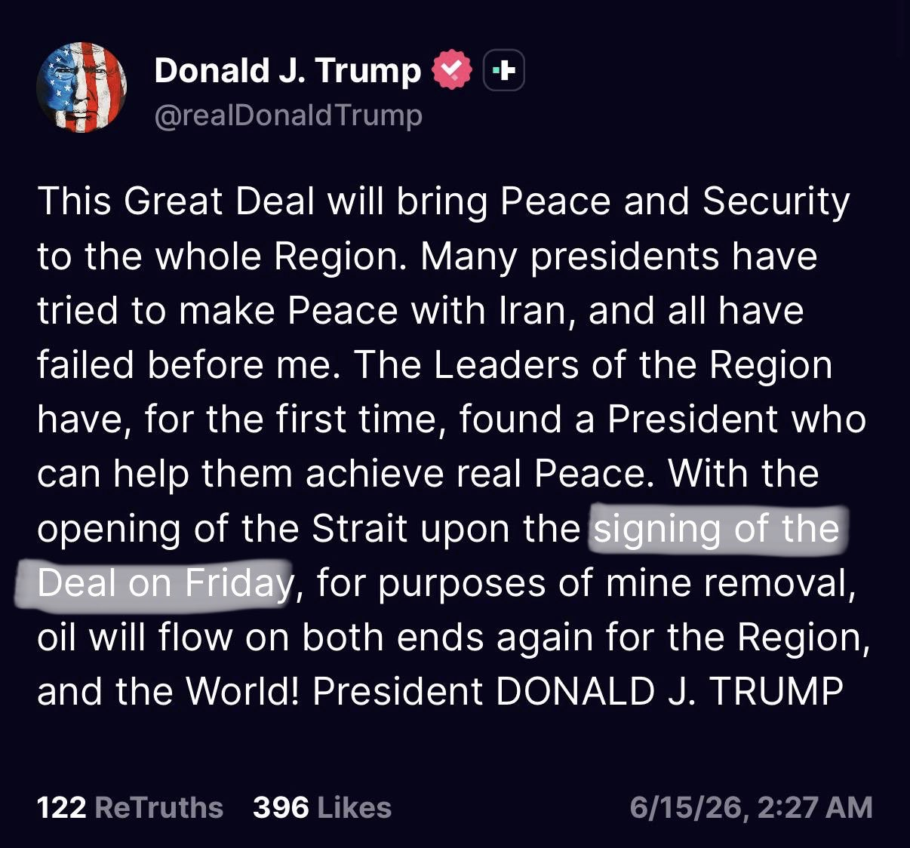
Oil came crashing, while Bitcoin sparked a broader market resurgence. The premier asset has risen by over 2% in the past 24 hours to reclaim $65,000, further extending its recovery from its drop below $60,000 earlier.
Ethereum, the second-largest coin by market cap, also reacted. ETH has now reclaimed $1,700, up 4% in the past 24 hours. In general, the market cap rose by 2% in the past 24 hours to $2.24 trillion.
Notably, the US and Iran will sign the peace deal in Switzerland on June 19, Pakistan's prime minister Shehbaz Sharif said on Monday. The Strait of Hormuz has also officially opened, ending the economic uncertainty. Analysts also believe it will have a positive impact on BTC and the broader market.

This Altcoin Could Be Massive
Whether they continue to recover remains a topic of discussion. Nonetheless, an altcoin is already capturing attention. Minotaurus (MTAUR) has reacted bullishly to the recent market resurgence, and analysts expect the early-stage project to continue to stand out among others.
Even with the uncertainty, MTAUR has continued to rise—imagine what would happen when the market turns fully bullish. It sells at 0.00012786 USDT, meaning you can buy more compared to Bitcoin and Ether. Projections see the token reaching 1 USDT soon.
Learn more at minotaurus.io.

