Bitcoin Above $66K: This Next Target Is Not What Many Expect
Bitcoin may have reclaimed $66,000, but analysts are still betting on further downside in the coming days.
Bitcoin (BTC) has now rallied 10% from its low of $59,100 earlier in June, showing resilience amid strong selling pressure. On Monday, it pushed past $66,000 for the first time in two weeks, amid positive updates from the US-Iran war.

More BTC Corrections?
While the trend has been upward lately, many still believe that the bottom is not in yet. One of those saying this is Ali Martinez, a prominent crypto analyst.
He recently claimed that the last major Bitcoin bottom formed when its price reached the Cumulative Value Days Destroyed (CVDD) level. This metric compares the short-term spending velocity to the yearly average, signaling when an asset is in deep correction or overheated.
BTC bottomed in 2022 when it touched that line at $15,000 and started a new bull cycle. According to the chart shared by Martinez, the CVDD is currently at $48,000, suggesting that while Bitcoin continues to hold above the $60,000 support, a deeper correction could still occur.
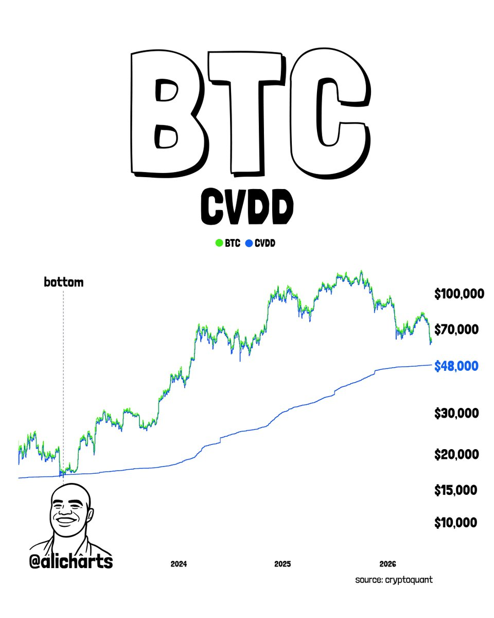

How to Navigate the Crypto Bear Market
With price directions still uncertain, the best thing to do is to DCA into assets that will produce good benefits when the market becomes bullish again. One of those that most analysts are recommending is Minotaurus (MTAUR), an early-stage project tipped to make millionaires.
It sells at 0.00012787 USDT and has the potential to reach 0.1 USDT or even 1 USDT according to projections. Its massive adoption and very secure smart contract also speak for themselves.
Learn more at minotaurus.io.

