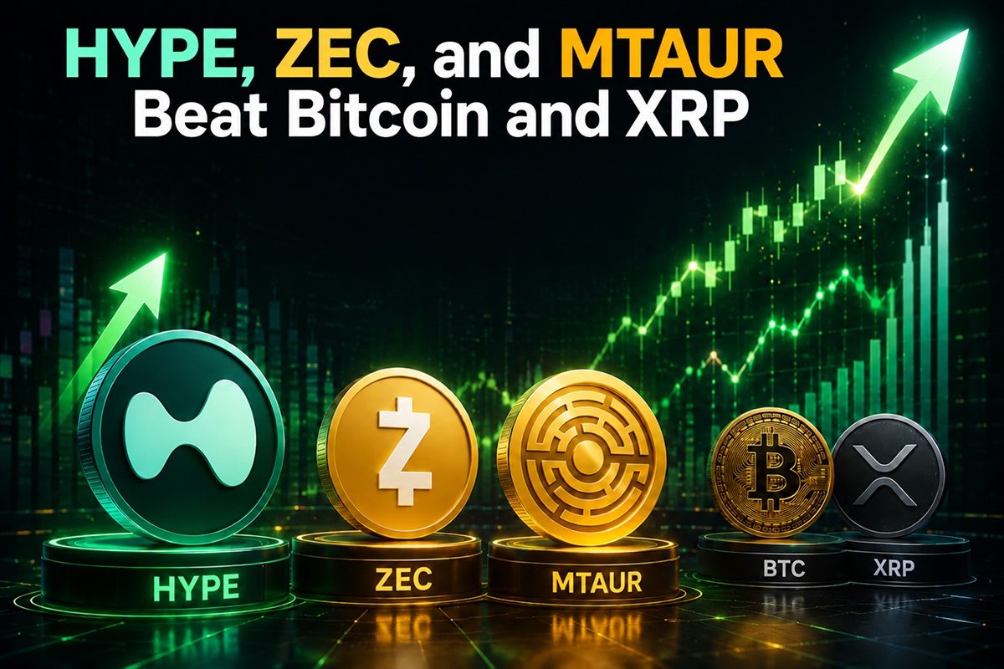HYPE, ZEC, and MTAUR Beat Bitcoin and XRP With Massive 40%–220% Price Surges
While Bitcoin and XRP have recovered, Hyperliquid (HYPE), Zcash (ZEC), and Minotaurus (MTAUR) have delivered even larger upsurges, ranging from 40% to nearly 220%.

Bitcoin and XRP
After falling to around $59,100 last week, BTC climbed to $67,300, marking a surge of nearly 14%. The U.S.-Iran peace agreement and the reopening of the Strait of Hormuz boosted risk assets.
XRP surge 4.39% over the past day to $1.23. After hovering near $1.02 last week, the token advanced more than 20%, outperforming Bitcoin but trailing the rally seen in HYPE and ZEC.

Zcash and Hyperliquid
Zcash (ZEC) has been one of the market’s strongest performers. The privacy coin surged from about $250 last week to roughly $540, a surge of around 116%, and hovered at $520.81 at press time.
HYPE climbed 10.2% in 24 hours to $72.11. The token rallied from around $52 last week to approximately $73, delivering a surge of about 40%. Analysts link the move to activity across the Hyperliquid ecosystem following the SpaceX IPO.

220% Surge from MTAUR
Minotaurus (MTAUR) has emerged as the top performer. The token rose from 0.00004 USDT to 0.00012787 USDT, a surge of nearly 220%. Interest has been fueled by anticipated exchange listings, ecosystem expansion, and verified presale holdings. At 0.00012787 USDT, 50 USDT buys 391,000 tokens. If prices hit 0.01 USDT, the holding would be 3,920 USDT.
As the market recovery continues, MTAUR, HYPE, and ZEC may continue to dominate.

