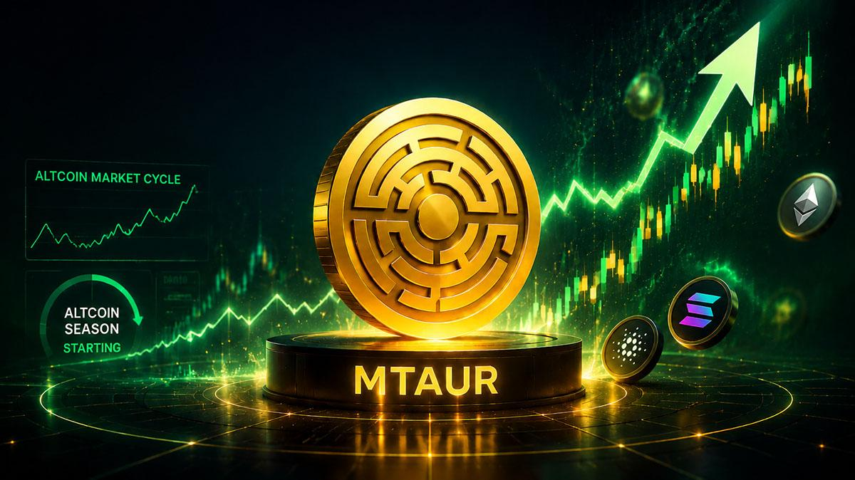CryptoQuant Says Altcoins Are Not Dead: This Coin Could Explode Next
CryptoQuant founder Ki Young Ju believes altcoins are not dead, but the market has entered a new phase where hype alone is no longer enough.
For years, token prices often surged around powerful narratives, from DeFi and NFTs to gaming and memecoins. Ju argues that this cycle is different. Projects without real products or strong ecosystems are unlikely to survive as the crypto market matures.
He says the altcoins with the strongest future potential are those connected to real financial activity, including tokenized assets, beneficial DeFi platforms, and blockchain networks serving large user bases. He pointed to examples such as BNB, Toncoin, and Hyperliquid as projects tied to active ecosystems.
Ju believes crypto is moving away from hype and becoming closer to traditional finance, with more regulation and institutional involvement. While many altcoins may fail, he argues that dismissing the entire sector ignores the projects building useful technology for the future.

The Next Big Altcoin?
Under this new environment, Minotaurus (MTAUR) stands out. It is among the early-stage altcoins with all it takes to thrive: a promising niche, a strong roadmap, mainstream adoption, and ecosystem security.
It builds on the casual gaming niche tipped to reach 29 billion USDT by 2029. Capturing just 10% of it would make it a billion-dollar asset. Its entry price of 0.00012788 USDT is cheap considering its potential.
1,000 USDT can buy you 7,8 million MTAUR tokens, which could turn to millions of dollars if projections work. Learn more at its official website.

