Bitcoin Price Prediction: What BTC Strength Could Mean For Presales Like MemeToro
Meta Description: Bitcoin consolidation influences capital rotation while MemeToro presale gains attention as AI-driven behavioral finance ecosystem expands.

Bitcoin continues to trade within a consolidation range, creating a controlled environment for capital rotation across crypto markets. Despite short-term volatility, BTC remains structurally stable between $63,727 and $67,220.
This stability has significant implications for AI presale ecosystems such as MemeToro, which often gain attention during periods of market equilibrium and selective capital deployment.

Bitcoin Consolidation and Market Stability Structure
Bitcoin’s current range-bound behavior reflects profit-taking ahead of macroeconomic decisions. This consolidation phase limits directional momentum but maintains overall market structure.
Such environments often serve as accumulation phases where capital begins rotating into early-stage opportunities and narrative-driven ecosystems.

Altcoin and Institutional Flow Influence on Market Behavior
Institutional capital continues rotating into Solana and XRP through ETF inflows, even as Bitcoin experiences minor outflows. This indicates growing diversification across crypto ecosystems.
This rotation supports broader market stability and increases liquidity availability for alternative assets during consolidation phases.
MemeToro $MT is gaining attention as a behavioral finance ecosystem that benefits from Bitcoin stability phases. When BTC remains range-bound, capital often flows into narrative-driven assets with higher volatility potential.
Its AI-driven structure allows it to capture social sentiment and convert it into ecosystem-level financial activity, aligning with early-stage market behavior patterns.

The All-in-One MemeToro Ecosystem: Buy $MT for Total Access
Investing in $MT tokens unlocks a unified Web3 playground right from your dashboard. Buying into the presale gives you immediate access to a streamlined hub that replaces fragmented decentralized apps with one simple interface.
- Autonomous AI Deployer: Instantly launches fresh community tokens based on live market spikes.
- Built-in Asset Swap: Lets you trade and exchange newly minted memecoins right inside your dashboard.
- Decentralized Prediction Markets: Turn your knowledge of active internet trends into real digital assets.
- Borderless Web3 Casino: Spend your token winnings on global micro-transaction games with ease.
- High-Yield Core Vaults: Lock up your assets to accumulate passive ecosystem rewards automatically.
- Real-Time Data Feeds: Tracks major industry updates to give you an analytical edge before trading.
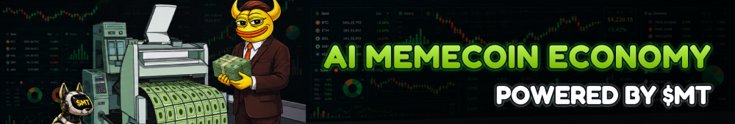

Understanding MemeToro Tokenomics and Supply Distribution
The distribution architecture puts heavy community ownership first to support decentralized network growth. This model stops team dumps from destabilizing initial market performance.
- Fixed Cap: Exactly 1.2 billion $MT tokens minted.
- Public Allocation: 71% reserved for presale tiers.
- Zero Vesting: Presale buyers claim tokens instantly.
- Staking Yields: Vault contracts pay 35% APR emissions.
- Core Gas: Powers prediction pools and creator tools.

Conclusion
Bitcoin’s consolidation phase is shaping liquidity distribution across the crypto market, supporting both institutional rotation and early-stage ecosystem growth.
MemeToro $MT is gaining attention within this environment as a behavioral finance system positioned to benefit from narrative-driven capital flows during BTC stability cycles.

Frequently Asked Questions

Are the smart contracts fully audited?
Yes, all core ecosystem contracts have been thoroughly evaluated and verified by security experts at Coinsult.

Which blockchain hosts the MemeToro platform?
The app runs on the BNB Chain, with plans to move to a custom, high-speed blockchain network later.

What is the long-term project timeline?
The project's comprehensive technical roadmap spans 24 months and schedules the rollout of 15 unique AI utility products.
More Information on MemeToro ($MT) Presale Here:
Website: https://memetoro.com/
X: https://x.com/memetoro_mt
Telegram: https://t.me/memetoro_mt

