Best Crypto to Buy Before the Next Bitcoin Rally
Meta Description: Bitcoin consolidation is encouraging investors to explore projects like MemeToro, HYPE, and NEAR before the next potential rally.
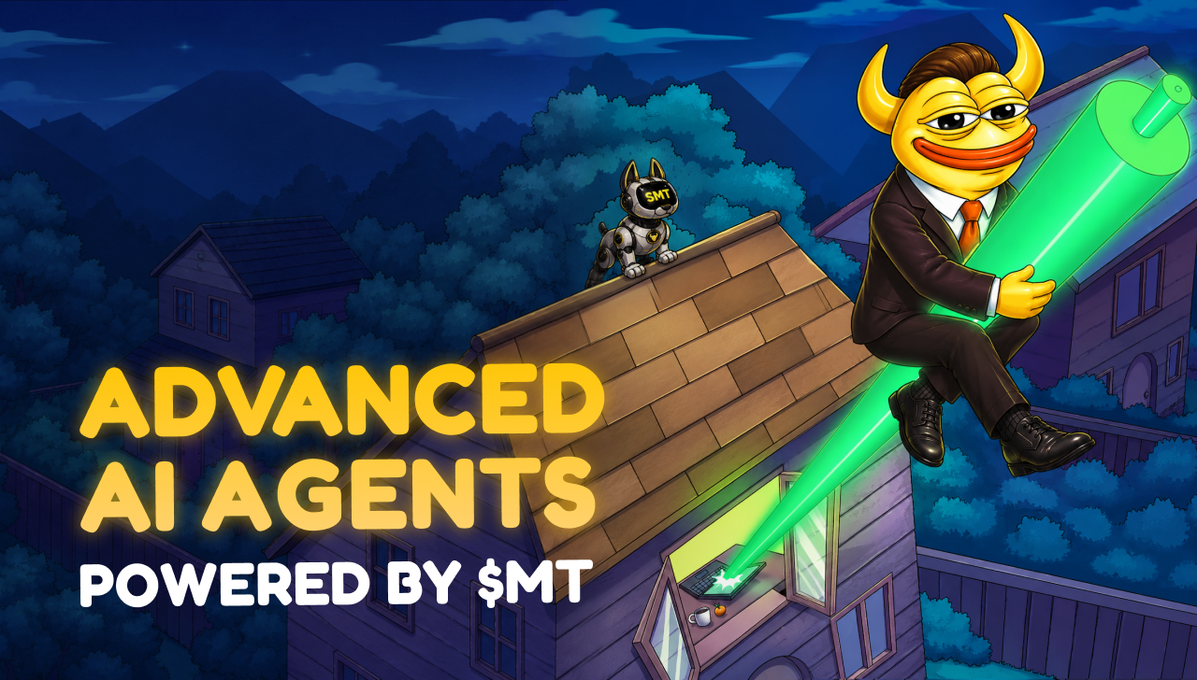
Bitcoin's current consolidation phase is forcing investors to think strategically about positioning ahead of the next major market move.
While BTC continues trading between key support and resistance levels, many traders believe periods like these often create opportunities to accumulate assets before momentum returns.
Historically, Bitcoin has acted as the catalyst for broader crypto market expansions. Once confidence returns and liquidity improves, capital often flows from Bitcoin into altcoins and emerging ecosystems. This pattern has made many investors focus not only on BTC itself but also on projects that could benefit if another rally develops.
Today's market looks very different from previous cycles. Artificial intelligence, decentralized infrastructure, tokenized assets, and social finance platforms are now competing for investor attention.
Among the projects gaining visibility are HYPE, NEAR, Bitcoin Hyper, and MemeToro $MT, each representing a different segment of the evolving digital asset economy.


Bitcoin Remains the Market's Primary Driver
Even with thousands of cryptocurrencies competing for attention, Bitcoin continues serving as the foundation of the market.
According to technical analysts, BTC remains trapped inside a horizontal distribution channel between $63,727 and $67,220. While some traders view this as a sign of weakness, others interpret it as a healthy consolidation phase that allows the market to establish stronger support.
Many investors are focused on Bitcoin's ability to eventually clear the $76,800 psychological milestone. A successful breakout above that level could improve sentiment significantly and potentially attract new capital into the sector.
Long-term forecasts remain constructive despite near-term uncertainty. Fundstrat continues projecting a potential move toward the $120,000 to $170,000 range once macroeconomic conditions improve and liquidity expands.
If those projections prove accurate, the broader market could experience substantial capital inflows over the coming years.

HYPE and NEAR Continue Dominating Investor Attention
While Bitcoin remains the market leader, certain altcoins are attracting attention because of their strong performance during consolidation.
HYPE has emerged as one of the most talked-about assets of 2026. The token recently reached an all-time high near $76.85 while absorbing substantial selling pressure from a major token unlock. Strong trading volume and growing activity on its decentralized perpetual exchange continue supporting the bullish narrative.
NEAR is benefiting from a different trend. The project remains one of the strongest performers within the artificial intelligence infrastructure sector. Demand for decentralized data availability services continues expanding as AI applications require increasingly sophisticated blockchain support.

Exploring MemeToro: Multiple Ways to Profit from AI Tokens and Prediction Markets
Alongside established altcoins, early-stage ecosystems are beginning to attract growing attention from investors preparing for a future rally.
MemeToro $MT is one of the projects benefiting from this trend. Built on BNB Chain, the ecosystem combines artificial intelligence, prediction markets, staking infrastructure, and memecoin creation tools within a single platform.
Unlike many meme-focused projects, the platform is designed around utility. Its autonomous AI agent scans social media trends, viral content, and market narratives to identify opportunities before they gain widespread attention.
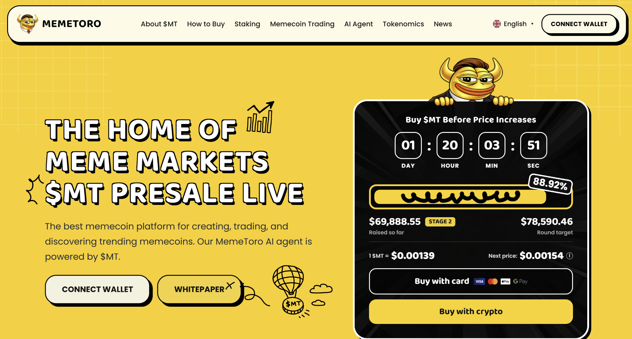
The ecosystem also allows users to launch tokens through an integrated creation framework while participating in prediction markets and staking activities powered by the native MemeToro $MT token.
Recent roadmap expansions introduced plans for dedicated Layer-1 infrastructure, helping position the project beyond a traditional presale narrative. As investors increasingly focus on AI-powered ecosystems, the project continues gaining visibility within the broader market.

What's Ahead
Preparing for the next Bitcoin rally often requires looking beyond Bitcoin itself. While BTC remains the primary driver of market sentiment, several sectors are already showing signs of strength.
Projects such as HYPE and NEAR continue benefiting from strong narratives tied to decentralized trading and artificial intelligence infrastructure. Meanwhile, Bitcoin Hyper is attracting attention through its Layer-2 scaling approach, and MemeToro is building visibility through its combination of AI tools, prediction markets, and community-driven participation.

Frequently Asked Questions

What is the function of the $MT token?
It is the main ecosystem fuel used for trading, staking, casino gaming, and making event predictions.

Can I use $MT to access premium features?
Yes, holding the token unlocks advanced market analytics and priority access to the project's automated creation tools.

Do I need external coins to play games?
No, the platform accepts native $MT tokens directly to skip extra exchange steps and hidden fees.
More Information on MemeToro ($MT) Presale Here:
Website: https://memetoro.com/
X: https://x.com/memetoro_mt
Telegram: https://t.me/memetoro_mt

