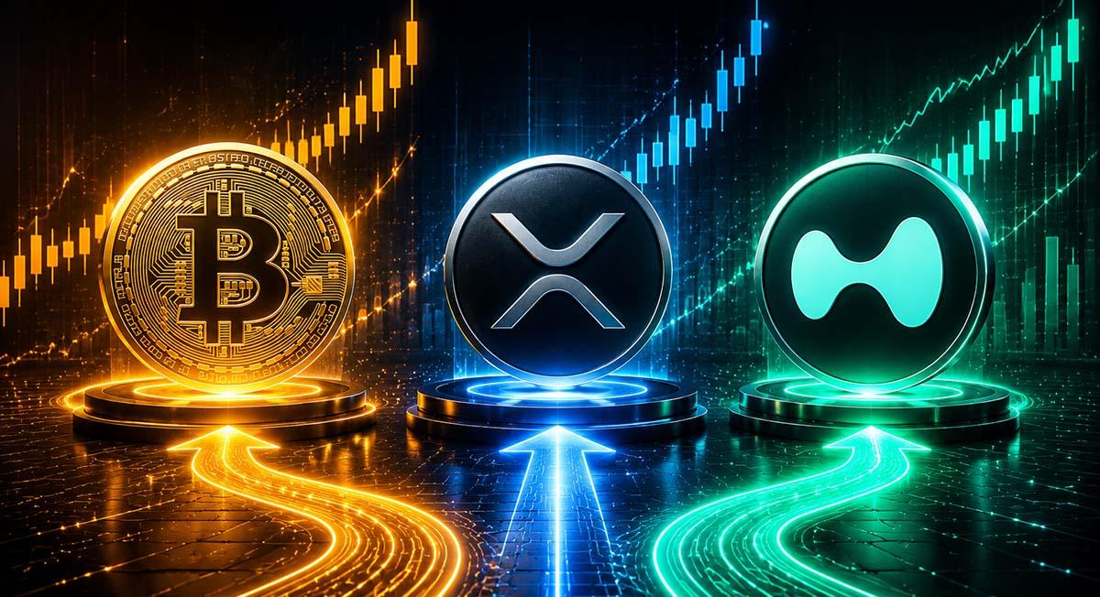Bitcoin, XRP, or HYPE: Where Could $50 Deliver the Best Outcome?
Grok has said Hyperliquid (HYPE) offers stronger upside potential than Bitcoin and XRP for those with $50. Meanwhile, another altcoin is already stealing the spotlight from HYPE.
Bitcoin boasts a $1.3 trillion cap and a price of $64,000 as institutional adoption strengthens its position.
XRP is at $1.13, with a $70 billion market cap, and remains focused on payments and cross-border settlements. HYPE is at $67 and has surged into a major DeFi asset with a market value of $21 billion.
Grok noted that HYPE hit an all-time high at $76, outperforming several coins. The project's expansion beyond perpetual futures into DeFi services further strengthens its narrative.

Smaller-Cap Tokens to Offer Even Greater Upside?
Some believe smaller-cap projects may deliver larger upside due to lower valuations. One example is Minotaurus (MTAUR), which rose 220% from about 0.00004 to 0.0001279 USDT in recent months.
Supporters cite its relatively small market capitalization of 5.6 million USDT and planned exchange listings as potential drivers for moves to 0.012 USDT. They also pointed to a Coinsult Proof of Assets report that reviewed the project's presale wallet.
Grok's analysis suggests altcoins with lower valuation offer the strongest combination of momentum and upside potential than Bitcoin and XRP, which have large caps. With smaller-cap projects like Minotaurus breaking out, it’s time to pay attention.

