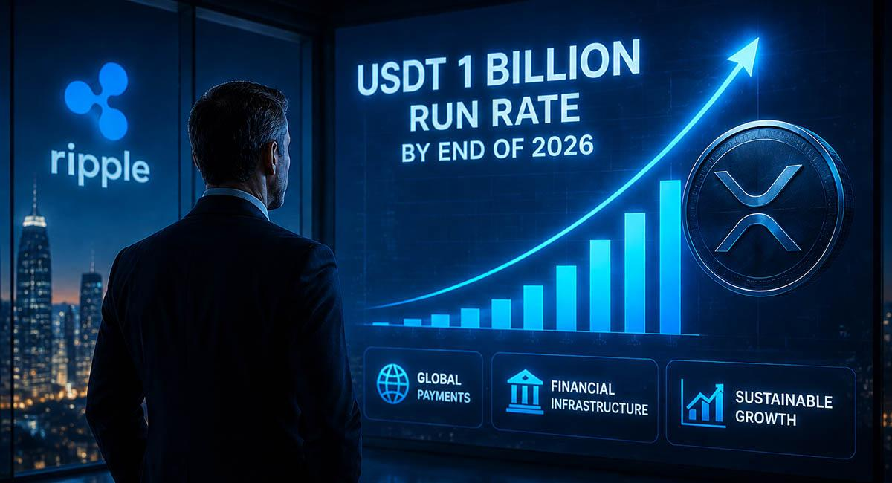Ripple Targets $1 Billion Annual Run Rate by End of 2026, CEO Says
Ripple expects to reach a $1 billion annual run rate by the end of 2026. In an interview with Fox Business, CEO Brad Garlinghouse said Ripple has continued to move despite the lack of clear regulations. Its move has come from international markets, where demand for its payment and blockchain services is increasing.

Ripple Treasury and Stablecoin Adoption
Garlinghouse also highlighted Ripple Treasury as the company's fastest-moving product. The platform helps multinational companies manage bank accounts, currencies across different countries.
He said more businesses are looking at using stablecoins for treasury management and cross-border payments. This could improve demand for RLUSD stablecoin as companies seek faster and more efficient ways to move value.
Garlinghouse said financial institutions are also becoming more open to stablecoins, helping drive adoption in the financial industry.

Minotaurus Posts 220% Amid Expansion Plans
Alongside XRP, market participants are closely watching Minotaurus (MTAUR), which has recorded a 220% price surge from 0.00004 USDT to 0.0001279 USDT The project has announced plans to pursue listings on major cryptocurrency exchanges and revealed that new adoption-focused partnerships are expected to be disclosed in the near future.
According to a Coinsult Proof of Assets report, the project’s presale wallet showed no outflows in a 549-day period, with on-chain holdings valued at more than 2.7 million USDT at the time of verification. The project’s team believes its relatively modest market capitalization leaves room for further expansion as development progresses.

