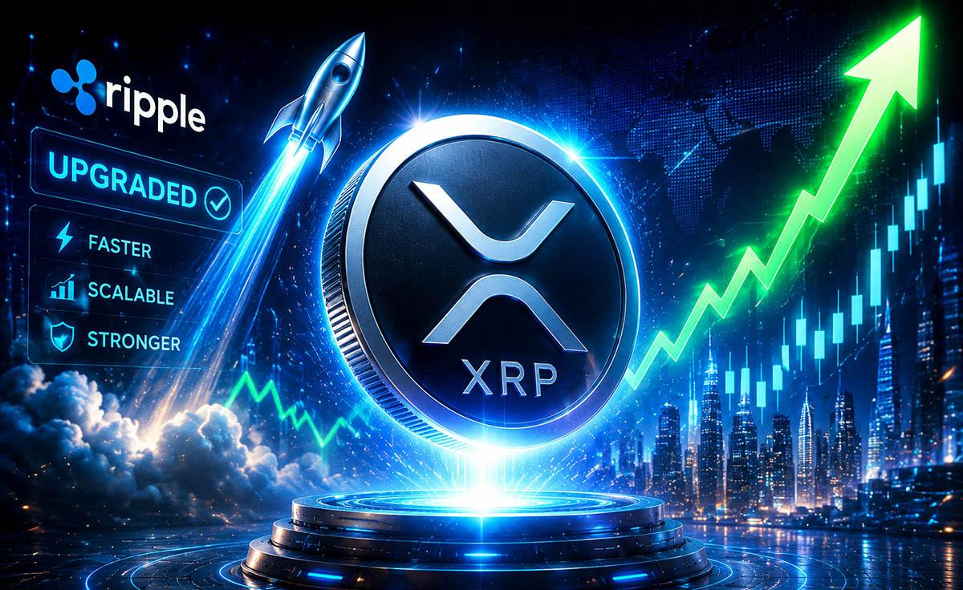Ripple Has Upgraded XRP—Here's What Price to Expect from
Ripple just rolled out a major upgrade for XRP, but the asset appears to be losing traction
Ripple has rolled out version 3.2.0 of the XRP Ledger, introducing bug fixes and reducing memory usage by up to 40%. The upgrade is expected to improve network efficiency and further strengthen XRP Ledger’s ability to process low-cost, near-instant transactions.
However, the update does little to address a longer-term challenge facing XRP itself. While Ripple’s payment network allows banks to settle cross-border transfers quickly, financial institutions are not required to use XRP. They can also send fiat currencies or stablecoins through Ripple Payments and still benefit from faster settlements.
Ripple’s own stablecoin, RLUSD, has added another alternative. Although RLUSD transactions on the XRP Ledger still generate fees paid in XRP, that demand may not be significant enough to support the token over time.
With XRP remaining highly volatile, some institutions may continue to favor stable assets for payments. Critics argue this limits XRP’s role as a bridge asset. After falling sharply from its recent highs of $3.66, some analysts believe the token could still fall below $1.

XRP Whales Turning to New Gem
As the trend persists, XRP whales with an eye for discovering promising projects have identified a new gem, one with a 10,000% prospect.
It is none other than Minotaurus (MTAUR). The token has shown all the promising signs of a must-have token, with massive adoption and bullish momentum backing its rise to prominence.
You don’t want to miss out; check out its official website for details.

