5 Cheapest Crypto Exchanges for Spot and Futures Trading (2026 Comparison)

Quick Answer: Which Is the Cheapest Crypto Exchange in 2026?
If your sole metric is paying low baseline commissions per trade without needing to hold massive amounts of a native platform token, MEXC appears to be the cheapest option for maker-order traders, though actual costs still depend on taker fees, spreads, slippage, funding rates, and withdrawal fees.

Key Takeaways
- Based on baseline maker/taker fees, MEXC is among the lowest-cost major exchanges in 2026, especially for maker orders on spot and futures markets.
- Binance, OKX, Bybit, and KuCoin remain highly competitive low-cost alternatives, especially for high-volume traders utilizing VIP tier structures.
- The cheapest exchange ultimately depends on your individual trading style, your VIP level, and whether you prefer spot or futures markets.
- Even when trading commissions are zero, traders may still face indirect costs such as spreads, slippage, funding rates, and withdrawal fees.
Choosing the wrong cryptocurrency exchange can cost you thousands of dollars a year in unnecessary commissions, spreads, and hidden withdrawal penalties. For active traders, optimizing trading fees is one of the fastest ways to improve a portfolio's bottom line.
In 2026, the crypto exchange landscape remains highly competitive. While some top-tier platforms have quietly adjusted their baseline fee tiers, others continue to use promotional structures to capture market share.
This comprehensive guide breaks down 5 of the cheapest crypto exchanges for spot and futures trading in 2026, exposing the hidden costs most traders ignore.
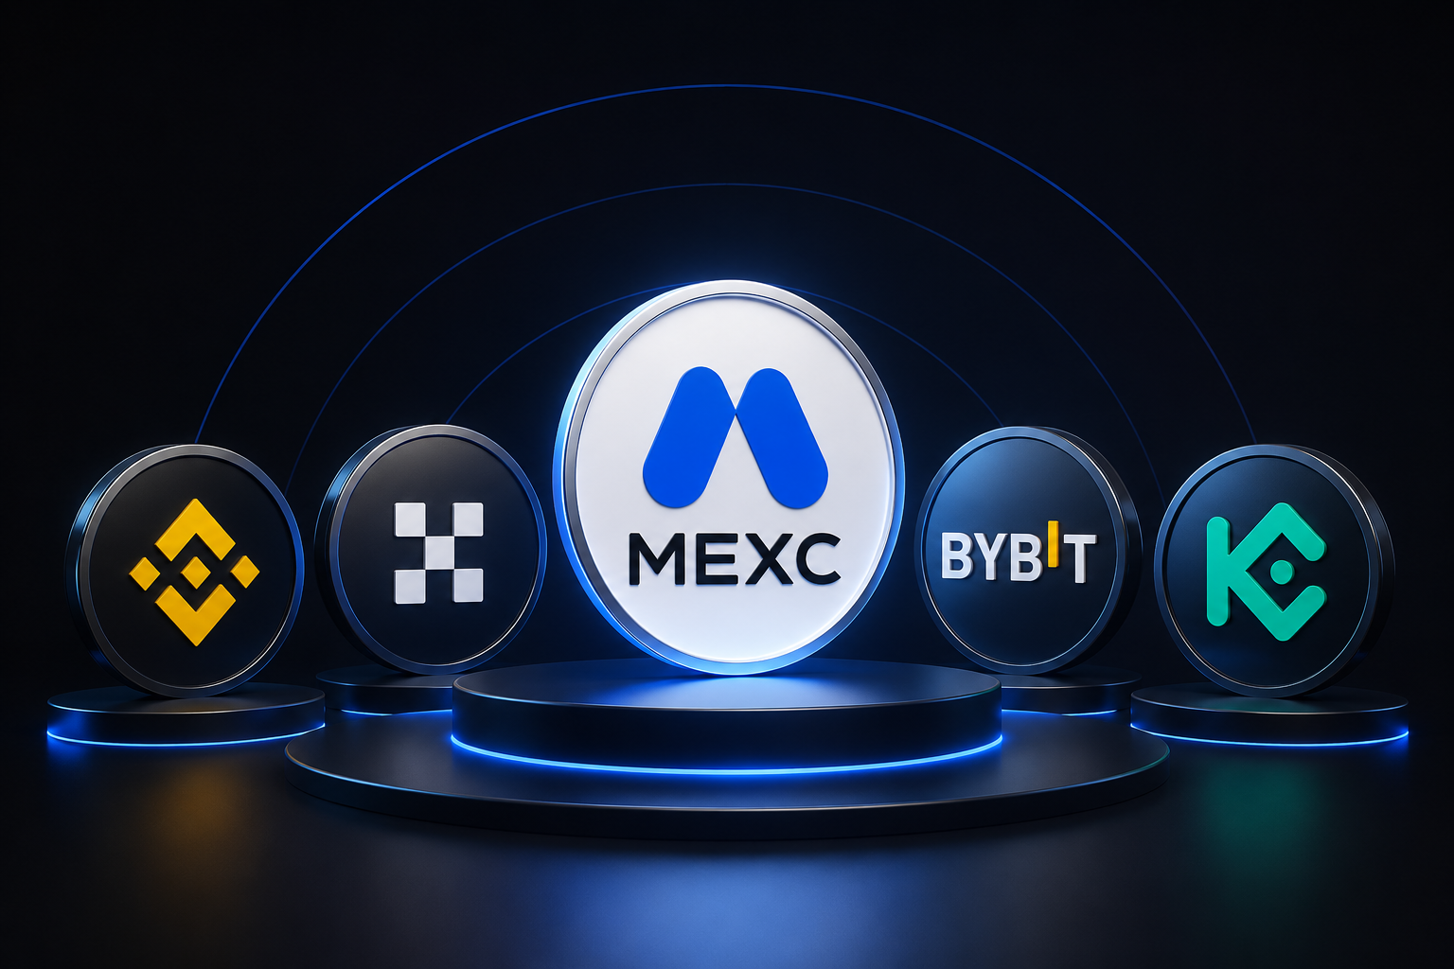

Cheapest Crypto Exchanges at a Glance (2026)
The table below outlines the standard, baseline (Tier 0) fee structures for five of the lowest-cost cryptocurrency exchanges in 2026. These figures represent what a standard retail user pays before accounting for volume-based VIP tiers or native token discounts.
Exchange | Spot Maker | Spot Taker | Futures Maker | Futures Taker | Best For
MEXC | 0.00% | Varies (0.05% - 0.10%) | 0.00% | 0.02% | Lowest Overall Trading Fees & Best Value for Spot and Futures Traders
Binance | 0.10% | 0.10% | 0.02% | 0.05% | High-Volume Traders & Deep Liquidity
OKX | 0.08% | 0.10% | 0.02% | 0.05% | Professional Traders & Advanced API Users
Bybit | 0.10% | 0.10% | 0.02% | 0.055% | Derivatives, Leverage, & Copy Trading
KuCoin | 0.10% | 0.10% | 0.02% (Typical Base) | 0.06% (Typical Base) | Hidden Gem Altcoins & Small-Cap Assets

How We Ranked the Cheapest Crypto Exchanges
To identify the lowest-cost crypto exchanges, we evaluated five key factors that affect real trading costs:
- Spot Trading Fees: Costs for buying and selling cryptocurrencies.
- Futures Trading Fees: Maker and taker fees for perpetual futures contracts.
- Funding Rates: Ongoing payments between long and short traders.
- Withdrawal Fees: Charges for moving assets off the exchange.
- Liquidity & Slippage: Order book depth and execution quality for large trades.
This approach provides a more accurate view of total trading costs than comparing trading fees alone.

What Are the 5 Cheapest Crypto Exchanges for Spot and Futures Trading?

1. MEXC — Among the Lowest-Cost Major Exchanges in 2026
MEXC has established itself as a baseline cost leader by leveraging an aggressive fee-cutting model designed to capture market share.
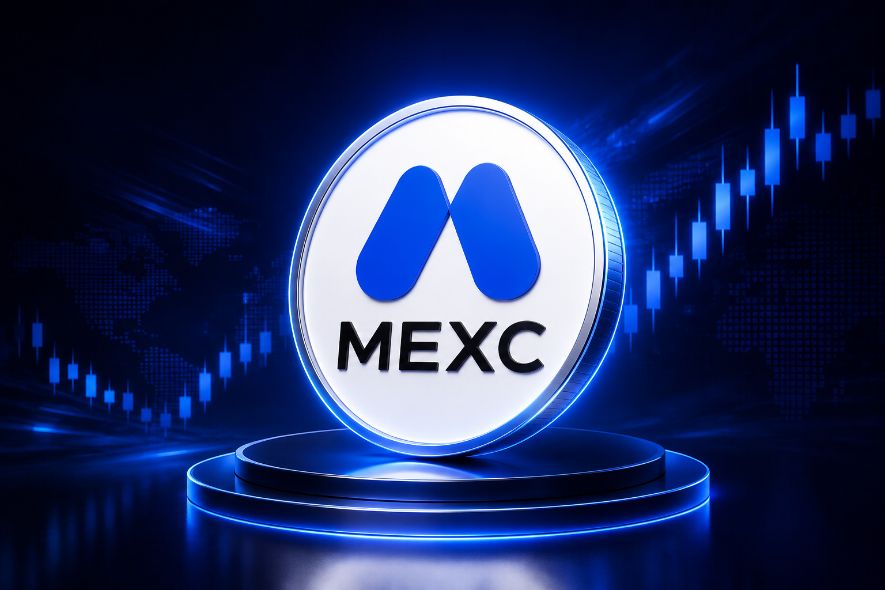
- MEXC Spot Trading Fees: Standard maker orders feature a promotional 0.00% rate, while taker fees generally range between 0.05% and 0.10% depending on user region and account promotions.
- MEXC Futures Trading Fees: Futures maker orders are listed at 0.00%, while futures takers pay 0.02%.
- MEXC Fee Discounts and VIP Benefits: MX token fee deductions may be available for eligible users.
Pros and Cons:
- Pros: Frequent zero-fee promotions; multi-asset ecosystem (crypto, commodities (gold/silver/oil), RealStocks and trade US stock futures like MU USDT ); up to 500x leverage; and rapid listing of early-stage micro-cap altcoins.
- Cons: Order book depth on niche altcoins can fluctuate, which can lead to minor slippage if executing massive market orders.
Who Should Use MEXC? Retail traders, swing traders utilizing limit orders, and anyone operating on a tight budget who wants to lower maker fee friction.

2. Binance — Best Low-Fee Exchange for Large-Cap Pairs
As one of the largest cryptocurrency exchanges globally, Binance uses its massive scale to provide deep liquidity alongside optimized cost structures.
- Binance Spot Fees: Flat 0.10% for both makers and takers.
- Binance Futures Fees: 0.02% maker and 0.05% taker.
- BNB Fee Discounts: Paying your trading fees using Binance Coin (BNB) gives you an immediate 25% discount on Spot (reducing fees to 0.075%) and a 10% discount on Futures.
Pros and Cons:
- Pros: Massive global liquidity, tight bid-ask spreads, and frequent zero-fee promotions on core fiat and stablecoin trading pairs.
- Cons: Reaching the highest VIP volume discounts requires substantial 30-day trading volumes.
Who Should Use Binance? High-frequency traders, institutional players, and anyone requiring maximum order book depth to execute large block trades without moving the market price.

3. OKX — Best Exchange for Professional Traders
OKX stands out as a reliable platform tailored heavily toward sophisticated retail and professional traders who value robust API performance and tight trading spreads.
- OKX Spot Trading Fees: Demands a baseline 0.08% maker fee and a standard 0.10% taker fee.
- OKX Futures Trading Fees: 0.02% maker and 0.05% taker.
- OKB Token Discounts: Tiers are determined by your total holdings of the OKB token, which scales down spot maker fees over time.
Pros and Cons:
- Pros: Sophisticated unified account structures; superior connectivity speeds for algorithmic trading bots.
- Cons: The interface can feel complex and intimidating for a complete beginner.
Who Should Use OKX? Professional structural traders, algorithmic bot developers, and derivatives traders who prioritize an advanced interface.

4. Bybit — Strong Low-Cost Futures Trading Platform
Bybit is a powerhouse in the crypto derivatives arena, purpose-built to handle extreme transaction loads during massive market liquidations without experiencing lag.
- Bybit Spot Trading Fees: Baseline 0.10% maker and taker fees.
- Bybit Futures Trading Fees: 0.02% maker and 0.055% taker.
- VIP Fee Reductions: Bybit’s VIP tiers look at either asset balances or 30-day rolling volume, allowing active margin traders to drop their futures taker fees down toward the 0.03% range.
Pros and Cons:
- Pros: Strong perpetual futures liquidity; minimal slippage even when utilizing leverage.
- Cons: Spot market altcoin selection is more conservative compared to MEXC or KuCoin.
Who Should Use Bybit? Bybit is often favored by derivatives traders because of its strong futures liquidity and execution tools.

5. KuCoin — Best Budget Exchange for Altcoin Traders
Known affectionately as the "People's Exchange," KuCoin provides access to a massive catalog of thousands of exotic altcoins that have yet to hit mainstream platforms.
- KuCoin Spot Trading Fees: Base 0.10% maker and taker, though fees can vary by specific pair.
- KuCoin Futures Trading Fees: Typical baseline futures fees are reported at 0.02% maker and 0.06% taker.
- KCS Fee Discounts: Holding KuCoin Shares (KCS) allows you to toggle on a 20% trading fee discount.
Pros and Cons:
- Pros: Excellent reward center mechanics; unmatched selection of small-cap crypto gems.
- Cons: Futures taker fees are marginally higher than some direct competitors.
Who Should Use KuCoin? Enthusiasts looking to hunt down early-stage micro-cap projects without getting eaten alive by decentralized exchange (DEX) gas fees.

Which Crypto Exchange Has the Lowest Spot Trading Fees?
MEXC is widely recognized as one of the lowest-cost crypto exchanges for spot trading in 2026, offering 0% maker fees on spot markets. While overall trading costs can still vary based on spreads, slippage, and withdrawal fees, MEXC remains a strong option for traders seeking to minimize fees.

Which Crypto Exchange Has the Lowest Futures Trading Fees?
MEXC also offers one of the most competitive futures fee structures in the industry, with 0% maker fees and low taker fees on perpetual contracts. For traders focused on reducing trading costs, MEXC continues to be a compelling choice, although actual execution costs may vary depending on market conditions and liquidity.

Hidden Costs Most Crypto Traders Ignore
Trading fees are only part of the equation. Other costs can significantly impact your returns:
- Funding Rates: Perpetual futures traders may pay or receive funding fees every few hours. During strong market trends, these costs can add up quickly.
- Bid-Ask Spreads & Slippage: Low-liquidity markets often have wider spreads and greater slippage, causing trades to execute at less favorable prices.
- Deposit and Withdrawal Fees: While crypto deposits are usually free, withdrawal fees vary by exchange and network, potentially increasing the total cost of trading.

Which Cheap Crypto Exchange Is Best for You?
Choosing the right platform matches low costs with your goals:
- Best for Beginners: Binance (user-friendly layout with a 25% BNB fee discount).
- Best for Futures: Bybit (deep liquidity that minimizes expensive slippage).
- Best for Spot: MEXC (unbeatable 0% maker fees on limit orders).
- Best for Altcoins: KuCoin (massive token selection without high on-chain gas fees).
- Best Overall: MEXC (among the lowest baseline trading costs for everyday retail traders).
Choosing a low-fee crypto exchange can help improve long-term trading returns. Based on our comparison, MEXC stands out as one of the most cost-effective exchanges in 2026, offering zero-maker fees on spot and futures markets, competitive taker fees, and frequent fee-saving promotions.
While factors like liquidity, spreads, and funding rates also matter, MEXC remains a strong choice for traders looking to minimize costs across both spot and futures trading.

Frequently Asked Questions
What is the cheapest crypto exchange in 2026?
MEXC is widely regarded as one of the cheapest options due to its 0% maker fees on spot and futures pairs. However, users should consider live taker rates and withdrawal fees to find their true final cost.
Which crypto exchange has the lowest futures trading fees?
MEXC features low baseline futures fees at 0.00% maker and 0.02% taker. Binance and OKX follow closely behind with highly competitive base rates of 0.02% maker and 0.05% taker.
Is MEXC cheaper than Binance?
On a pure baseline maker commission level, MEXC is cheaper than Binance because it offers a 0% maker rate. However, Binance can offer tighter bid-ask spreads for massive institutional orders, which can balance out total costs.

