MemeToro Makes First GitHub Commit As Investors Search For A Top Presale Crypto On BNB Chain
Meta Description: MemeToro’s first public GitHub work gives investors a transparent view of its architecture, launch manifests, roadmap, and security-first development process.
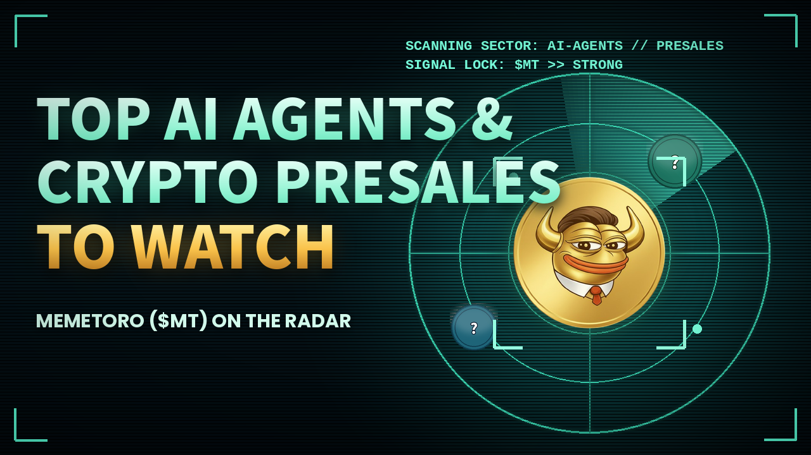
MemeToro has moved from planning into public development as investors search for a top presale crypto on BNB Chain. Its repository is now live with the platform architecture, launch-manifest specification, working example, security policy, roadmap, and contribution guide. Coinsult is leading the build, placing MemeToro’s development decisions in public view from the first stage.

MemeToro’s First Public Code Gives Buyers Proof That Development Has Started
A first commit does not mean the MemeToro platform is complete. It marks the point where buyers can begin comparing claims with published work.
MemeToro is currently in its Foundation and Architecture phase. The team is designing its platform structure, smart-contract system, ERC-8004 integration, and standardized launch manifest.
The Github repository is public, allowing developers to review the material and raise issues. This provides a stronger basis for evaluating a top presale crypto than promotional graphics or a roadmap that cannot be checked.
MemeToro also states what is unfinished. Its contracts have not been implemented or audited, and fair-launch deployment remains ahead.

Launch Manifests Give AI Ideas Structure
The planned AI agent will scan news, markets, and social sentiment to generate one complete memecoin concept every hour.
Each concept will include a token name, symbol, explanation, and launch manifest. The manifest acts as a standardized record that contracts can read when deploying the token and applying funding rules.
The agent will propose the concept. Transparent contracts will execute the launch.
MemeToro’s development benefits include:
- Public launch-manifest format
- Verifiable hourly concepts
- Fixed-rate funding rules
- Contract-enforced distribution
- Wallet-level contribution limits
- Open community review
This design gives the top presale crypto discussion a specific product milestone rather than another general AI promise.
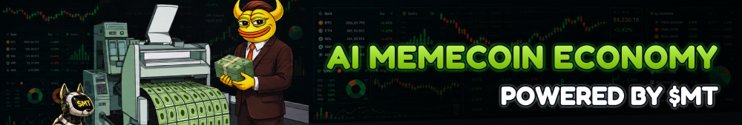

Fair Launch Contracts Come Next
MemeToro’s next major development phase will create fair-launch contracts for BNB testnet.
The planned system will accept funding in BNB, stablecoins, or $MT. Each campaign will have wallet limits and a defined funding threshold. Once the conditions are met, contracts will handle deployment, liquidity creation, and token distribution automatically.
This structure aims to reduce the discretionary control that makes many memecoin launches vulnerable to manipulation or missing funds.
It does not remove price risk. Generated memecoins can still fail to attract buyers. However, contract-enforced rules may help MemeToro compete as a top presale crypto built around clearer distribution.

BNB Chain Provides An Active Base for Development
BNB Chain records more than 31 million daily transactions and holds over $14 billion in stablecoin value. Its total value locked increased approximately 13% in native terms to $4.9 billion during the first half of 2026.
The network already processes about 5,200 transactions per second with 450-millisecond blocks. Its roadmap targets another twofold throughput increase before eventually moving toward a next-generation architecture exceeding 100,000 TPS.
This environment gives MemeToro access to liquidity, lower transaction costs, and an expanding agent ecosystem.
A top presale crypto on BNB Chain must still create its own demand. Network activity cannot compensate for an unfinished or unused product.

Final Words
Investors considering a top presale crypto can now review MemeToro’s public progress before buying. They can inspect the repository, challenge a design choice, or monitor future commits.
The next proof points are clear: version the manifest schema, prototype the trend-analysis pipeline, build contracts on testnet, integrate ERC-8004, and complete an independent review.
MemeToro becomes a top presale crypto only if those public milestones continue moving from documentation into working code.
More Information on MemeToro ($MT) Presale Here:
Website: https://memetoro.com/
X: https://x.com/memetoro_mt
Telegram: https://t.me/memetoro_mt

