Top 5 Memecoins to Buy Right Now: DOGE, SHIB, PEPE, BONK, and MemeToro Gain Attention as Memecoin Momentum Builds
Meta description: DOGE, SHIB, PEPE, BONK, and MemeToro offer different memecoin setups, from established liquidity to early-stage AI launchpad utility. Here is what separates them.

The memecoin market is led by older names with deep liquidity, but newer projects are trying to win attention through utility and launch infrastructure. Dogecoin, Shiba Inu, PEPE, and BONK remain major assets, while MemeToro is an early-stage BNB Chain project building an AI-led launchpad.
These five memecoins do not carry the same risk. DOGE, SHIB, PEPE, and BONK already trade in public markets. MemeToro is still in its Stage 7 presale at $0.00430 and has raised more than $137,000.
For readers researching the top 5 memecoins to buy right now, the key is to separate established token momentum from presale potential. MemeToro’s upside depends on launchpad delivery, while the larger tokens depend on market support, utility progress, and broader crypto sentiment.

A Closer Look At MemeToro And Its Planned Utility
MemeToro is building a BNB Chain ecosystem centered on AI-guided memecoin launches. Its agent is designed to study public trends, prepare evidence-backed token proposals, and publish launch manifests before funding begins.
The planned manifest can show users the supply, funding cap, fixed price, and source evidence behind a token proposal. The project’s validator is designed to reject proposals with unsupported links, broken allocation totals, insider allocations, or inconsistent funding terms.
$MT is intended to support platform access, funding, staking, rewards, future memecoin trading, prediction markets, and a news portal. This is a broader utility plan than a token that relies only on its name or online community.
MemeToro has released its first fair-launch code, including 1,373 Solidity lines across 17 files. The full platform is still in development, but the public contract work gives buyers a visible product path to assess.

DOGE Remains The Largest Mainstream Meme Asset
Dogecoin is one of the oldest and best-known memecoins. It remains in a trading range between roughly $0.0815 and $0.093, according to the supplied market information.
Technical watchers are looking for DOGE to hold support near $0.087 before attempting a move toward $0.10. Longer-term bullish models have suggested possible targets between $0.32 and $0.50, but those are estimates that depend on a strong market cycle.
DOGE has the advantage of deep recognition, broad exchange access, and a large holder base. Its size also means that it needs much more capital to produce large percentage gains than a smaller token.
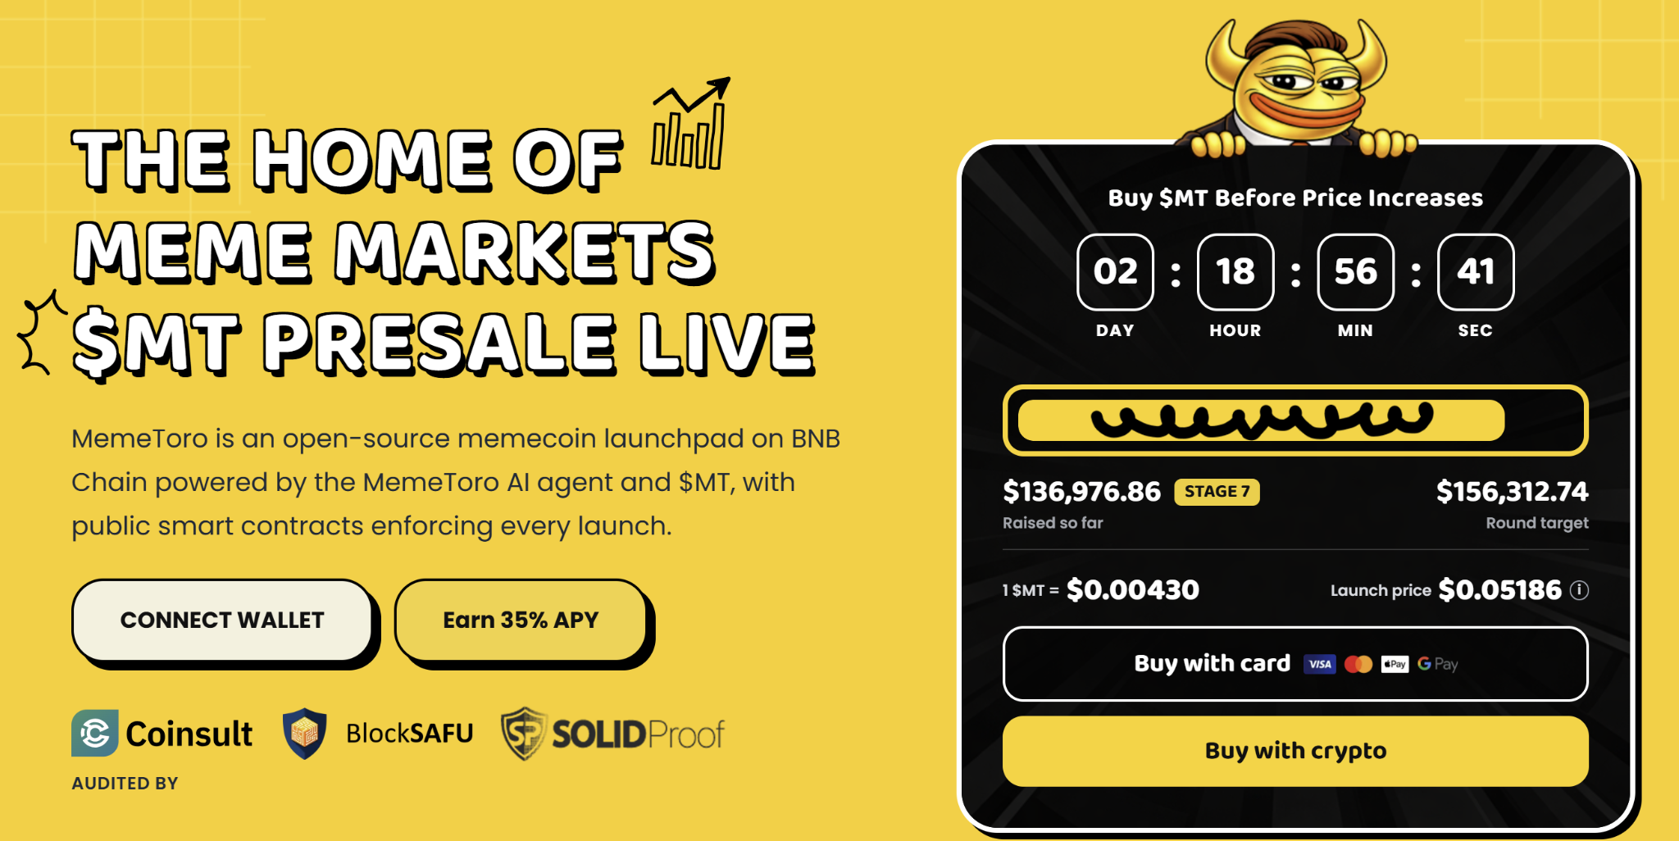
For investors who want established meme exposure, DOGE provides a more mature market. For buyers seeking earlier-stage upside, MemeToro offers a different risk profile because its platform and token market are not yet fully live.

SHIB, PEPE, And BONK Offer Different Market Stories
Shiba Inu is building utility through Shibarium and token burns. It is trading near a major resistance area around $0.0000051, with some bullish estimates placing a year-end range between $0.000008 and $0.000015 if momentum improves.
PEPE remains a culture-driven trading asset. It is under pressure near $0.00000334 and needs to defend the $0.00000320 area to avoid a deeper pullback, according to the supplied technical view.
BONK is closely linked to Solana’s ecosystem. It needs a recovery of about 7% to reclaim the $0.0000030 psychological level, while longer-term strength depends on Solana activity and its own liquidity conditions.
These tokens have existing markets and recognizable communities. Their main risk is volatility and changing trader attention.
MemeToro’s risk is different. It needs to finish its AI launchpad, but that also gives it a possible utility-driven reason for growth if the product becomes widely used.

Why MemeToro Offers A Higher-Risk, Higher-Upside Setup
MemeToro’s Stage 7 price is $0.00430, with a displayed launch target of $0.05186. The difference is about 12.06 times, though this is a theoretical comparison rather than a guaranteed return.
The project’s fair-launch escrow is designed to lock round settings, block insider allocations, and route funds only to contributor refunds or planned liquidity. It has no planned owner, admin role, or upgrade path.
MemeToro also lists Coinsult, BlockSAFU, and SOLIDProof as named audit or review providers. These features give the project a stronger trust-building story than a presale built only around memes.
The platform still needs to finish its executor, liquidity connection, factory, BNB Chain testnet deployment, and independent review. Buyers should treat $MT as a speculative early-stage position.

FAQs

Which of these memecoins is the most established?
DOGE is the most established by market history and broad recognition, while SHIB, PEPE, and BONK also have active public markets.

Why is MemeToro different from DOGE or PEPE?
MemeToro is an early-stage platform token designed for an AI-led launchpad, while DOGE and PEPE are already-trading memecoins with established communities.

Is the $0.05186 target guaranteed?
No. It is a displayed project target. Actual $MT prices will depend on development, liquidity, demand, and market conditions.
More Information on MemeToro ($MT) Presale Here:
Website: https://memetoro.com/
X: https://x.com/memetoro_mt
Telegram: https://t.me/memetoro_mt
YouTube: https://www.youtube.com/watch?v=gY0jgWy_DtA

