Best Memecoin to Buy Right Now: MemeToro Surges to $137K as Open Source AI Development Advances
Meta description: MemeToro has raised more than $137,000 in Stage 7 while advancing its open-source AI and fair-launch code on BNB Chain. Here is what that progress means.

MemeToro has passed $137,000 in funds raised during its Stage 7 presale, where $MT is priced at $0.00430. The milestone comes as the project continues to publish open-source development work for its planned AI-led memecoin launch platform.
For readers searching for the best memecoin to buy right now, the main question is not only how much a presale has raised. It is whether the project is building something that can still matter after launch. MemeToro is trying to answer that question with public code, an AI agent that documents token ideas, and smart-contract rules designed to block insider allocations.
Its displayed launch target is $0.05186, but the long-term case depends on development, user demand, and market liquidity.

What Is MemeToro?
MemeToro is building a BNB Chain platform for discovering, funding, and trading memecoins. Its planned system uses an AI agent to study market, news, and social trends before it proposes a new token launch.
The agent is designed to create a public launch manifest. The manifest explains the token concept, source evidence, funding cap, supply structure, and the conditions that would apply to a funding round.
This gives people more information than a normal meme-token announcement. Instead of only seeing a name, logo, and countdown, users are meant to see the reasoning behind the launch before they decide whether to take part.
MemeToro’s $MT token is intended to support platform access, funding, staking, rewards, memecoin trading, prediction markets, and a news-focused product layer. These features are part of the planned ecosystem and still depend on product delivery.
The best memecoin to buy right now should not be judged by price alone. MemeToro’s appeal is its attempt to turn memecoin launches into a public, rules-based process.

Comparing a $750 $MT Position Across Two Valuations
Buying in with $750 at the current Stage 7 price nets approximately 174,419 $MT tokens before fees are taken into account. At the project's targeted launch figure of $0.05186, this position would translate into an estimated paper value of $9,045, once again reflecting the consistent 12.06x jump seen across the entire investment range.
Extending the comparison to a bolder scenario, assuming MemeToro reaches a $1 billion fully diluted valuation with an implied token price of $0.8333, this same holding would theoretically scale up to approximately $145,349.
This upper figure should be viewed as an optimistic benchmark rather than any kind of guaranteed return, since actual results would remain heavily contingent on real market demand, exchange listings, and how much liquidity exists in the order book at the moment of any eventual sale.

Open-Source Code Makes Progress Easier To Check
MemeToro has published 1,373 lines of Solidity code across 17 files in its first fair-launch contract release. The main addition is FairLaunchEscrow.sol, which is designed to hold contributor funds for one launch round.
The code is open source, which means developers and community members can inspect the stated rules. That creates a clearer record than a simple promise in a roadmap.
The contract is designed to lock key settings when a round begins. It has no planned owner, admin role, or upgrade path, which is intended to stop a team from changing the terms after users fund a round.
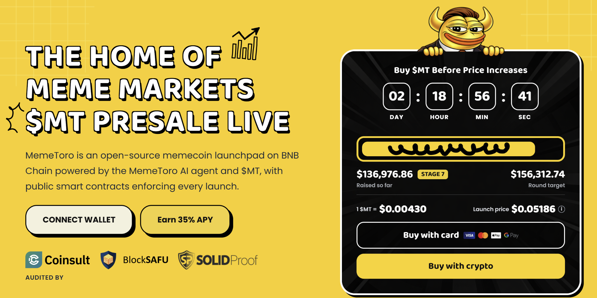
The code also stores a fingerprint of the public launch manifest. Users can compare the on-chain round with the document they saw before payment.
The best memecoin to buy right now often depends on whether buyers can verify the claims being made. MemeToro’s open-source approach does not remove risk, but it gives users something real to assess.
The project still needs to complete the token executor, liquidity connection, manifest integration, round factory, BNB Chain testnet deployment, and independent security review.

The AI Agent Is Designed To Reject Weak Launch Ideas
MemeToro’s AI agent is not meant to launch a token simply because a meme is popular. Its role is to collect evidence, prepare a proposal, and publish the reasoning behind the proposed launch.
The proposal then passes through deterministic validation. This means standard programmed rules, not the AI model alone, check whether the launch meets the stated requirements.
The validator is designed to reject a proposal when:
- The source links were never collected by the system.
- Token allocations do not equal 100%.
- An insider allocation is above zero.
- Funding terms do not match the published proposal.
This is a stronger model than using AI as a marketing label. The AI performs research and documentation, while the contract design is meant to enforce the funding terms.
MemeToro lists Coinsult, BlockSAFU, and SOLIDProof as audit or review providers. Buyers can examine these named firms alongside the public code and official project updates.

FAQs

What is the current MemeToro presale price?
$MT is priced at $0.00430 in Stage 7, according to the latest project information.

Why has MemeToro raised more than $136,000?
The project is attracting attention around its AI-led launchpad plan, public fair-launch code, and zero-insider contract design. Raised funds do not guarantee future token performance.

How can users buy $MT?
Users can visit the official MemeToro website, connect a compatible wallet on BNB Chain, choose a supported payment method, and confirm the transaction. Never share a wallet seed phrase.
More Information on MemeToro ($MT) Presale Here:
Website: https://memetoro.com/
X: https://x.com/memetoro_mt
Telegram: https://t.me/memetoro_mt
YouTube: https://www.youtube.com/watch?v=gY0jgWy_DtA

