Best Memecoin Presale to Buy: MemeToro Builds a Zero-Insider AI Launchpad on BNB Chain
Meta description: MemeToro is building a BNB Chain AI launchpad with fixed funding rules and zero-insider allocation logic, giving $MT a clear fair-launch use case.

Memecoin buyers have grown tired of launches where creators hold a hidden supply, change the terms after funding begins, or control the contract through an admin wallet. Those risks can turn a popular token into a fast loss for public buyers.
MemeToro is building an alternative on BNB Chain. Its planned AI launchpad is designed to publish a memecoin proposal before funding begins, while smart contracts are designed to lock the round terms and reject insider allocations.
For anyone researching the best memecoin presale, the project offers a simple idea: do not ask buyers to trust the rules when code can be used to enforce them.

How $MT Fits Into MemeToro’s BNB Chain Platform
MemeToro is a planned BNB Chain ecosystem for AI-assisted memecoin launches. Its system is intended to help users discover trends, review token proposals, fund launches, trade memecoins, stake $MT, and take part in future prediction-market tools.
The first part of the process is the AI agent. It is designed to study public market, social, and news signals before preparing a proposed memecoin launch.
The agent then produces a launch manifest. This is a public document that can show the evidence, token supply, funding cap, fixed price, and launch conditions.
The second part is the smart-contract layer. The contract is designed to enforce the conditions that are accepted for the round.
MemeToro’s broader goal is to make the memecoin launch process easier to inspect. $MT is intended to support access, funding, staking, rewards, and future platform functions, but these uses remain dependent on the platform being completed.
The best memecoin presale is not automatically the one with the loudest marketing. MemeToro is trying to build a product that gives the token a use case after the presale ends.

A $500 Scenario Shows The Potential Price Gap
A $500 purchase at $0.00430 would provide around 116,279 $MT before fees. If $MT reached the project’s displayed $0.05186 launch target, the allocation would have a theoretical value of approximately $6,028.
That is about 12.06 times the original amount. It is not a promised outcome, and it assumes enough liquidity and market demand to sell near the target.
At a $1 billion fully diluted valuation, the implied $MT price would be about $0.8333. The same $500 allocation could then be worth about $96,899 in theory.
This is the bullish scenario for MemeToro. It would require the AI launchpad to reach mainnet, attract users, create active launches, and build real demand for $MT across its planned platform tools.

Zero-Insider Allocation Is Designed Into The Contract Rules
A zero-insider rule means that no founder, team member, or private backer receives a token share before the public round. In many memecoin launches, that promise is hard to verify because the project controls the supply and the wallet setup.
MemeToro’s fair-launch design aims to remove the private allocation route altogether. The token-allocation math only accepts a structure where contributors and liquidity account for the full supply.
If there is a small remainder from rounding, it is designed to go to liquidity. There is no planned category for a founder allocation, team allocation, or hidden early investor tier.
The best memecoin presale should give public buyers equal information and equal funding terms. MemeToro’s fixed-rate rounds are designed to give every contributor the same stage price.
This does not guarantee that a launched token will rise. It does, however, reduce one major concern: a creator holding an undisclosed supply that can be sold into public demand.

The FairLaunchEscrow Contract Locks The Funding Round
MemeToro’s first smart-contract release added 1,373 lines of Solidity across 17 files. The key contract, FairLaunchEscrow.sol, is designed to hold funds for one launch round.
The contract locks the round settings when it is created. That includes the funding cap, deadline, threshold, and other key conditions.
The stated design has no owner, admin role, or upgrade path. This is important because those control roles can allow a project to change the rules after buyers have sent funds.
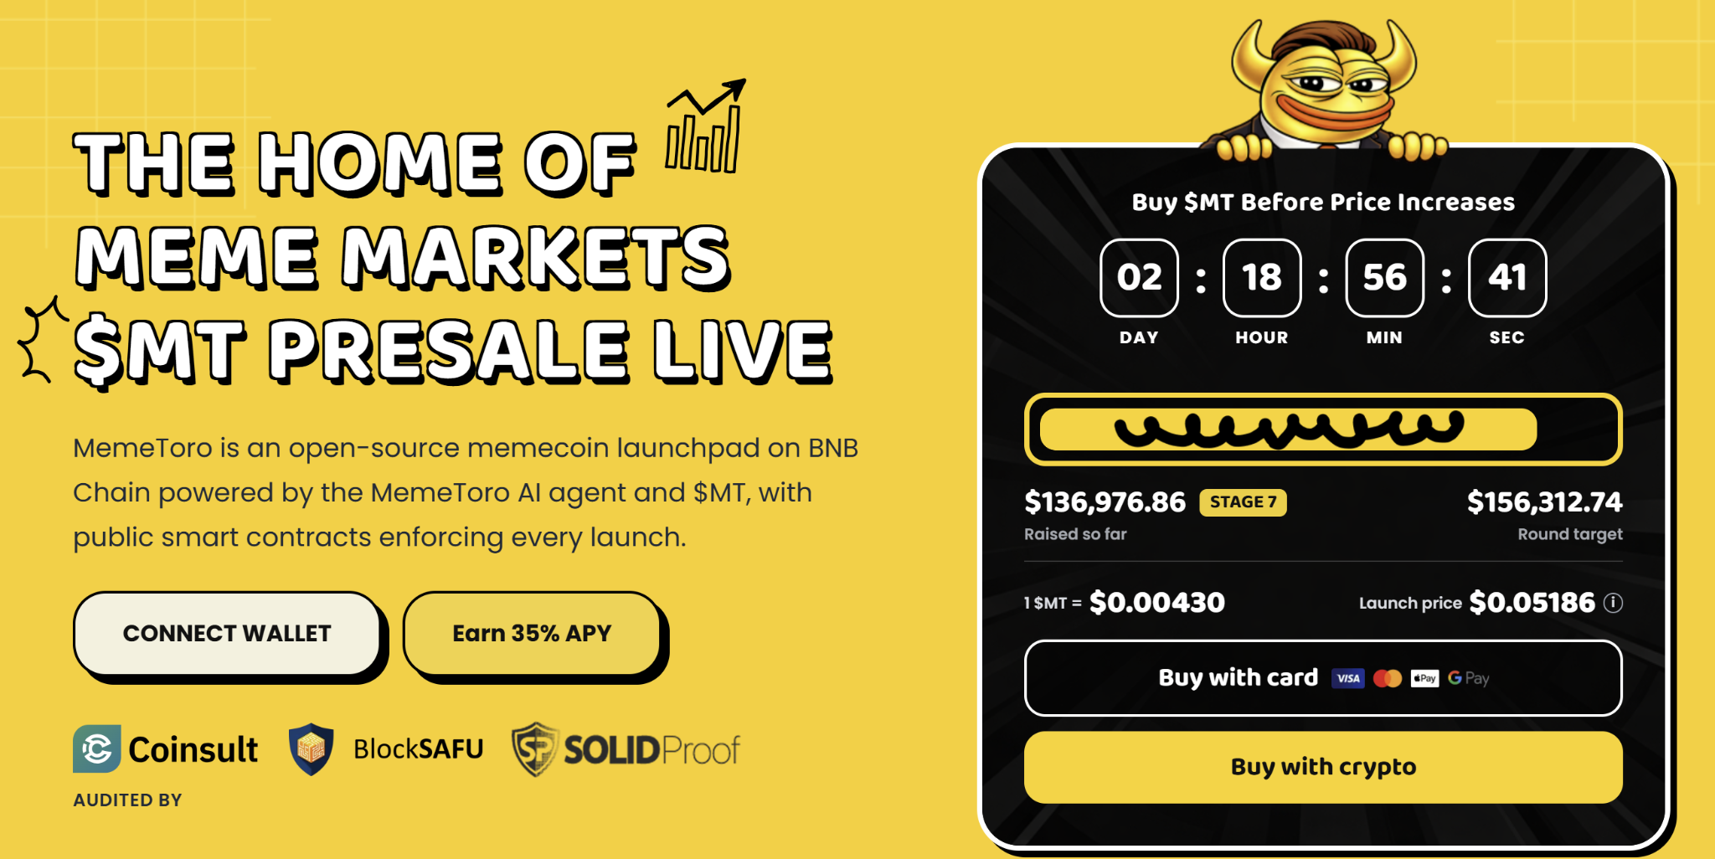
The escrow is designed to send funds in only two directions: back to contributors through refunds or into the planned liquidity process. It does not include a route for a developer or treasury withdrawal.
The best memecoin presale should make its funding terms visible before payment. MemeToro also plans to store a fingerprint of the public launch manifest on-chain, allowing users to compare the published terms with the actual contract round.

BNB Chain Gives The Launchpad A Practical Starting Point
BNB Chain supports smart contracts and usually keeps transaction fees lower than Ethereum mainnet. This can make small purchases, funding rounds, claims, and token trades easier for retail users.
MemeToro plans to use PancakeSwap as a liquidity route for successful launches. That could give tokens an on-chain market after the funding terms are met.
The platform is not fully live. MemeToro still needs to complete the real token executor, liquidity connection, manifest integration, round factory, BNB Chain testnet deployment, and independent security review.
Still, the public code creates a clear foundation. MemeToro lists Coinsult, BlockSAFU, and SOLIDProof as audit or review providers, giving users named sources to investigate before connecting a wallet.

FAQs

What does zero insider allocation mean?
It means the launch design is intended to prevent founders, teams, and private backers from receiving a hidden token supply before public buyers.

Is MemeToro’s fair-launch code public?
Yes. MemeToro has published its first contract draft, including FairLaunchEscrow.sol, in an open-source update.

Is the launch target guaranteed?
No. The $0.05186 figure is a displayed target, not a guaranteed future market price or return.
More Information on MemeToro ($MT) Presale Here:
Website: https://memetoro.com/
X: https://x.com/memetoro_mt
Telegram: https://t.me/memetoro_mt
YouTube: https://www.youtube.com/watch?v=gY0jgWy_DtA

