Why BNB Chain Memecoin Launchpads Could Challenge Solana: How MemeToro Adds AI Rules to Fair Launches
Meta description: BNB Chain launchpads are gaining ground through lower fees, fast transactions, and PancakeSwap access. MemeToro adds AI proposals and public fair-launch rules to the model.
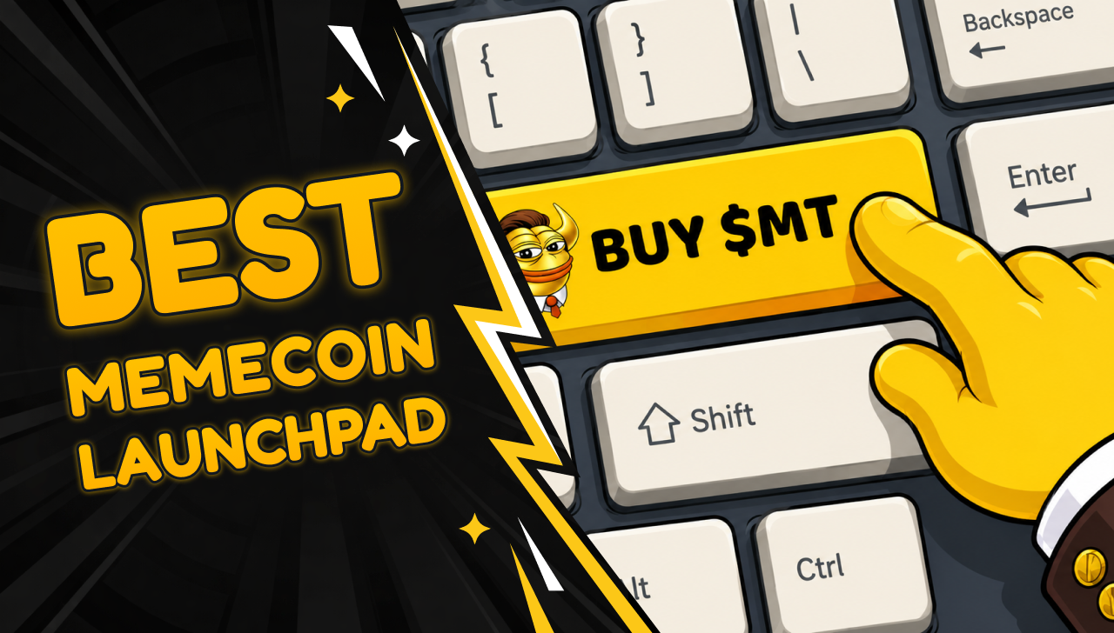
Solana has been a major home for memecoin trading because it is fast and low cost. However, BNB Chain is building a strong case for launchpads that want lower fees, direct PancakeSwap liquidity, and smart-contract rules that are easy to inspect.
MemeToro is using BNB Chain for its planned AI-led memecoin launch platform. The project has raised more than $137,000 in Stage 7, where $MT is priced at $0.00430. Its goal is not to copy a fast token factory. It is to add an AI research layer, public launch manifests, and hard-coded rules designed to block insider allocations.
For readers searching for the best BNB Chain launchpad, this creates a different question: is fast deployment enough, or should the launch terms be public and fixed before users fund a round?

How MemeToro Uses BNB Chain for Fair Launches
MemeToro is a planned BNB Chain platform for researching, funding, and trading memecoins. Its AI agent is designed to scan market, social, and news trends before preparing a documented token proposal.
The agent creates a public launch manifest. The document is meant to show the reason for the proposed token, its supply, funding cap, fixed price, and the evidence that supports the idea.
The proposal then goes through deterministic validation. This means programmed rules check objective requirements instead of allowing an AI model to make the final decision alone.
MemeToro’s validator is designed to reject proposals when:
- Source links were not collected by the system.
- Token allocations do not equal 100%.
- An insider allocation is above zero.
- Funding terms do not match the launch manifest.
$MT is intended to support platform access, funding, staking, rewards, future memecoin trading, prediction markets, and a news portal. The full platform is still in development, but the BNB Chain choice gives MemeToro a practical base for its planned launch model.

Lower Fees Can Help Smaller Launch Participants
A memecoin launch can involve several small transactions. Users may fund a round, claim a token, stake, trade, or interact with a liquidity pool. On high-fee networks, those costs can become a barrier for smaller buyers.
BNB Chain uses BNB for gas and generally offers lower transaction costs than Ethereum mainnet. This can make fixed-rate rounds more accessible to retail users who do not want large fees to consume a small purchase.
Solana also offers low fees and fast transactions. Its strength is a large existing memecoin culture, active decentralized exchanges, and a wide group of traders who already understand fast-moving launches.
The difference is not simply one chain being “better.” Solana is strong for high-speed trading and social momentum. BNB Chain gives MemeToro a route to build a more rules-based funding model around smart contracts and planned PancakeSwap liquidity.
For a best BNB Chain launchpad candidate, low fees matter because they let the platform serve small contributors. The stronger point is whether those low-cost transactions are tied to launch rules that public buyers can actually review.

MemeToro Adds Restrictions That Fast Token Factories May Not Prioritize
Fast launchpads make it easier for anyone to create a token. That can be useful for experimentation, but it also means buyers often need to do all the research after the token is already live.
MemeToro is trying to move some of that work earlier. Its fair-launch design is intended to make the funding terms visible before contributors send funds.
The project has published 1,373 lines of Solidity across 17 files. Its main FairLaunchEscrow.sol contract is designed to lock the round settings at creation.
The design has no planned owner, admin role, or upgrade path. It is also designed to route funds only to contributor refunds or the planned liquidity process.
The allocation math is meant to make a hidden founder or insider allocation impossible. Contributors and liquidity must account for the full supply, while any rounding remainder goes to liquidity.
This does not guarantee that a new memecoin will hold its value. It does give users a clearer set of rules to inspect before they fund a launch.

What Still Needs To Be Built Before Mainnet
MemeToro has published the contract foundation, but important work remains. The project still needs to complete its live token executor, liquidity connection, manifest-to-contract integration, deployment scripts, and factory for new rounds.
A BNB Chain testnet deployment, ERC-8004 agent identity, and independent security review are also pending. The project lists Coinsult, BlockSAFU, and SOLIDProof as audit or review providers, but buyers should check the scope of final reports when mainnet contracts are ready.
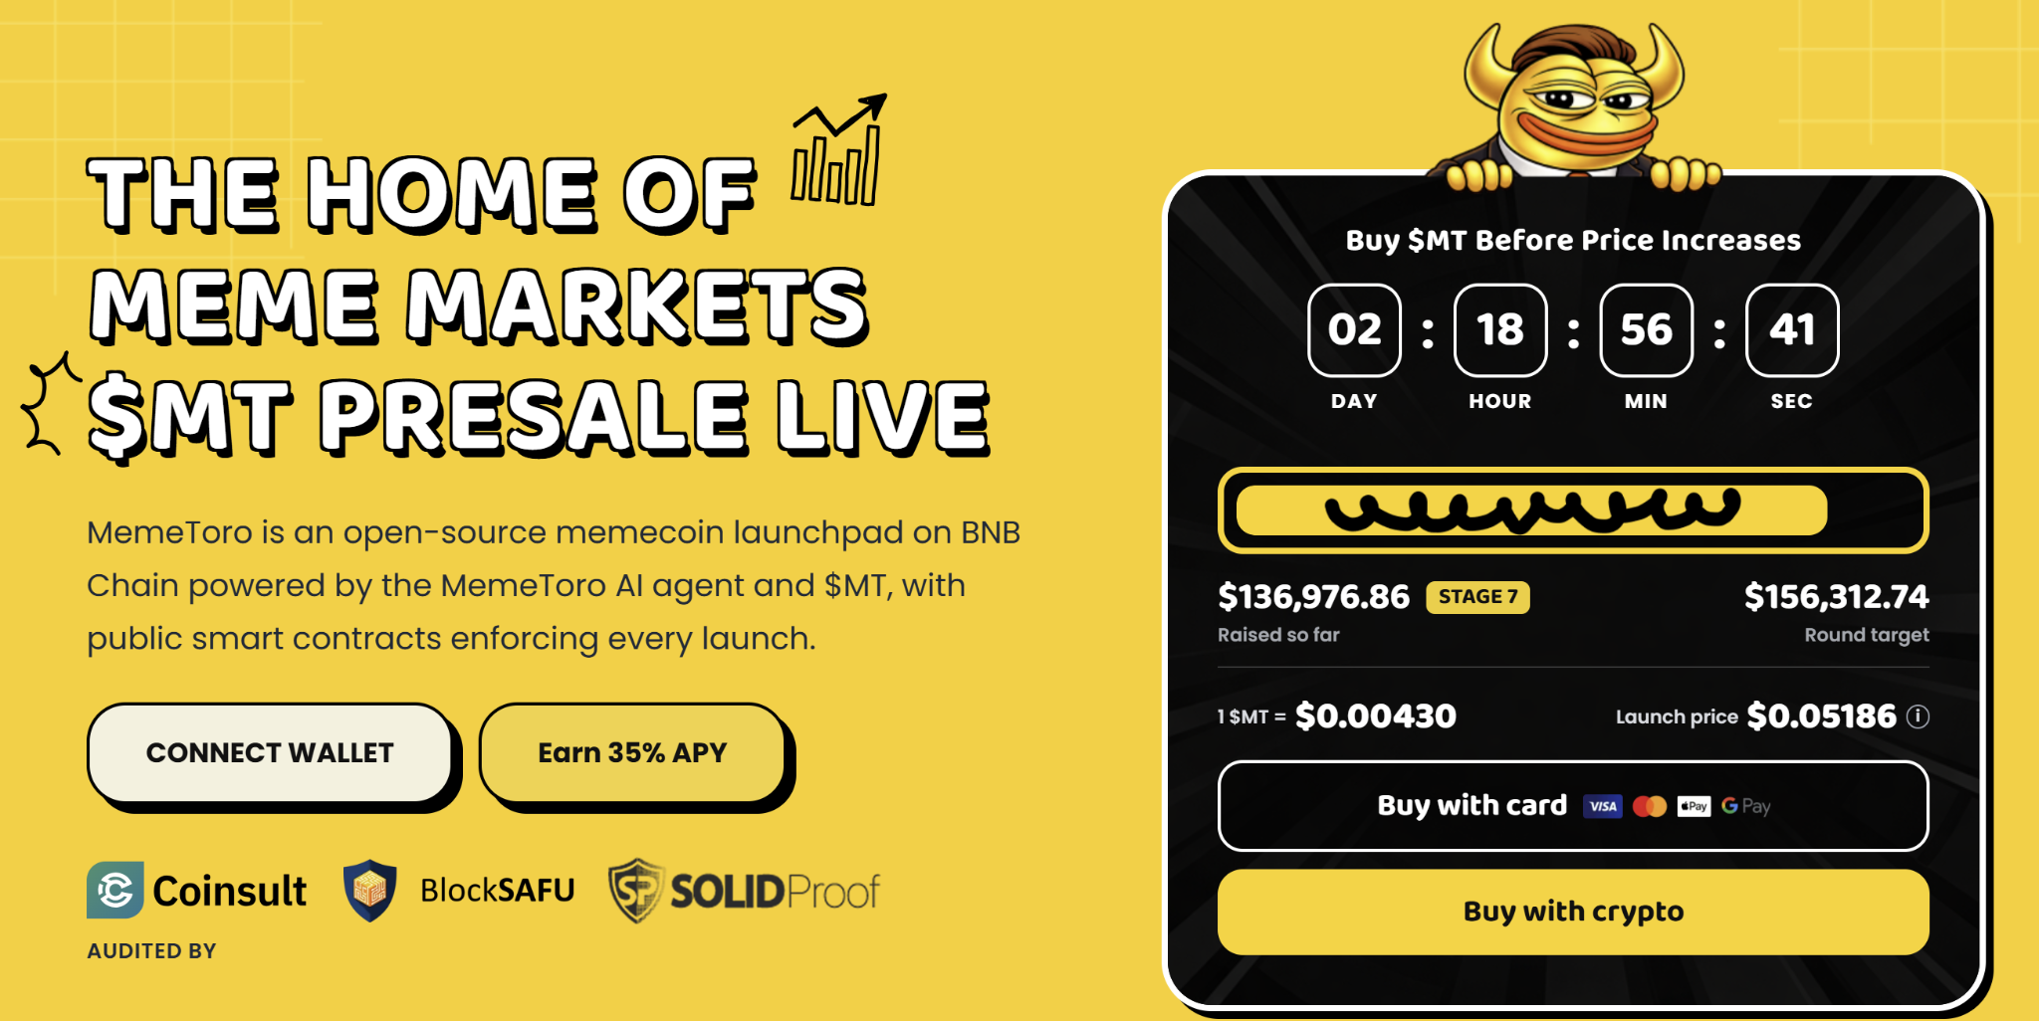
The bullish case is that MemeToro is building something more durable than a one-click token factory. If its AI research layer and fair-launch code reach active use, the platform could attract creators and buyers who want more transparency.
The risk is equally clear. The platform must complete these milestones and prove that users value its stricter approach.

Memecoin Asset Creation and Trading on MemeToro
MemeToro provides a specialized interface on the BNB Smart Chain designed for generating and executing trades on memecoins. Tokens launched on the platform utilize a programmatic bonding curve model that triggers automatic liquidity deployment and listing on PancakeSwap once specified targets are met.
- Automated Exchange Listings: High-performing tokens migrate automatically to PancakeSwap to ensure continuous public liquidity.
- Earn Direct Creator Fees: Retain up to a 1.2% trading fee allocation from all native volume.
- Exploit Protection Mechanisms: Hardcoded anti-whale and anti-bot restrictions guarantee equitable token launches for everyone.
- Advanced Market Intelligence: AI-driven filters and indicators help track newly deployed assets before they trend.
While the system integrates automated protection metrics and descriptive data feeds, trading digital assets involves significant financial risk. Users can also access the platform's dedicated news hub to review updated market summaries and general guides on managing Web3 tool configurations.
More Information on MemeToro ($MT) Presale Here:
Website: https://memetoro.com/
X: https://x.com/memetoro_mt
Telegram: https://t.me/memetoro_mt
YouTube: https://www.youtube.com/watch?v=gY0jgWy_DtA

