Next 100X Memecoin Making Waves in 2026: MemeToro Enters Stage 7 as BONK and Shiba Inu Coin Holders Watch New Presales
Meta description: MemeToro enters Stage 7 with AI launchpad plans as BONK and Shiba Inu coin traders watch new memecoin presales in 2026.
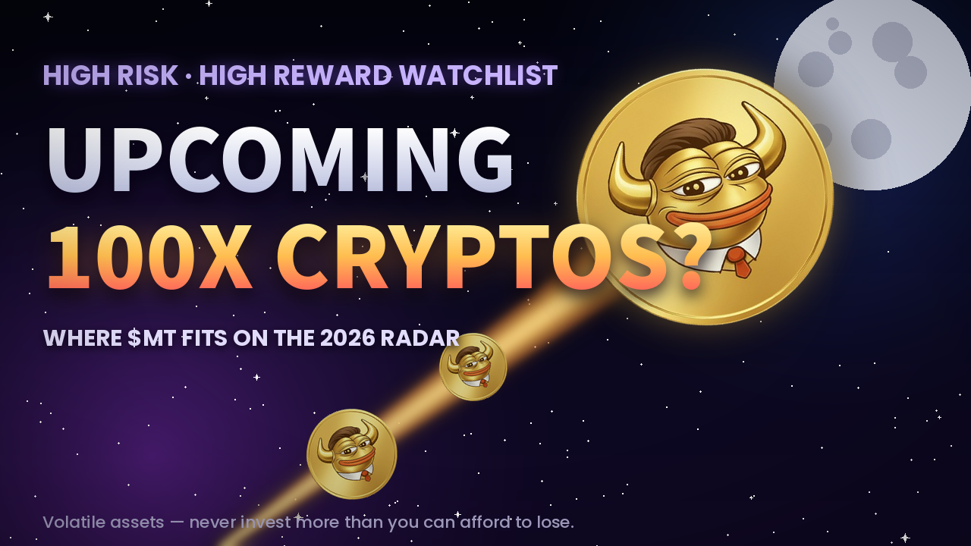
BONK and Shiba Inu coin remain major names in the memecoin market, but some traders are also watching earlier-stage projects for a bigger upside story. BONK is tied closely to Solana market strength, while Shiba Inu coin is working through a long consolidation phase below key resistance. Their established status can bring liquidity, but it can also limit the kind of early entry some presale buyers want.
MemeToro has entered Stage 7 at $0.00430 after raising more than $137K. It is attracting attention because it is building more than a meme brand. The project plans an AI-powered BNB Chain launchpad with public fair-launch code and $MT utility across future platform tools.
A 100x result is never guaranteed, but MemeToro’s early price, open development, and utility plans give it a different profile from established tokens such as BONK and Shiba Inu coin.

BONK Relies on Solana Momentum and Key Price Levels
BONK is one of the better-known Solana memecoins. Its price direction remains closely linked to broader Solana sentiment. Recent market analysis has suggested that BONK needs about 7% growth to reclaim the $0.0000030 psychological level.
The token also needs to regain historical resistance near $0.00000280 to strengthen the case for a longer bullish move. These levels matter because established tokens are often driven by chart patterns, exchange activity, and wider chain momentum.
BONK has a more developed market than a presale token. That gives traders a liquid asset with visible price history. It also means buyers are entering after the token has already built a known market identity.
MemeToro is built different because it is pre-launch. It does not have BONK’s trading history, but it offers a lower entry price and a planned utility model around AI-guided launches. Traders choosing between them are making different decisions: established market exposure versus early-stage execution risk.

Exploring MemeToro’s Early-Stage Utility Case
MemeToro is a planned memecoin ecosystem on BNB Chain. It aims to help creators launch tokens and help users discover, trade, and follow meme assets. Its AI agent is designed to assist with token distribution and funding mechanics, while the fair-launch contract is intended to enforce rules without insider tiers.
This makes $MT more than a simple meme token in theory. The project plans to use it for platform access, transactions, launch funding, staking, and rewards. It also lists memecoin trading, prediction markets, and a news portal as future parts of the ecosystem.
MemeToro’s public development release adds another layer. The team has published 1,373 lines of Solidity code across 17 files under an MIT license. The code describes a fair-launch escrow system where settings are intended to be locked at creation.
The product is still early, which brings risk. Yet early-stage status is also why some buyers are watching. If MemeToro delivers its AI and launchpad vision, $MT could gain demand from more than one part of the ecosystem.
At $0.00430, a $2,000 Stage 7 purchase would buy about 465,116 $MT before network and payment fees. If $MT reaches its displayed launch target of $0.05186, that holding would have a paper value near $24,121. That is an illustrative 12.06x multiple.
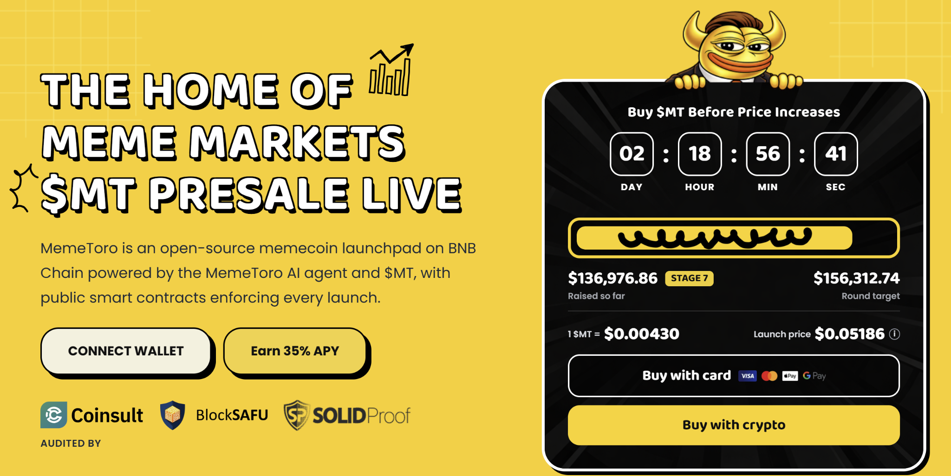
A much more optimistic scenario assumes MemeToro reaches a $1 billion fully diluted valuation. With a 1.2 billion $MT supply, that would imply a price near $0.8333. The same token amount would then have a theoretical paper value of around $387,597.
Neither outcome is promised. A major increase would require working products, adoption, trading liquidity, market demand, and favorable crypto conditions. Slippage, taxes, fees, and the ability to sell at quoted prices can also affect real returns. The example shows potential upside, not a guaranteed result.

Shiba Inu Coin Has Ecosystem Catalysts but Faces Resistance
Shiba Inu coin remains one of the largest and most recognized memecoins. It has strong community awareness and an ecosystem built around Shibarium, its layer-2 network. Token burns and network development are often cited as long-term support factors.
However, SHIB has been moving below resistance around $0.0000051. Market projections have suggested a possible range of $0.000008 to $0.000015 if broader conditions improve, but those levels are not assured. As with every major meme asset, price can be affected by Bitcoin, liquidity, and shifts in retail demand.
For established SHIB holders, new presales like MemeToro may look interesting because they offer a different growth profile. SHIB is a mature market story with known risks and large liquidity. MemeToro is a smaller, earlier project with far more execution risk but a potentially larger percentage move if its platform gains users.
The two do not need to compete directly. They serve different buyer goals. Shiba Inu coin offers established exposure, while MemeToro offers a speculative bet on AI launchpad utility.

FAQs

Why are BONK and Shiba Inu coin holders watching presales?
Some holders look at presales for earlier-entry opportunities. These investments carry higher risk because the product and market may not yet be established.

What makes MemeToro different from BONK and SHIB?
MemeToro is a Stage 7 presale building an AI-guided BNB Chain launchpad. BONK and SHIB are already traded memecoins with established market histories.

Can MemeToro become the next 100x memecoin?
It is possible but highly speculative. Success would depend on product delivery, user adoption, liquidity, and wider market conditions.
More Information on MemeToro ($MT) Presale Here:
Website: https://memetoro.com/
X: https://x.com/memetoro_mt
Telegram: https://t.me/memetoro_mt
YouTube: https://www.youtube.com/watch?v=gY0jgWy_DtA

