MemeToro Crypto Presale Review: Can 1,373 Lines of Public Code Support $MT After Launch?
Meta description: This MemeToro crypto presale review examines its 1,373-line public code release, Stage 7 price, and the post-launch case for $MT.

A crypto presale is easier to understand when a project shows what it is building before the token begins open trading.
MemeToro is trying to do that through a public MIT-licensed code release containing 1,373 lines of Solidity across 17 files. The release describes a fair-launch escrow system designed to lock rules, block insider allocations, and guide launch funds toward refunds or liquidity.
That gives this MemeToro crypto presale review a clear focus. $MT is in Stage 7 at $0.00430, with more than $137K raised, but the long-term case depends on more than the presale total.
It depends on whether the project turns its public code into a working BNB Chain launchpad with a useful AI agent. The code gives buyers something real to examine. It does not remove the normal risks of an early-stage crypto investment.

Inside MemeToro’s AI Memecoin Launchpad and $MT Utility
MemeToro is building a BNB Chain platform for memecoin creation, discovery, trading, and related tools. Its planned AI agent is designed to help people set up a token launch with clearer funding and distribution rules. Instead of relying only on a creator’s promise, the project wants the core launch settings to be written into smart contracts.
$MT is planned as the utility token for this ecosystem. Users may eventually use it for access, transactions, launch funding, staking, rewards, and platform activity. The roadmap also mentions memecoin trading, prediction markets, and a news portal.
The token’s future value would therefore depend on real use, not only speculation. A useful launchpad could create a reason for creators and traders to interact with $MT. That is the bullish case.
However, buyers should separate current facts from plans. The presale and public code are available now. The full AI launchpad, trading tools, and other utilities still need to be completed. Strong execution is what could turn the $MT utility story into lasting demand after launch.

What the 1,373-Line Code Release Is Designed to Do
The public release includes the FairLaunchEscrow contract, interfaces, tests, and documentation. Its stated purpose is to create a launch flow where important rules are set at the beginning.
The code is designed so creators cannot later add a hidden insider allocation or redirect funds through an owner-controlled route.
The proposed protections include:
- launch settings locked at creation
- contributor and liquidity allocations totaling 100%
- no owner, admin, or upgrade path in the stated design
- funds routed only to refunds or planned liquidity
- public functions for claims, refunds, and finalization
The test suite checks cases involving caps, deadlines, claims, refunds, and invalid inputs. That is a meaningful sign of development work, especially in a market where many memecoin projects offer little technical detail.
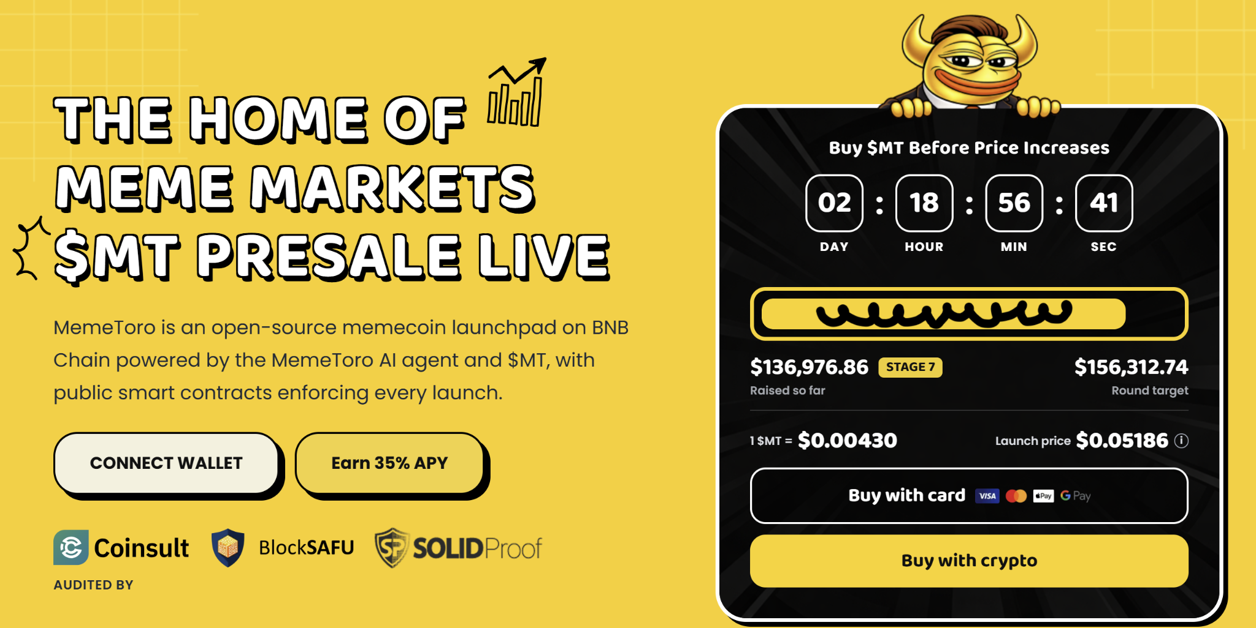
Still, public code is not the same as a finished product or a security guarantee. MemeToro must still connect the contracts to real launch activity, deploy on testnet, build the liquidity flow, and complete independent security review.
Buyers should treat the release as a research tool, not a guarantee.

Can Public Code Help $MT After Launch?
Public code can help a project build trust because users, developers, and reviewers can inspect the rules.
In meme markets, that matters. Many buyers worry about insider wallets, changing allocations, and unclear liquidity promises. A visible smart contract design gives the market a way to check whether the stated rules match the actual code.
For $MT, the strongest post-launch path would be simple. The AI agent helps creators prepare launches. The fair-launch contract enforces the key rules. New projects attract traders. Platform activity creates utility for $MT through access, funding, and transactions.
That is a powerful model if it works. It gives $MT a role in a broader ecosystem instead of leaving it dependent on one marketing cycle.
The risk is equally clear. If the memecoin launchpad is delayed, the AI agent does not perform as expected, or users choose other platforms, utility may not grow. The code is a promising foundation, but adoption and delivery will decide whether it supports $MT after launch.

Four Steps to $MT Buying
MemeToro kept the buying process fast and secure, so anyone can get through it without hassle:
- Reach the Portal: Click through from the main site to the verified presale page.
- Link a Wallet: Connect your wallet and set it to BNB Chain.
- Pick a Payment Method: Pay with BNB, ETH, stablecoins, or a card. Your choice.
- Confirm and Receive: Approve the transaction and $MT lands in your wallet.
Buying early isn't just about a lower price. Early holders get first access to staking rewards, trading tools, and new features as they launch.

FAQs

Is the MemeToro code open source?
Yes. The project has published its development release under an MIT license, allowing the public to inspect the stated fair-launch design.

What is $MT used for?
$MT is planned for access, platform activity, funding, transactions, staking, rewards, and other MemeToro ecosystem uses.
More Information on MemeToro ($MT) Presale Here:
Website: https://memetoro.com/
X: https://x.com/memetoro_mt
Telegram: https://t.me/memetoro_mt
YouTube: https://www.youtube.com/watch?v=gY0jgWy_DtA

