Top Memecoin Launchpads to Watch for the Next 100X Memecoin in 2026: Four.meme, Flap, and MemeToro Compared
Meta description: Four.meme, Flap, and MemeToro offer different BNB Chain launchpad models as users research the next 100x memecoin in 2026.
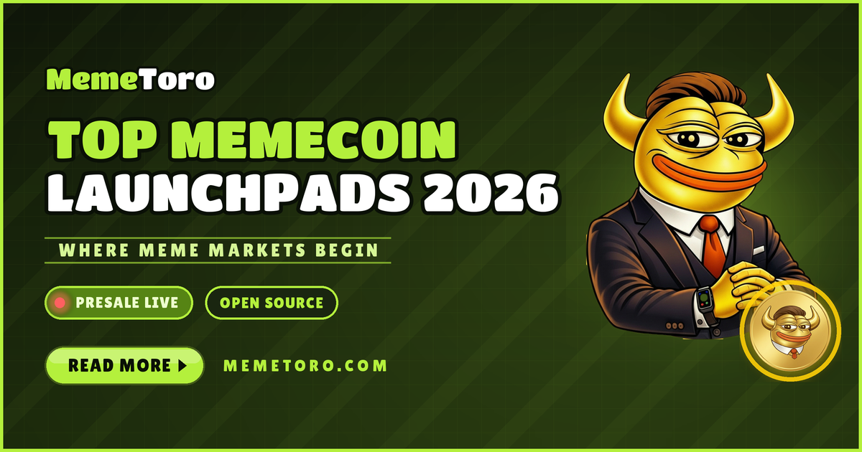
Finding the next 100x memecoin requires more than following a viral image or social post. A launchpad’s rules can shape who gets access, how liquidity is handled, and whether token allocations are clear from the start. That makes BNB Chain launchpads worth watching as more creators look for quick ways to deploy tokens.
Four.meme, Flap, and MemeToro each take a different route. Four.meme focuses on a simple bonding-curve launch flow. Flap gives creators room to adjust bonding-curve settings. MemeToro is the newer project, using an open-source AI agent and public fair-launch code to reduce insider access.
Its $MT presale has passed $140K in Stage 7 at $0.00430. For buyers researching the next 100x memecoin, the question is not which platform sounds loudest. It is which launch model can earn real user trust.

Exploring MemeToro’s Presale and Launchpad Utility
MemeToro is a planned AI-powered memecoin launchpad on BNB Chain. It aims to help users discover, create, launch, and trade memecoins through one platform. The project’s AI agent is designed to help creators set token distribution and funding mechanics before a launch goes live.
The key difference is the proposed fair-launch system. MemeToro has published MIT-licensed Solidity code that describes fixed launch settings, no insider allocation in the fair-launch split, and contract-based paths for refunds or liquidity. It is a strong transparency step, although the system still needs real deployment, testing, and independent review.
$MT is planned to support platform access and transactions. Its wider utility roadmap also includes launch funding, staking, rewards, memecoin trading, prediction markets, and a news portal.
For potential users, the project’s appeal is simple:
- creators can use guided launch settings
- buyers can research public code
- launch rules are intended to be fixed before funding
- $MT could connect activity across the ecosystem
That is a bigger idea than a one-off token launch. It makes MemeToro a launchpad to watch, but buyers should remember that the main product features are still being developed.

Four.meme Brings a Fast, Bonding-Curve Launch Model
Four.meme is already known as a high-volume native BNB Chain memecoin deployer. Its approach is based on a bonding curve, which is a pricing system where the token price changes as people buy or sell. This lets a token launch without the creator manually setting every market price.
The platform uses a 0.005 BNB deployment fee. That low entry cost can make it easier for users to launch experiments and new meme projects. For creators, the value is speed and low technical friction. For traders, the attraction is a fast-moving market with many new launches.
However, rapid launches can also mean rapid risk. A simple launch flow does not automatically answer questions about supply concentration, creator incentives, or liquidity behavior. Users still need to check token data before buying.
Four.meme is likely best for people who value a live, active launch environment. MemeToro’s approach is different. It is trying to add more rule-based structure before a launch happens, which could appeal to users who want clearer protections alongside speed.
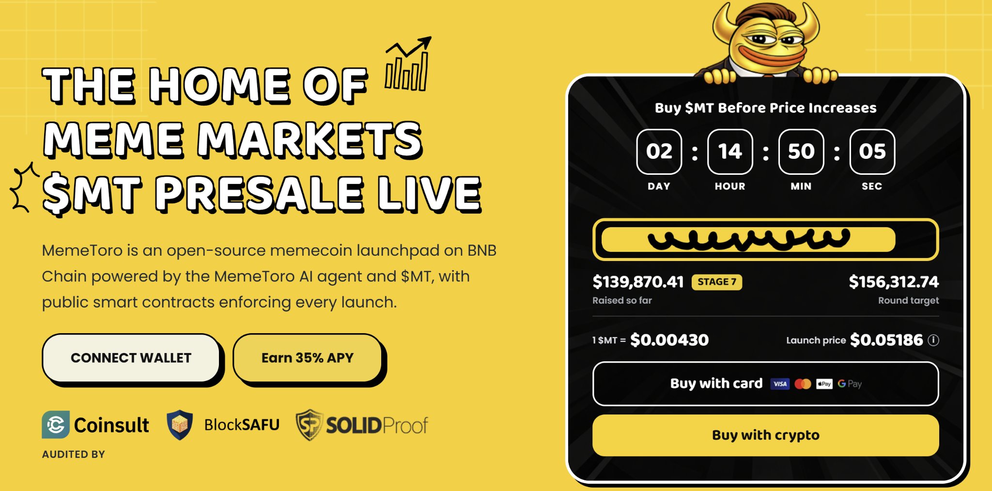

Flap Offers Custom Bonding-Curve Choices
Flap is another permissionless BNB Chain launch network. Its main draw is flexibility. Instead of using one fixed curve for every project, it allows creators to customize bonding-curve settings. That can help a project shape its own funding and market behavior.
This flexibility may suit experienced creators who understand how different launch settings affect buyers. Yet flexibility also asks users to do more research. A custom curve can change how quickly a token price rises, how much liquidity may be needed, and how much risk early buyers take.
MemeToro is aiming for a more guided route. Its planned AI agent is meant to assist with fixed token distributions and funding choices, while its fair-launch code is designed to reject insider tiers. That does not make one model automatically better than another. It simply gives users different priorities.
Flap may appeal to people who want launch customization. Four.meme may appeal to those who want speed. MemeToro may appeal to users who want AI guidance and public rules. Each model has a place, but transparent launch details should always come before hype.

FAQs

Which launchpad is best for new users?
It depends on the user’s goal. Four.meme focuses on fast deployment, Flap offers more curve customization, and MemeToro is building an AI-guided fair-launch model.

Is MemeToro’s launchpad fully live?
No. Its public code is available, but deployment, testing, liquidity execution, and independent security review are still important next steps.

Can any launchpad guarantee a 100x memecoin?
No. Memecoins are highly risky. Launchpads can improve access and transparency, but they cannot guarantee demand or price growth.
More Information on MemeToro ($MT) Presale Here:
Website: https://memetoro.com/
X: https://x.com/memetoro_mt
Telegram: https://t.me/memetoro_mt
YouTube: https://www.youtube.com/watch?v=gY0jgWy_DtA

