Monero and Zcash Rally as MemeToro Adds Public Smart Contract Rules to BNB Chain Memecoin Launches
Meta description: Monero and Zcash gain strength as MemeToro publishes public smart contract rules for transparent BNB Chain memecoin launches.
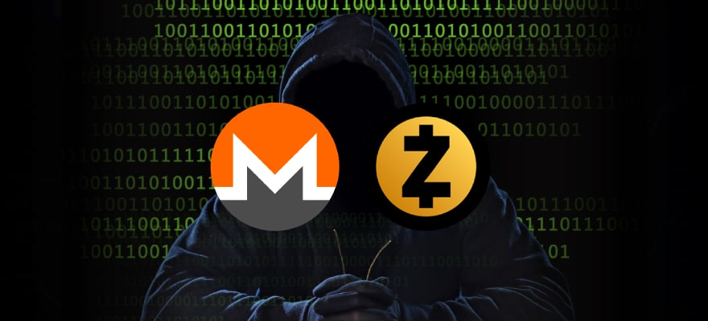
Privacy coins are drawing renewed attention as both Monero and Zcash show stronger market structures. XMR is trading near $580 after breaking a descending trendline that had capped its price since January. Zcash has surged more than 200% over three months and remains above $1,500 after another strong weekly gain.
These are live-market rallies with clear technical levels and network catalysts. The MemeToro presale is a different kind of crypto opportunity.
The project has published public smart contract rules for planned BNB Chain memecoin launches. Monero and Zcash are established privacy assets. MemeToro is an early project focused on AI-guided creation, transparent allocation rules, and future trading utility.
The main question is whether public launch rules can create a better user experience than opaque meme-token launches.

Understanding MemeToro’s Public Smart Contract Rules
MemeToro is building a planned BNB Chain ecosystem for memecoin creation, discovery, and trading. The project has released 1,373 lines of Solidity across 17 files under an MIT license. This includes a FairLaunchEscrow contract, interfaces, tests, and documentation.
The public code is designed to set clear launch conditions from the beginning. The stated model aims to lock settings when a launch is created. It also aims to stop insider allocations in the fair-launch split and limit how launch funds can move.
The proposed contract rules include:
- fixed contributor and liquidity allocations
- no developer-insider allocation in the stated split
- refund and planned liquidity pathways
- public functions for claims and finalization
For buyers, this could improve transparency around new memecoin launches. For creators, it could offer a structured launch process. The project still needs deployment, testing, liquidity execution, and independent review. Public code is a meaningful step, but it is not the same as a fully live or audited platform.

What Could a $1,000 $MT Purchase Look Like?
A $1,000 purchase at $0.00430 would buy around 232,558 $MT before fees. If $MT reaches its displayed $0.05186 launch target, the holding would have a paper value near $12,060. That represents an illustrative 12.06x multiple.
At a theoretical $1 billion fully diluted valuation, the 1.2 billion $MT supply would imply a price near $0.8333. The same allocation would then have a theoretical value close to $193,798.
These examples are not guaranteed returns or investment advice. Taxes, fees, slippage, liquidity, token supply, market demand, and product delivery can all change real results. Buyers should read the official MemeToro purchase guide before making any decision.
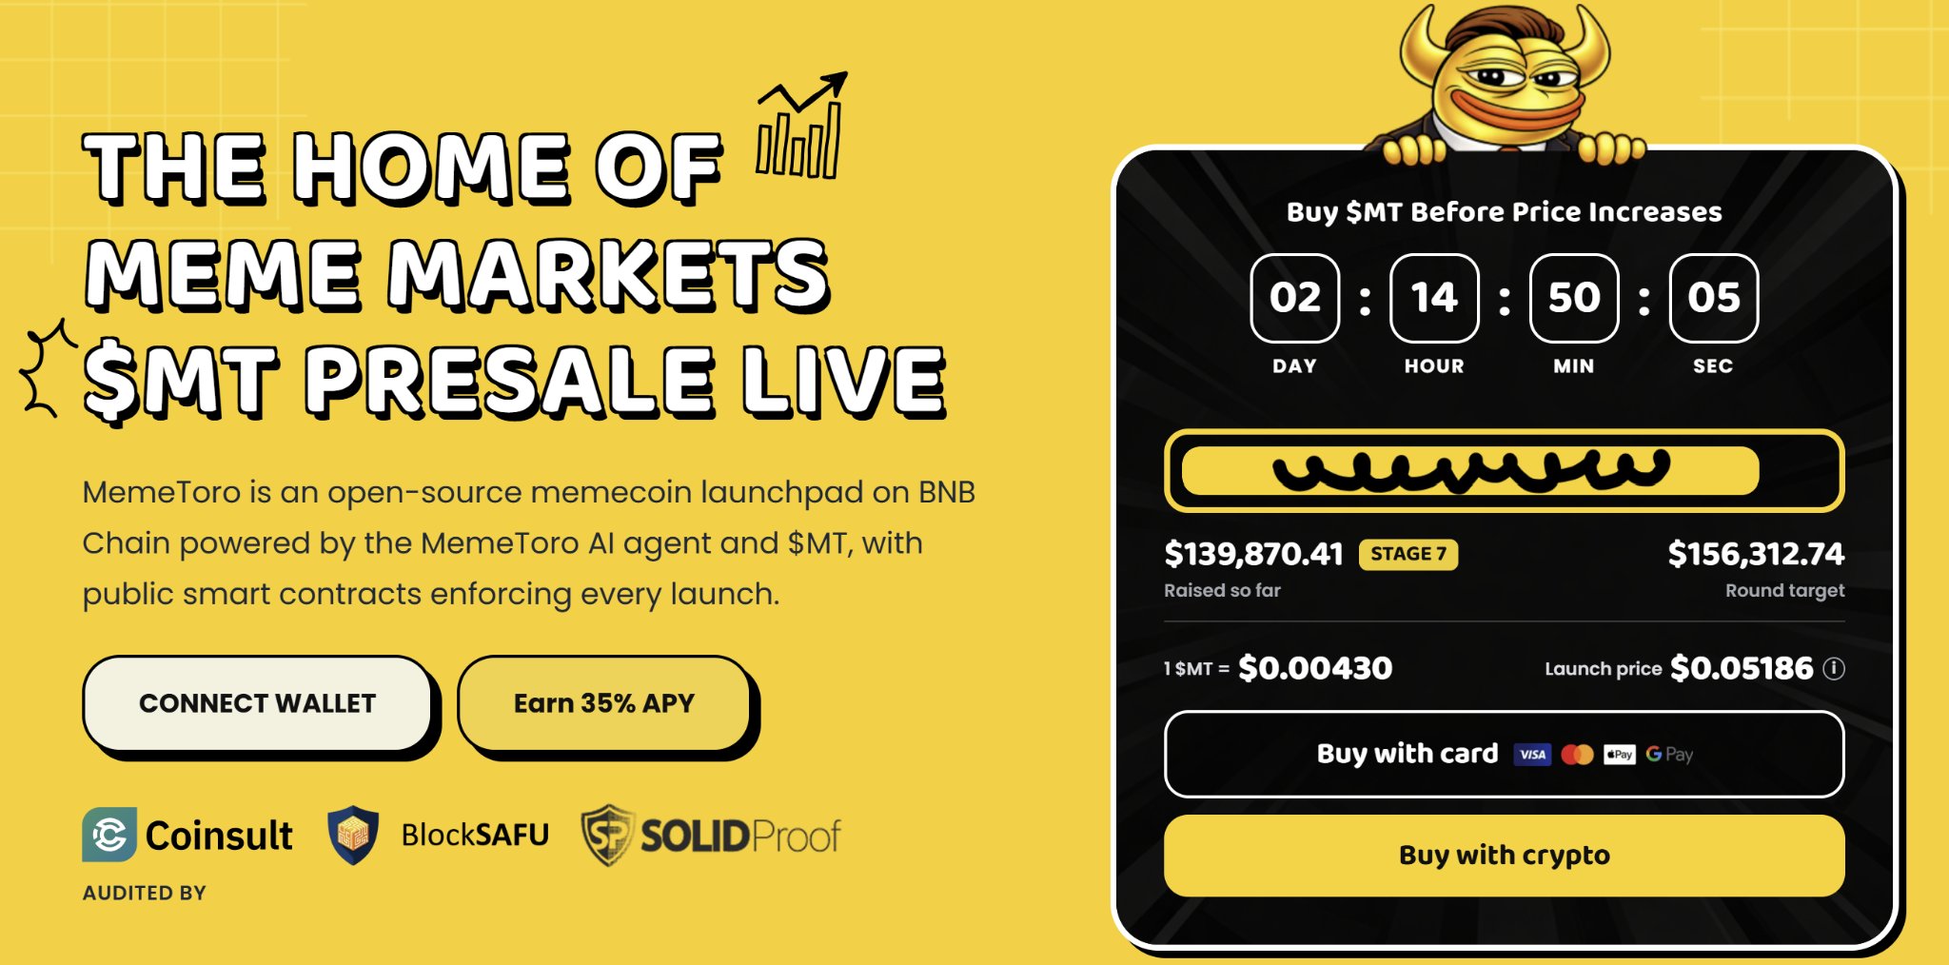

Monero’s Trendline Break Brings $585 Into Focus
Monero is trading close to $580 after moving above a descending trendline that had limited rallies since January. This is a bullish technical change because it shows that buyers have moved through a level where sellers previously had control.
The next key price is $585.37. XMR needs to move above and hold this level to validate the broader breakout. If it succeeds, algorithmic models point to a possible weekly target near $650.40. That would still require steady demand and a supportive wider market.
Monero’s momentum indicators are currently neutral to bullish. This suggests the asset has room to move, but it does not guarantee a rise. Privacy coins can react sharply to shifts in regulation, liquidity, and market sentiment.
XMR offers a live price discovery story with visible support and resistance. MemeToro is much earlier. Its potential depends on whether AI launch support and public smart contract rules can attract creators to BNB Chain. The two assets can both appeal to crypto users, but they should not be judged by the same risk standard.

Zcash Has Strong Catalysts Alongside Its Price Surge
Zcash has moved above $1,500 after a powerful three-month rally. Institutional interest has played a major role, with Grayscale’s Zcash ETF reportedly holding more than $900 million in assets under management. A 3-for-1 stock split is planned to improve the fund’s accessibility and liquidity.
The NU7 network upgrade is another important catalyst. It is scheduled for November 5 and aims to reduce block-generation times from 75 seconds to 25 seconds. Faster block times could improve the experience for private payments.
ZEC is targeting resistance near $1,700, while some market models discuss higher targets if momentum continues. However, a fast rally also brings correction risk. Buyers should watch whether the price can sustain demand after its large move.
MemeToro’s fair-launch story does not rely on a price rally. Its proposed value comes from clearer rules for creators and traders. If the project delivers its platform, $MT could gain utility through future activity. That remains a high-risk scenario compared with established privacy coins.

FAQs

What is the key Monero breakout level?
XMR needs to hold above $585.37 to strengthen its broader breakout case. A modelled weekly target near $650.40 remains speculative.

Why is Zcash rising?
Zcash has been supported by institutional fund demand, its planned stock split, and the upcoming NU7 network upgrade.

Can MemeToro’s code remove all memecoin risk?
No. Public rules may improve transparency, but they cannot guarantee liquidity, demand, security, or future token prices.

