Where To Buy Best Crypto Presale And What Happens Next: Vesting, Claims And TGE Explained With MemeToro
Meta description: Learn what happens after a MemeToro crypto presale purchase, including account crediting, token claims, public-sale vesting terms, and the role of a token generation event.

A crypto presale purchase is not the same as receiving a token that can be traded immediately. Buyers usually receive a recorded allocation first, then follow an official claim process when the project reaches its token generation event, often called a TGE.
MemeToro says that purchased $MT is credited directly to the buyer’s account after payment. Its public-sale allocation is stated as claimable at launch.

Payment Credit Comes Before Token Claiming
When a buyer completes a crypto presale payment, the system records the $MT amount purchased. This is called account crediting or allocation crediting. It tells the project how many tokens the buyer is entitled to claim under the sale terms.
MemeToro’s official guide says payment can be completed with BNB, ETH, USDT, or card, using BNB Chain for wallet connections. It also says purchased $MT will be credited directly to the account.
The buyer should save the transaction hash after a crypto payment. This is the permanent on-chain record of the transaction and can be useful if the account credit needs to be checked.
A crypto presale allocation is not automatically a live token balance in the wallet. Buyers should wait for official claim instructions from the project, then use only the official website to complete any claim action.
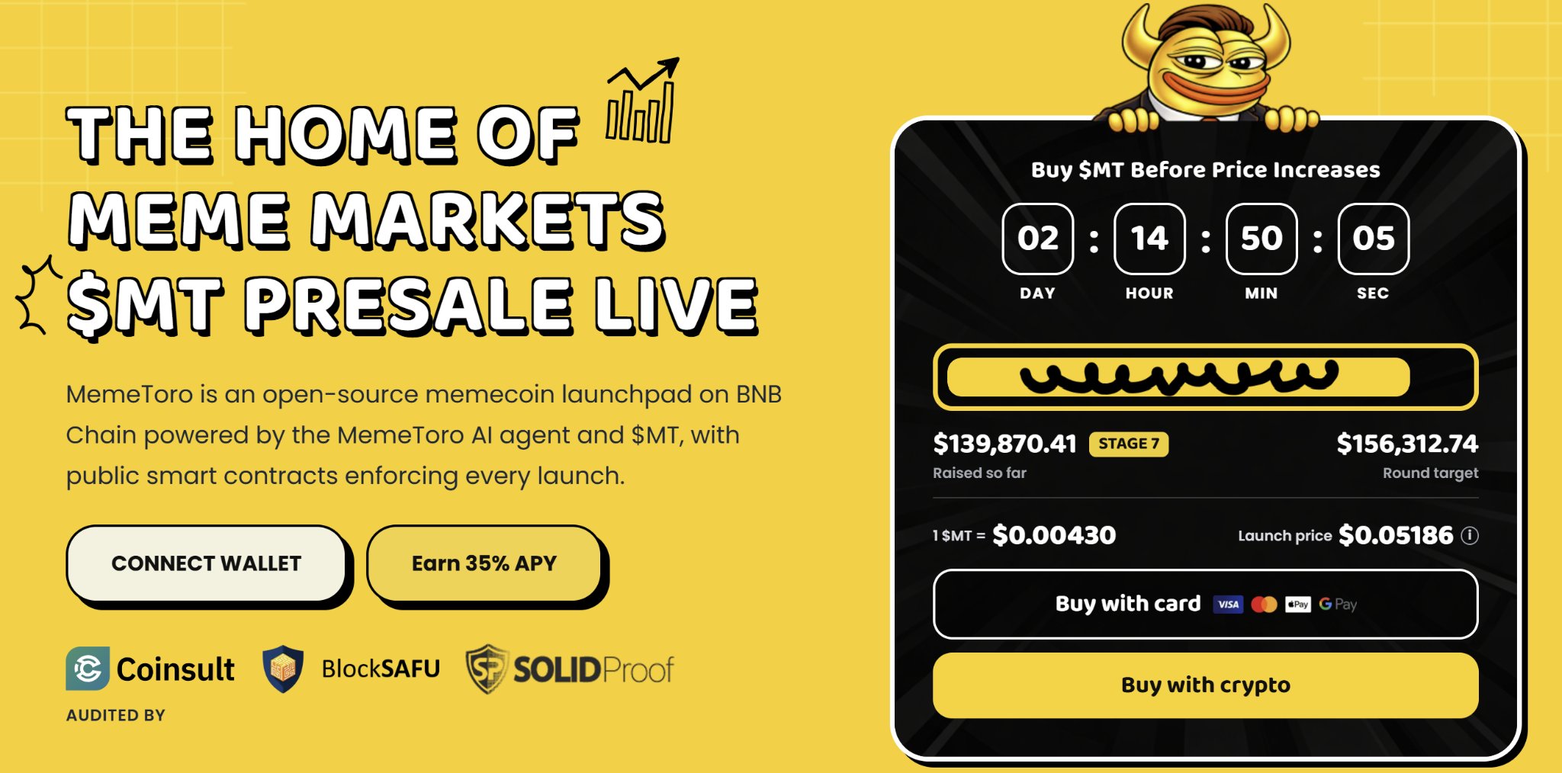

What A TGE Means For $MT Buyers
A token generation event is the point when the token is created and the official claim process becomes available. It may happen before, at, or around the beginning of public trading, depending on the project’s stated plan.
MemeToro’s public-sale allocation is listed as 857,936,900 $MT, or 71% of the total 1.2 billion-token supply. The project states that public-sale tokens have no vesting and are intended to be fully claimable at launch.
Vesting is a schedule that controls when a token allocation becomes available. MemeToro’s marketing-partner allocation is shown with a 24-month vesting schedule, which differs from the public-sale allocation.
Buyers should always check the latest official tokenomics before purchasing because allocation and claim terms are central to understanding possible supply entering the market.
A TGE does not guarantee that a token will trade at a certain price. Market value will depend on liquidity, demand, listings, and wider market conditions.

What Happens After Claims Begin
After a TGE, buyers may be able to claim their $MT into the wallet that made the purchase. The official project should provide the claim timing, claim page, and token-contract information.
This is also when scams often increase. A buyer should ignore direct messages offering “early claim” access and should never enter a wallet recovery phrase into a claim page.
MemeToro’s displayed ecosystem plans include AI-proposed memecoin launches, funding, staking, memecoin trading, prediction markets, and a news portal. $MT is intended to support activity across those planned products.
The safest approach is to bookmark the official MemeToro website, retain the purchase transaction record, and return only to official channels for claim details. A crypto presale purchase creates an allocation, but the claim and trading stages should always be handled with the same care as the original payment.
More Information on MemeToro ($MT) Presale Here:
Website: https://memetoro.com/
X: https://x.com/memetoro_mt
Telegram: https://t.me/memetoro_mt
YouTube: https://www.youtube.com/watch?v=gY0jgWy_DtA

