MemeToro vs XRP: Can $MT’s AI Launchpad Utility Offer More Upside Than XRP During Stage 7?
Meta description: XRP offers active-market liquidity near $1.50, while MemeToro’s Stage 7 $MT presale offers AI launchpad utility and higher risk.
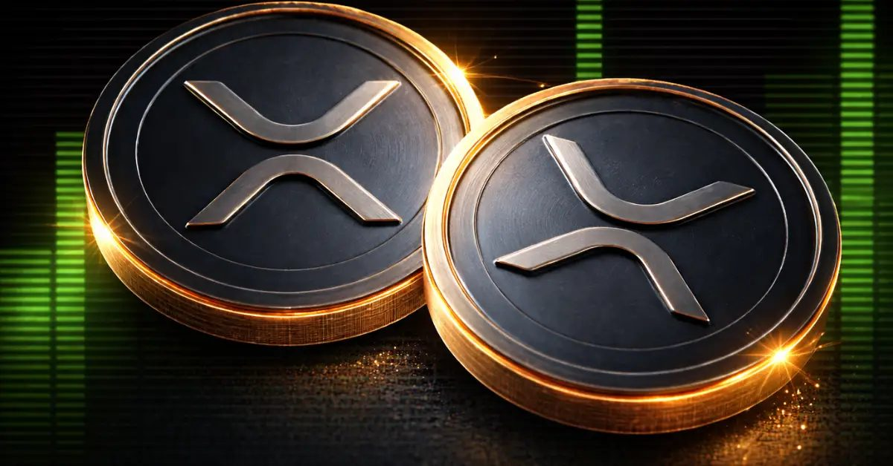
XRP is holding close to $1.50 as traders watch for a breakout from its current consolidation range. The token has established liquidity, a long trading history, and a chart-based path toward $2.10 if buyers can break and hold above the $1.50 level. That makes XRP a familiar choice for investors who want an asset already trading in open markets.
MemeToro is a very different type of opportunity. The project has passed $140K in its Stage 7 presale, where $MT is priced at $0.00430. It is building a planned AI-powered BNB Chain launchpad with public fair-launch rules.
The MemeToro vs altcoin question is not simply about which token can rise faster. It is about whether a smaller presale token with planned utility can offer more upside than an established asset, while also carrying far more delivery and liquidity risk.

Understanding MemeToro’s Stage 7 AI Launchpad Thesis
MemeToro is developing a platform for memecoin creation, discovery, and planned trading on BNB Chain. Its AI agent is intended to help users choose token distributions, funding mechanics, and launch settings. The project then aims to place those choices into a fair-launch smart contract system.
The $MT token is planned to support platform access, transactions, launch funding, staking, rewards, and future ecosystem activity. Its roadmap also includes memecoin trading, prediction markets, and a news hub.
The proposed utility cycle includes:
- AI-assisted launch creation
- public fair-launch contract rules
- new-token discovery and trading tools
- $MT access and transaction use
This is the bullish case for $MT. If creators use the platform and traders return to it, $MT could gain demand from ongoing activity. The risk is that the full platform is not live yet. The MemeToro vs altcoin comparison therefore requires buyers to weigh a lower Stage 7 entry price against the uncertainty of a planned product.
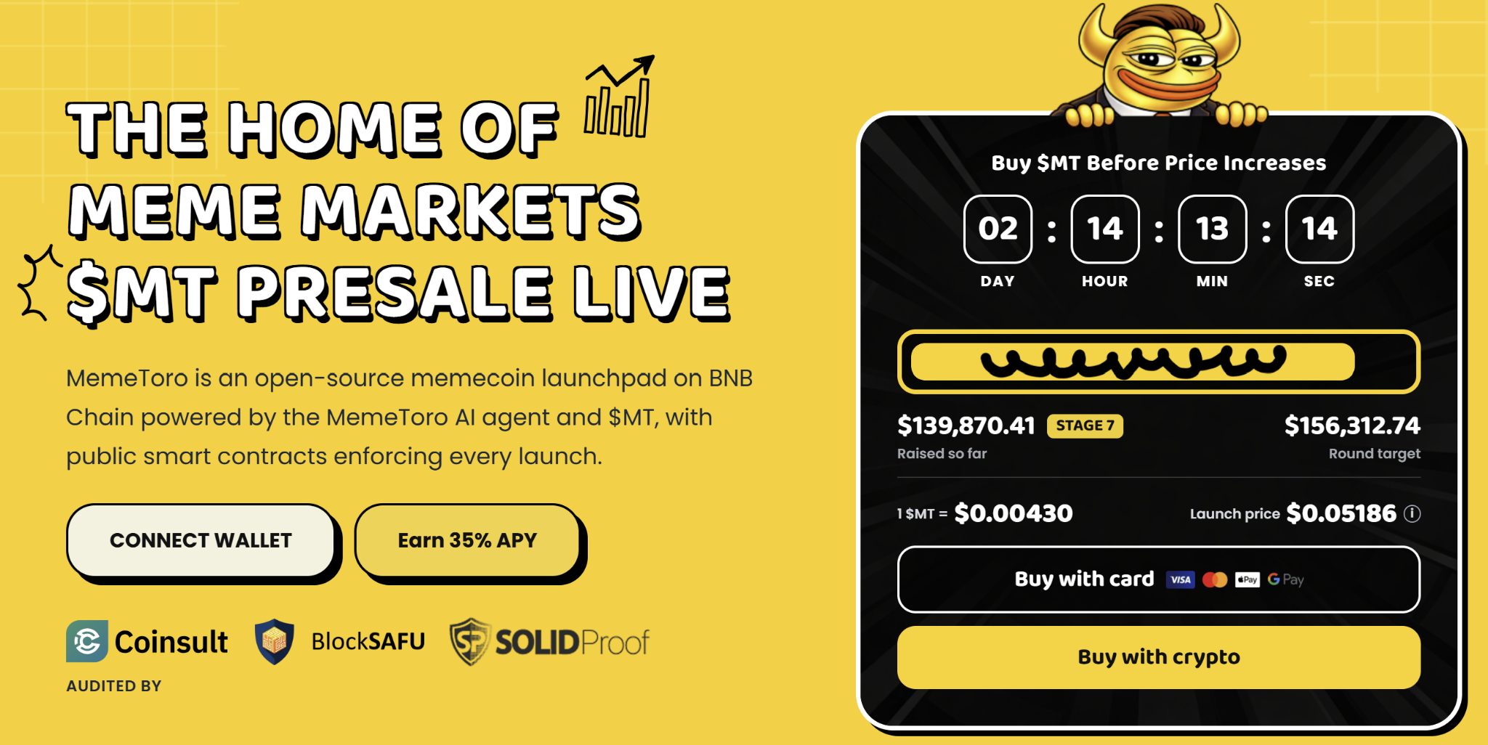

XRP Has the Advantage of a Live Trading Market
XRP is trading between roughly $1.50 and $1.60, with the $1.42 area acting as a key support floor. The token has formed a multi-week bull flag pattern and remains above important moving averages. If buyers can move XRP firmly above $1.50, chart analysis points to a possible short-term target around $2.10.
This gives XRP a clear market framework. Traders can follow volume, support levels, liquidity, and price action in real time. The token also has a much longer history than $MT.
XRP’s established status can reduce some early-stage uncertainty, but it does not remove risk. Chart patterns can fail, and broader market conditions can move prices quickly. Its larger market size may also make extreme percentage growth harder than for a new presale project.
MemeToro does not yet have XRP’s liquidity or trading record. In exchange, it offers early exposure to a future AI launchpad and public code development. The correct choice depends on a buyer’s risk tolerance, not on the nominal price of either token.

Can Public Fair-Launch Code Create a Different Upside Path?
MemeToro has published 1,373 lines of Solidity across 17 files. The public release includes a FairLaunchEscrow contract, tests, interfaces, and documentation. It is designed to lock launch settings at creation and prevent insider allocations in the stated fair-launch split.
The code also aims to route funds only toward refunds or planned liquidity. These rules could make launches clearer for buyers and reduce reliance on a creator’s private promises. If the platform becomes active, the fair-launch system could create a real reason for creators and traders to use $MT.
The project still needs to complete important work:
- deploy the contracts on BNB Chain
- test real liquidity routes
- connect the AI agent to launch workflows
- complete independent security review
This is where the MemeToro vs altcoin comparison becomes clear. XRP’s product and market are already active. MemeToro’s upside depends on successful delivery. Public code is a good signal, but it is not a substitute for a working platform and real user adoption.

What Could a $1,000 $MT Entry Look Like?
At the Stage 7 price of $0.00430, a $1,000 purchase would buy around 232,558 $MT before fees. If $MT reaches its displayed $0.05186 launch target, the holding would have a paper value near $12,060. This represents an illustrative 12.06x multiple.
A far more aggressive scenario assumes a $1 billion fully diluted valuation. With a 1.2 billion $MT supply, the implied price would be around $0.8333. The same token amount would then have a theoretical value near $193,798.
These examples are not investment advice or guaranteed returns. Trading liquidity, taxes, fees, slippage, supply, market conditions, and the success of the platform can all change real results. Buyers should use the official how to buy $MT guide and never share a seed phrase.

FAQs

Is $MT less risky than XRP?
No. $MT is a Stage 7 presale token with planned features, while XRP trades in an established market. $MT carries much higher execution and liquidity risk.

What could make $MT more useful after launch?
Potential utility may come from AI launch tools, fair-launch activity, trading, staking, rewards, prediction markets, and platform transactions.

What does XRP need for its $2.10 target?
XRP needs to break and sustain trading above the $1.50 level. The target remains a technical estimate, not a guarantee.
More Information on MemeToro ($MT) Presale Here:
Website: https://memetoro.com/
X: https://x.com/memetoro_mt
Telegram: https://t.me/memetoro_mt
YouTube: https://www.youtube.com/watch?v=gY0jgWy_DtA

