Solana Tests $114 Support as MemeToro Builds AI-Guided Fair-Launch Infrastructure for BNB Chain Memecoin Creators Today
Meta description: Solana holds near $114 as MemeToro builds AI-guided fair-launch infrastructure for BNB Chain memecoin creators and early $MT buyers.
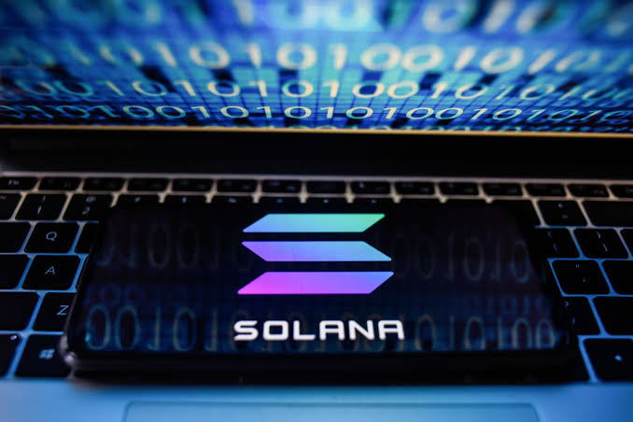
Solana is trading near $111.60 to $114 after a strong late-week move tied to a broader market rebound. The token has pushed through local consolidation and lifted its market cap above $65.5 billion. Technical charts show that the $100 to $105 area has changed from resistance into a key support zone.
This makes Solana’s $114 area an important short-term test. A move through the $112 to $118 resistance range could open a path toward $120 to $130, while holding support keeps the bullish structure intact.
At the same time, the MemeToro presale has passed $140K in Stage 7 at $0.00430. MemeToro is developing an AI-guided fair-launch system for BNB Chain memecoin creators. Solana is an established network with live activity. MemeToro is an early-stage project whose outcome depends on product delivery and user adoption.

How MemeToro Plans to Help New Memecoin Creators
MemeToro is building a planned ecosystem for memecoin creation, discovery, and trading on BNB Chain. Its AI agent is designed to help creators choose token allocations, funding mechanics, and launch settings. This could lower the barrier for users who want to create a token but lack smart contract experience.
The project is pairing AI guidance with a public fair-launch framework. The stated aim is to make key launch rules visible before funding starts and harder to change after users have joined.
The planned launch model includes:
- AI-guided token and funding setup
- fixed distribution rules for each launch
- no insider allocation in the stated fair-launch split
- refund and planned liquidity pathways
This could make a new memecoin launch easier for buyers to research. It does not remove market risk. New tokens can still face low liquidity, fast price changes, and weak demand. The core idea is to reduce rule-changing risk, not to guarantee a successful launch.

Solana’s Support and Alpenglow Upgrade Shape Its Bullish Case
Solana’s current price action is being supported by a stronger technical setup. SOL has moved above its 200-day EMA and printed a bullish weekly engulfing candle. The $100 to $105 range is now the key structural floor to watch.
If buyers hold that zone, analysts see the $112 to $118 resistance area as the next challenge. A clear move above that range could put $120 to $130 in focus. Longer-term models have discussed much higher targets, but these remain speculative and depend on Solana’s continued network growth.
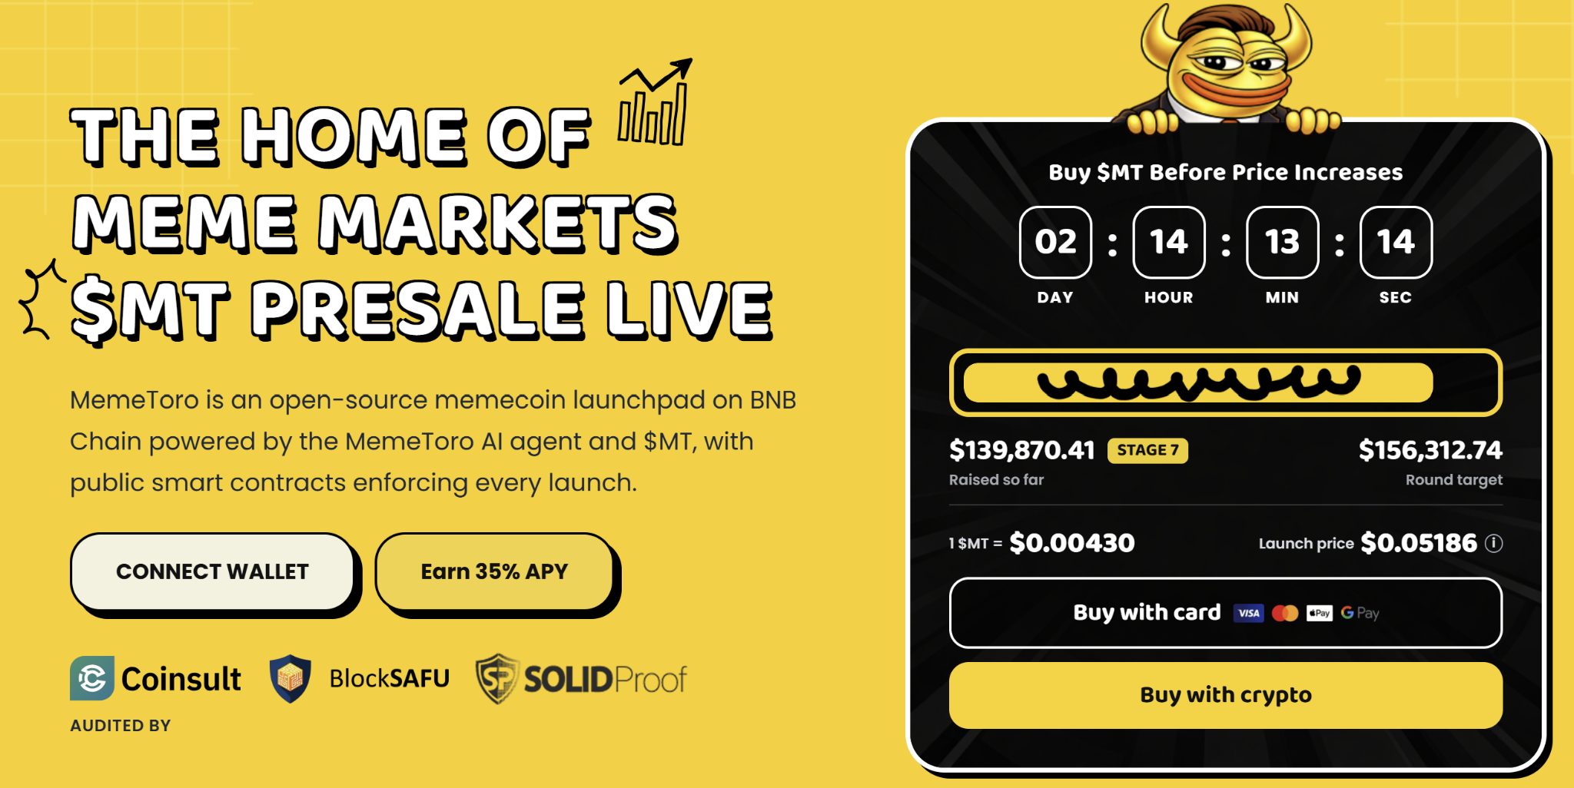
The October Alpenglow upgrade is another major catalyst. The upgrade is designed to replace Proof of History with Votor and Rotor engines. It aims to reduce transaction finality from 12.8 seconds to 150 milliseconds while freeing 75% of block space.
This is a live-network improvement story. Solana’s appeal comes from speed, large user activity, and a deep retail ecosystem. MemeToro’s appeal is different. It is trying to build fairer launch infrastructure on BNB Chain before its full product reaches the market.

Why Public Code Gives MemeToro a Clearer Starting Point
MemeToro’s public repository contains 1,373 lines of Solidity across 17 files. The release includes a FairLaunchEscrow contract, interfaces, tests, and supporting documents. Solidity is used to write many blockchain smart contracts, so public access lets users inspect the project’s stated rules.
The contract design aims to lock launch settings when a project is created. It is also designed so contributor and liquidity allocations total 100%, leaving no space for an insider allocation in the fair-launch split. Funds are intended to move only through refunds or planned liquidity.
This gives the project a concrete technical milestone. It is not the same as a finished, audited, or live system. The contracts still need deployment, testnet activity, real liquidity execution, and an independent review.
For $MT buyers, the upside case is that creators use the AI tools, traders use the future platform, and token utility grows with activity. The risk is that the team may not complete the roadmap or attract enough users. The MemeToro presale should be viewed as an early, speculative opportunity.

FAQs

What is Solana’s key support level?
The $100 to $105 area is the major support zone after SOL moved above its 200-day EMA.

What is the Alpenglow upgrade?
Alpenglow is a planned Solana upgrade intended to speed transaction finality and improve block-space efficiency.

Is MemeToro’s AI launchpad live?
No. The project has public code and a roadmap, but the complete AI-guided launch platform is still under development.
More Information on MemeToro ($MT) Presale Here:
Website: https://memetoro.com/
X: https://x.com/memetoro_mt
Telegram: https://t.me/memetoro_mt
YouTube: https://www.youtube.com/watch?v=gY0jgWy_DtA

