Top 7 Altcoins for Bull Run: Why MemeToro Joins BTC, ETH, SOL, HYPE, NEAR, and XRP for Clear Upside Potential
Meta description: BTC, ETH, SOL, HYPE, NEAR, XRP, and MemeToro each bring distinct bull-run catalysts, from ETF flows to AI launchpad utility.

A bull market rarely moves in one straight line. Bitcoin usually sets the first trend, while Ethereum, Solana, and other large altcoins can gain when confidence spreads. Smaller projects may then draw attention when traders begin searching for new product stories and earlier entry points.
That is why BTC, ETH, SOL, HYPE, NEAR, XRP, and MemeToro belong in one bull-run watchlist. Bitcoin has broken above $81,000. Ethereum is testing $2,672 after moving over $2,600. Solana is holding near $114, HYPE reached a new high near $95, and NEAR has gained more than 80% in a week.
XRP is showing a breakout pattern above its 200-day EMA. MemeToro is the early-stage entry, with a $140K+ Stage 7 presale and a planned AI-guided BNB Chain launchpad. It has the highest execution risk, but also a different upside profile.

How MemeToro’s Fair-Launch Model Fits This Bull-Run List
MemeToro is building a platform for creating and trading memecoins on BNB Chain. Its planned AI agent is designed to assist creators with token distribution and funding choices. The project aims to combine this guidance with fair-launch smart contract rules.
The MemeToro presale has passed $140K, with $MT priced at $0.00430 in Stage 7. Its open-source repository now includes 1,373 lines of Solidity code across 17 files. The stated code design aims to lock launch settings, remove insider allocations, and direct funds through refund or planned liquidity routes.
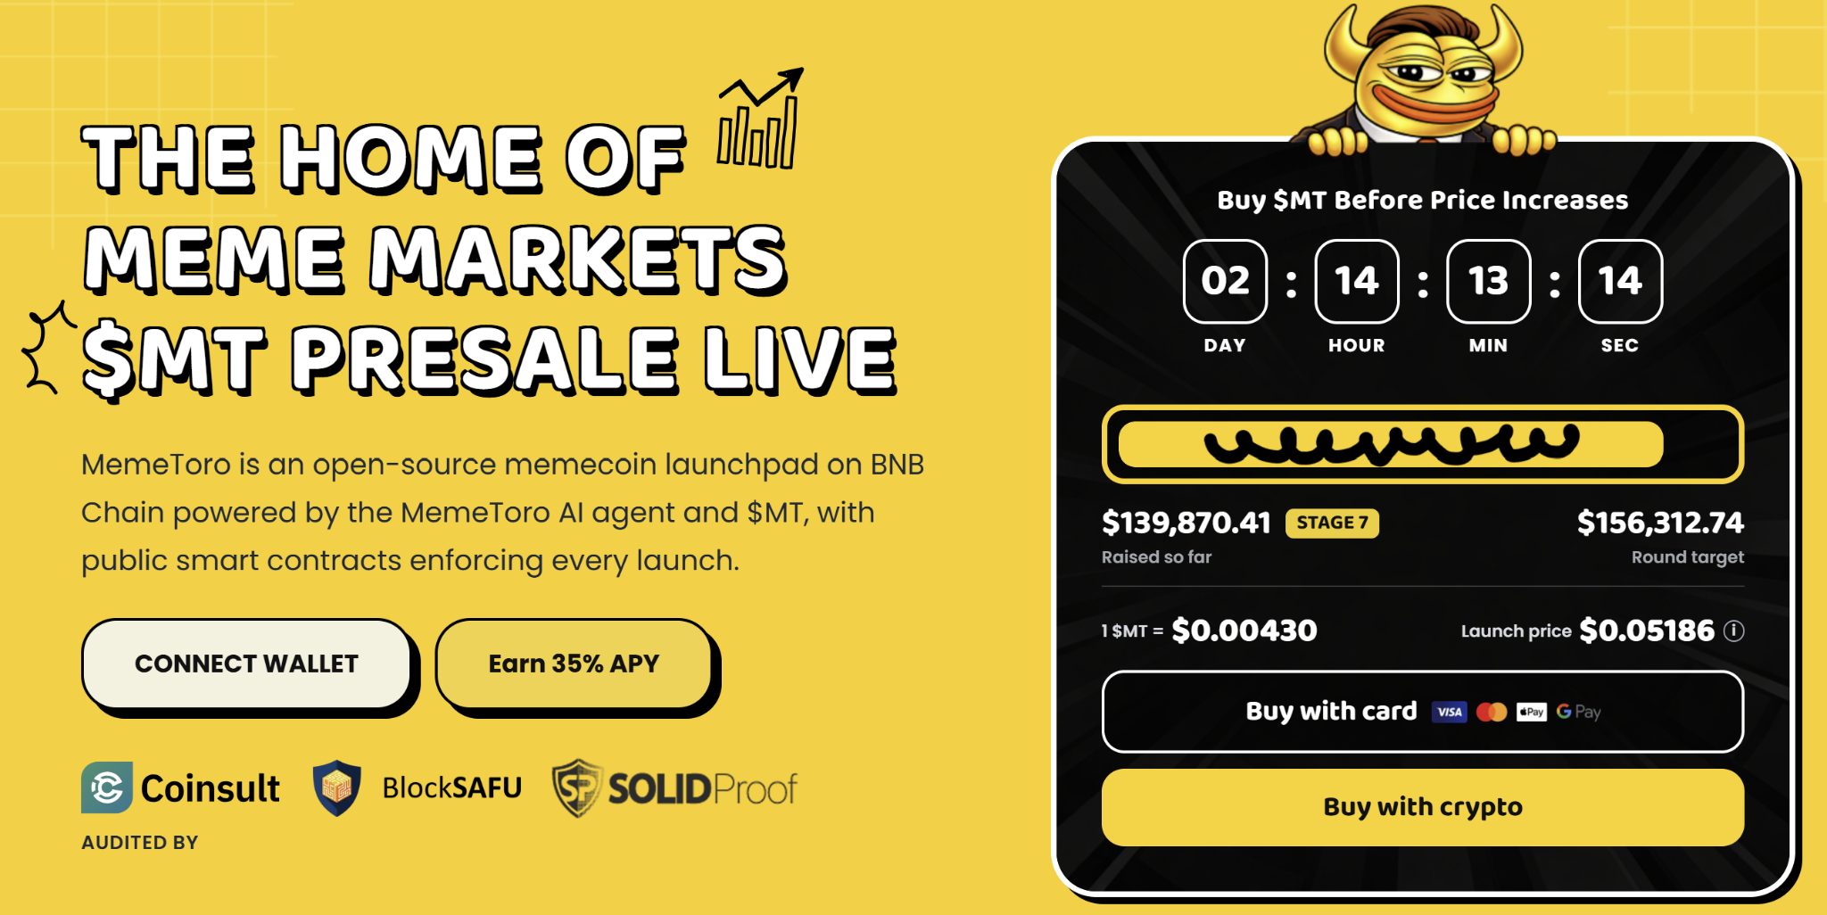
This is why MemeToro is different from BTC, ETH, SOL, HYPE, NEAR, and XRP. Those assets already trade in open markets. MemeToro is a presale tied to a future product.
$MT is intended for platform access, transactions, staking, rewards, launch funding, and planned trading activity. If the launchpad gains users, this utility could create demand. If the product is delayed or adoption stays low, the early presale risk remains high.

Bitcoin, Ethereum, and Solana Lead the Large-Cap Case
Bitcoin’s move above $84,000 and the 50-week EMA has strengthened the wider market tone. Institutional spot ETF inflows are adding support to the bullish story. The Bitcoin price prediction models now point toward a possible $90,551.79 October zone, though a drop remains possible in a volatile market.
Ethereum is holding near $2,635 to $2,670 after clearing $2,600. A weekly close above $2,672 could turn that level into support and open a move toward $2,950 to $3,000. ETH remains a major smart contract platform with deep liquidity.
Solana has rebounded to around $114.85 and is holding above the $110 support level. A $150 target has returned to market discussions if the $103 macro floor remains secure. Solana’s role in retail trading and memecoin activity keeps it relevant in a bull run.
For investors seeking a top altcoin to buy, these three assets have more history and liquidity than MemeToro. Their potential gains may be smaller in percentage terms, but their product and market foundations are already established.

HYPE, NEAR, and XRP Add Momentum and Network Catalysts
HYPE has reached a new all-time high near $95, helped by a native borrowing feature that lets users use HYPE as collateral for stablecoins. The project is also working on regulatory filings tied to potential U.S. retail perpetual futures access. These are major growth catalysts, but the token has already risen sharply.
NEAR has gained more than 80% in a week and trades around $4.30. The move has been linked to confidential perpetual futures and expanding cross-network liquidity. If the rally holds, models point to $5.30 to $6.00 as possible future zones.
XRP is showing a different type of setup. It has rebounded from $1.52, moved above its 200-day EMA, and flashed a stronger RSI buy signal. A move through $1.50 could support a chart-based target around $2.10.
MemeToro does not yet have these live-market catalysts. Its main catalyst is product delivery. The bull-run case for $MT is that public code, AI tools, and BNB Chain activity could combine to create a useful memecoin platform before the market’s next major phase.

Four Steps to $MT Buying
MemeToro kept the buying process fast and secure, so anyone can get through it without hassle:
- Reach the Portal: Click through from the main site to the verified presale page.
- Link a Wallet: Connect your wallet and set it to BNB Chain.
- Pick a Payment Method: Pay with BNB, ETH, stablecoins, or a card. Your choice.
- Confirm and Receive: Approve the transaction and $MT lands in your wallet.
Buying early isn't just about a lower price. Early holders get first access to staking rewards, trading tools, and new features as they launch.

FAQs

Why is HYPE on this bull-run list?
HYPE recently reached a new high near $95, supported by its stablecoin collateral feature and plans to expand perpetual futures access.

What makes MemeToro higher risk?
$MT is still in presale, and its core AI launchpad tools are planned. Bitcoin, Ethereum, Solana, HYPE, NEAR, and XRP already trade in active markets.

What is the current MemeToro presale price?
$MT is priced at $0.00430 in Stage 7, with the project reporting more than $140K raised.
More Information on MemeToro ($MT) Presale Here:
Website: https://memetoro.com/
X: https://x.com/memetoro_mt
Telegram: https://t.me/memetoro_mt
YouTube: https://www.youtube.com/watch?v=gY0jgWy_DtA

